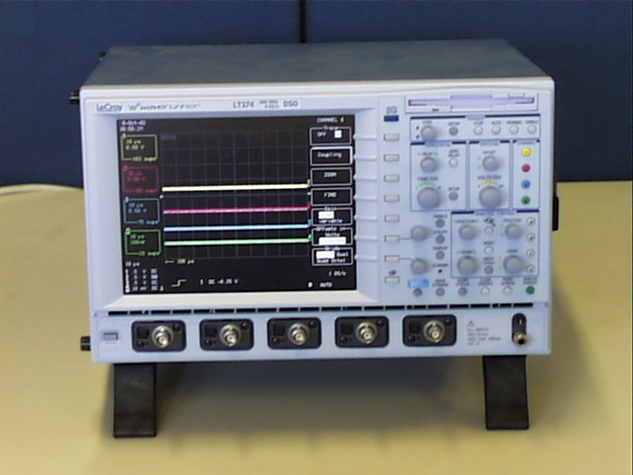

OSCILLOSCOPE - LE CROY WAVERUNNER LT374

Main Features:

Bandwidth: 500 MHz
Channels: Four
Sample Rate/ch: 2 GS/s
Maximum Sample Rate: 4 GS/s
Acq. Memory per Ch/Max: 250 kpt/500 kpt

LT374.pdf

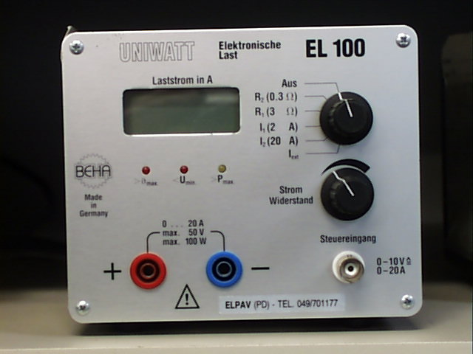

ELECTRONIC LOAD – UNIWATT EL100

Main Features:

50V 2A 100W max load
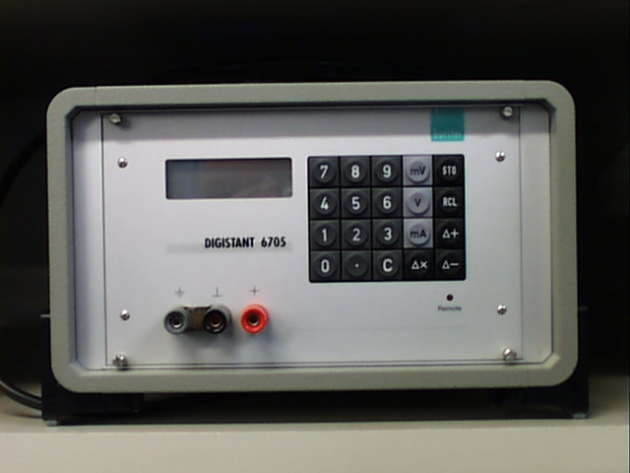

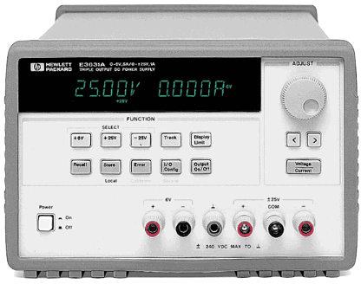

POWER SUPPLY - Hewlett Packard HP E3631A triple-output

Main Features:

Equipped GPIB and RS-232 as standard.
All programming is done to use SCPI (Standard Commands for Programmable Instruments).
80-watt triple output supply
Three independent 0 to +6V/5A and 0 to +/-25V/1A outputs.
The 6V output is electrically isolated from the +/-25V supply
The +/-25V outputs can be set to track each other.

HP E3631A.pdf
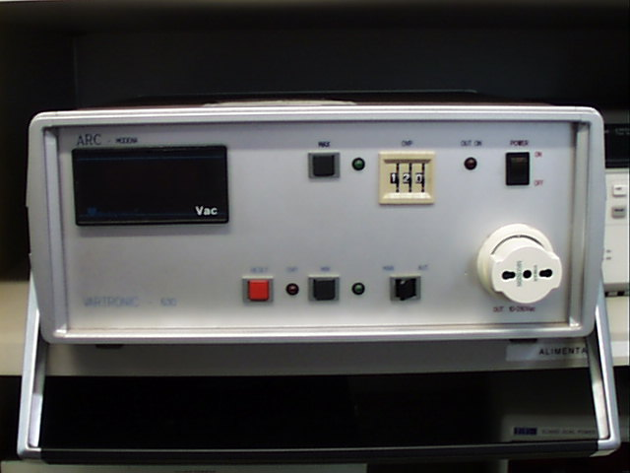

AC POWER SUPPLY - VAR630

Main Features:

Nominal voltage: 220Vac monophase, frequency: 50Hz;
Output voltage: 10-270 Vac;
Power output: 800VA;
Max output current: 3,5 A (7.5A, 15A, 20A);
Programmable ext reference output voltage: 0-10Vdc;
Tollerance: Vout +/-5% vs. reference output voltage 0-10Vdc;
Overvoltage protection programmable range 10÷270Vac;
Automatic and manual mode.

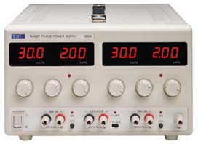

POWER SUPPLY - Thurlby Thandar EL302D

Main Features:

Dual outputs, 30V/2A
Independent digital voltage and current meters
for each output with 3 digit resolution
Constant voltage or constant current operation
DC output switch, automatic mode indication

TTI EL302D.pdf

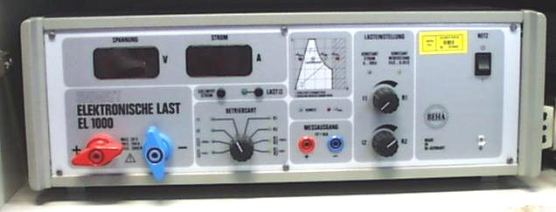

ELECTRONIC LOAD – UNIWATT EL100

Main Features:

30V 100A 1kW max load

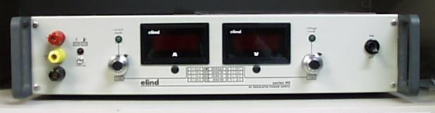

POWER SUPPLY - Elind 50HS6,4

Main Features:

Output voltage: 0-50V
Output current: 0-6.4A
Voltage Insulating (input-gnd, input-output, output-gnd) >50Mohm@500Vcc
Remote sensing for each conductor 0.5V
Line regulation: CV 0,01% + 0.005%; CC 0.02% + 0.01%
Load regulation: CV 0,01% + 0.005%; CC 0.02% + 0.01%
Residual ripple (20Hz-20.kHz): CV 300uV + 5uV/V; CC600uA + 50uA/A

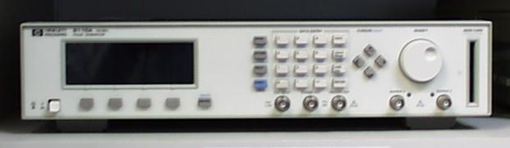

PULSE PATTERN GENERATOR – Hewlett Packard HP8110A

Main Features:

150MHz
Variable pulse parameters
PLL module& Deskew module
Number of Channels: 2 ch
Maximum Frequency: 150 MHz
Frequency Accuracy: 5 %
Minimum Pulse Width: 3.3 ns
Maximum Pulse Width: 998 ms
Maximum Output Voltage: 20 V
Minimum Period: 6.65 ns
Maximum Period: 999 ms
Minimum Delay: 0.00 ns
Maximum Delay: 998 ms
Output Data Format: NRZ
Output Impedance: 50 Ohm

HP8110A.pdf

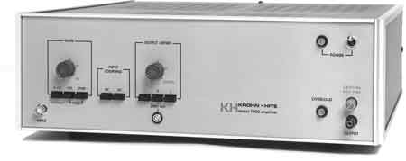

WIDEBAND POWER AMPLIFIER - Krohn-Hite 7500

Main Features:

75 Watts
Frequency Range: DC to 1MHz
Frequency Response: <±0.1dB
Distortion: <0.1%
Maximum Voltage: 140Vrms, Open Circuit
Voltage Gain: 0dB to 40dB
Variable DC Offset: 0V to 200V Peak
Short-Circuit Protection

KrohneHite7500.pdf
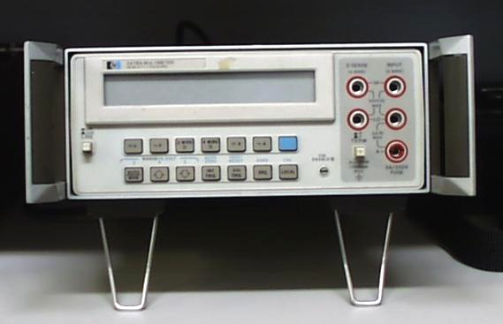

MULTIMETER - Hewlett Packard HP3478A

HP3478A.pdf

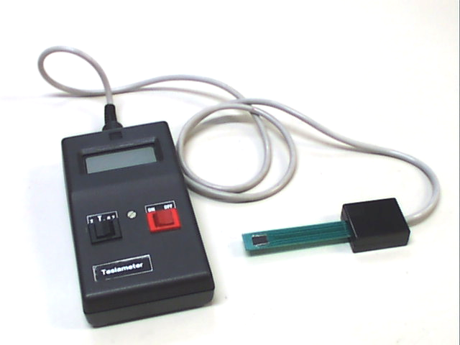

TESLAMETER

Range selection: 0.2T, 2T

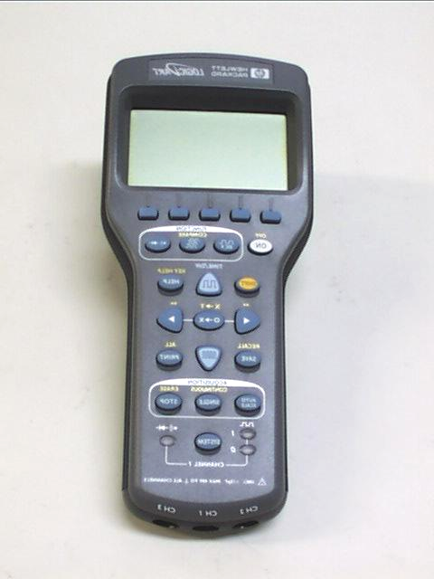

LOGIC PROBE - HP LogicDart E2310A

Main Features:

100 MSa/s logic timing for TTL / CMOS/ ECL / Custom
3 channel timing display with tristate
Logic monitor with 15 ns glitch detect
3 1 / 2 digit dc voltage to 35 volts
Continuity, frequency, resistance, & diode test

HP2310A.pdf

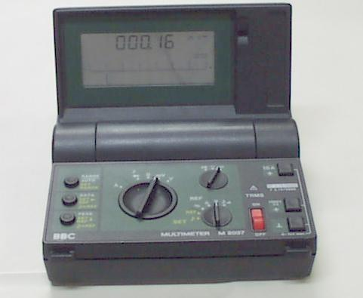

MULTIMETER – BBC M2037

Main Features:

Vcc range:300mV-1kV
Vac range:300mV-1kV
Acc range:300uA-3A
Aac range:300uA-3A
Ohm range: 300ohm-30Mohm

BBC M2037.pdf
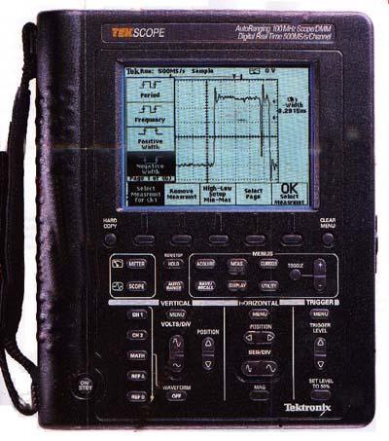

OSCILLOSCOPE MULTIMETER HANDHELD - TEKTRONIX THS720A

Main Features:

Bandwidth100 MHz
Sample Rate 500 MS/s (Each Channel)
Time/Division Range5 ns to 50s/div
Channels - Two.

THS720.pdf

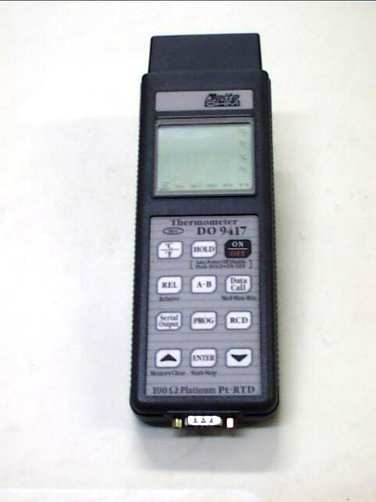

THERMOMETER DATA-LOGGER – Delta Ohm DO9416
Main Features:

Potable microprocessor instrument for thermocoupler probes type K, J, T, E, R, S o B
Principal characteristics:
double liquid crystal display,12.5 mm high
double input
optoinsulated RS232C serial output,baud rate selectable from 300 to 19200 baud
storage of the maximun,minimum and mean temperature values
relative measurements
power supply : 9v battery (50 hours' use)
measuring range:
K 200°C.... + 1370°C 328°F + 1999°F
J 1 00°'C.... + 750°C 148°F + 1382°F
T 200°C . 450°C 328°F + 662°F
E 200°C . 750°C 328°F + 1382°F
R +200°C.... + 1480°C +392°F.... + 1999°F
S +200°C + 1480°C +392°F . 1 999°F
B +200°C . 1800°C +392°F + 1999°F
Resolution: 0,1°C/0.1°F
from -199.9 to 199.9 1°C/1°F beyond that
Precision (instrument alone) with temperature from 18°C to 25°C:

DO9416.pdf
DO9416 manual.pdf

THERMOMETER DATA-LOGGER – Delta Ohm DO9417
Main Features:

Potable microprocessor instrument for Pt100 probes
Principal characteristics:
double liquid crystal display,12.5 mm high
double input
optoinsulated RS232C serial output,baud rate selectable from 300 to 19200 baud
storage of the maximun,minimum and mean temperature values
relative measurements
power supply : 9v battery (50 hours' use)
measuring range:-200°C ...+800°C
resolution: 0.1°C from -199.9°C to +199.9°C, 1°C beyond
DO9417.pdf
DO9417 manual.pdf

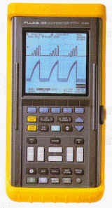
SCOPEMETER - Fluke 105B ScopeMeter Series II

Main Features:

2 channel and ext trigger - video trigger.
100MHz bandwidth, 5Gs/s sample rate.
Normal true RMS 3000 count DMM plus db.
Complete with software

Fluke105B.pdf

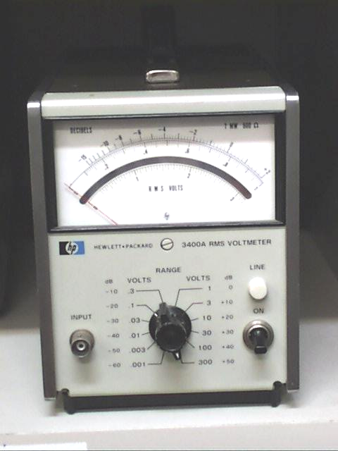

TRUE ROOT-MEAN-SQUARE VOLTMETER - Hewlett-Packard 3400A

Main Features:

Voltage range 1mV to 300V full scale
Frequency range 10 Hz to 10 MHz
Maximum DC input 600V
Response time less than 5 sec to a step function
Input impedance 10 MOhm and less than 50 pF for 1mV to 0.3V range
10 MOhm and less than 20 pF for 1V to 300 V range
Meter accuracy
10Hz-50Hz 5%
50Hz-1MHz 1%
1MHz-2MHz 2%
2MHz-3MHz 3%
3MHz-10MHz 5%
AC to DC Converter accuracy
10Hz-50Hz 5%
50Hz-1MHz 0.75%
1MHz-2MHz 2%
2MHz-3MHz 3%
3MHz-10MHz 5%

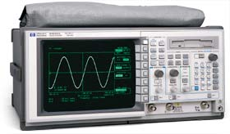

OSCILLOSCOPE - Hewlett Packard HP54520A
500 MHz, 2 Ch. 1 GS/s
Internal 3-1/2" floppy drive and HP-IB.

Main Features:

Bandwidth 500 MHz
Number of Channels 2 ch
Simultaneous Channels 2 ch
Simultaneous Maximum Sampling Rate/ch 500 MSa/s
One ch. only max. sampling rate 1 GSa/s
Max. Single Shot bandwidth 250 MHz
Max. Record Length 501 pt/sec
Min. Vertical Sensitivity 1 mV/div
Maximum Vertical Sensitivity 5 V/div
Rise time 700 ps
Number of Bits 8 bits
Input Impedance 1 MOhm
Input Impedance (alternate) 50 Ohm
Input Coupling AC,DC
Maximum Input Voltage 250 Vrms
Main time base - lowest 500 ps/div
Main time base - highest 5 s/div
Timebase accuracy 0.005 %
Trigger Source External,Internal
Trigger Modes Auto,Edge,Glitch,Logic,Trigger,TV Trigger
Sensitivity 0.5 mV
Minimum Glitch Trigger 1 ns
Display Type CRT Monochrome
Display modes average, envelope, persistence

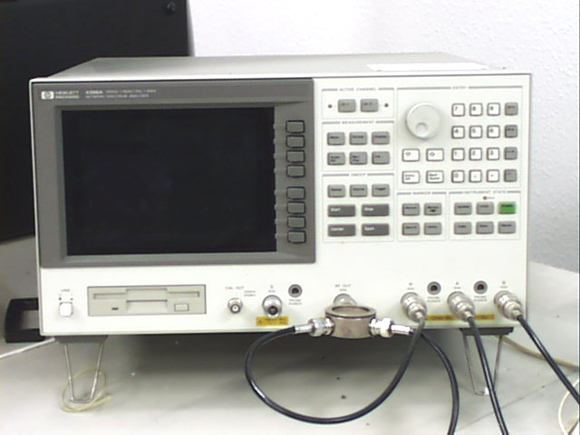

NETWORK/SPECTRUM ANALYZER – Hewlett Packard HP 4396A 1.8GHz

Vector network analyzer specifications:

Frequency operations: 100kHz to 1.8GHz with 1mHz resolution
Integrated synthesized level source: -60 to +20dBm of output power with 0.1dB resolution
Dynamic magnitude: ±0.05 dB
Phase accuracy ±0.3°
Spectrum analyzer specifications: the 3496A
Frequency operations: 2Hz to 1.8GHz with resolution-bandwidths (RBWs) spanning 1Hz to 3MHz Direct A/D conversion (no LOG amplifier is used) results in ±1.0dB overall level accuracy.
Noise sidebands fall below -105dBc/Hz offset 10kHz from carriers below 1GHz
Sensitivity: -150dBm/Hz @ 10MHz and -147dBm @ 1GHz.
Color CRT and built-in disk drive/RAM disk

HP4396A.pdf

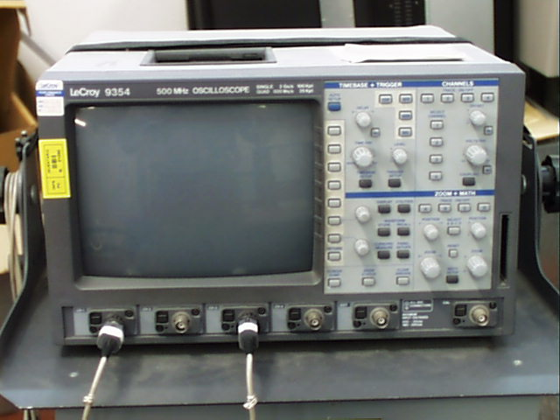

DIGITAL OSCILLOSCOPE - LeCroy 9374
Main Features:

Bandwidth 1 GHz
Number of Channels 4 ch
Simultaneous Maximum Sampling Rate/ch 500 MSa/s
One ch. only max. sampling rate 2 GSa/s

LECROY9354.pdf
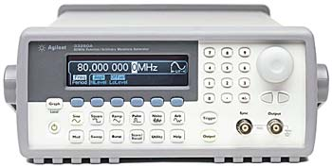

FUNCTION ARBITRARY WAVEFORM GENERATOR – Agilent 33250A

Specifications:

Sine, square, pulse, ramp, noise
AM, FM, FSK modulation
80 MHz sine and square wave outputs
50 MHz pulse waveforms with variable rise/fall times
12-bit, 200 MSa/s, 64K-point deep arbitrary waveform
GPIB and RS-232C interface

33250A.pdf

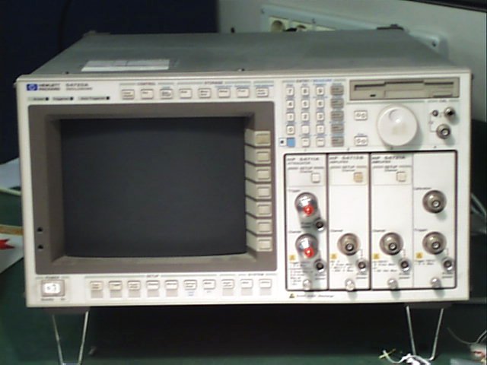

DIGITIZING OSCILLOSCOPE SYSTEM– Hewlett Packard HP54720A

Main Features:

FFT, measurement limit test, color graded display, histograms
3½" MS-DOS compatible disk drive
Time base scale (full screen is 10 div): 100 ps/div to 1 s/div
Maximum sampling rate real time: 4 GSa/s
Equivalent time: 500 MSa/s
Maximum waveform record length/plug-in: 32,768 points

PLUG-INs:

HP 54711A Attenuator
50ohm attenuator plug-in with external trigger. (1.5GHz bandwidth with HP 54710A and 54720A.
HP 54713B Amplifier
50ohm /1Mohm amplifier with internal trigger. (500MHz bandwidth with HP54710A and 54720A).
HP 54721A Two-Wide Amplifier Plug-In
Bandwidth: 1GHz with HP 54710A and 54720A.
Sample rate 4GSa/s.
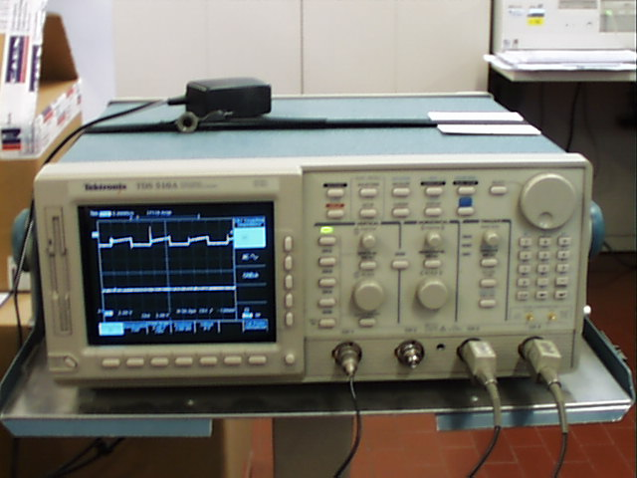

DIGITIZING OSCILLOSCOPE SYSTEM – Tektronix TDS 510A

Main Features:

500 MHz Bandwidth
Sample Rates to 500 MS/s
4 Channels
Width, 2 ns Glitch, Runt, State, and Pattern Triggering
1 mV to 10 V/div Sensitivity
Infinite and Variable Persistence
8-Bit Vertical Resolution Up to 12-Bit in Hi-Res Mode
1% Vertical Accuracy
FFT, Integration, Differentiation (option 2F)
25 Automatic Measurements
GPIB Programmable
3.5 in. Floppy Disk Drive

TDS510A.pdf

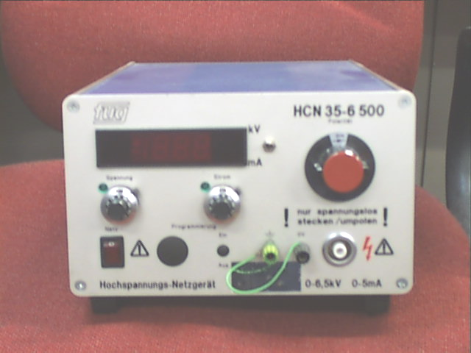

HIGH VOLTAGE POWER SUPPLY – FUG HCN 35-6 500

Features:

Output voltage: 0-6,5kV
Output current: 0-5 mA

FUG.pdf
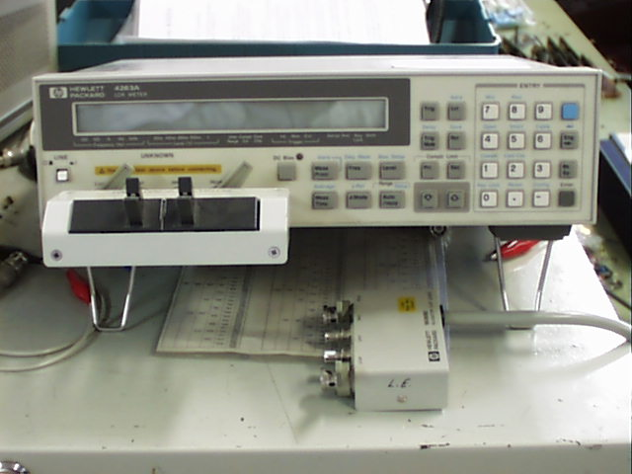

LCR METER - Hewlett Packard HP4263A

Main Features:

0.1% basic accuracy
100 Hz, 120 Hz, 1 kHz, 10 kHz, 100 kHz test frequencies
50 m, 100 m, 250 m, 500 m, 1 Vrms test levels
High-speed measurement: 25 ms
High-speed contact check
Quick test recovery
Wide capacitance test range
Front-end protection
Built-in comparator
Transformer parameter measurements

HP4263A.pdf

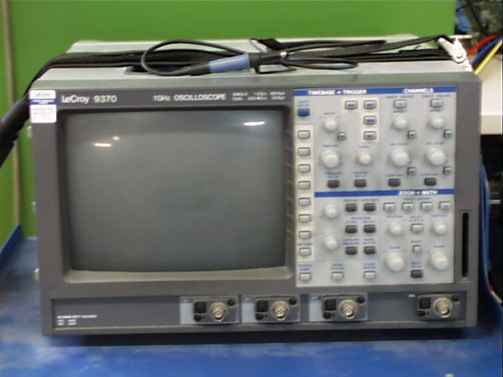

DIGITAL OSCILLOSCOPE – LECROY 9370
Main Features:

1 GHz Bandwidth, 2 GS/s
Up to 8M Point record length
8-bit vertical resolution, 11 with ERES option
Two Channel
Portable Hard Disk (PCMCIA III), Memory Card and DOS Compatible Floppy Disk options
Peak Detect
Glitch, Pattern, Qualified, Interval, Dropout and TV Triggers
Fully programmable via GPIB and RS-232-C
Internal Graphics Printer Option
Automatic PASS/FAIL testing
Advanced Signal Processing

LECROY9370.pdf

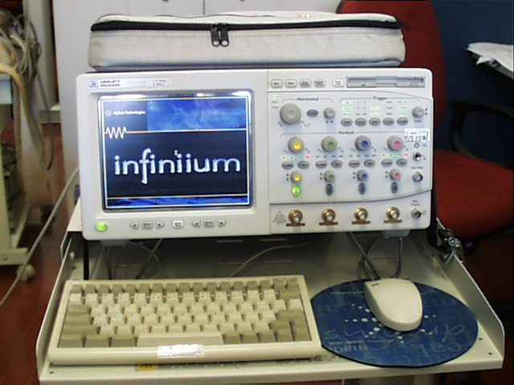

DIGITAL OSCILLOSCOPE – Agilent/HP54845A
Features:

1.5 GHz bandwidth
2 or 4 channels
8 GSa/s sample rates (2 channel mode)
4 GSa/s sample rates (4 channel mode)
Simple, analog-like front panel
Windows® 98-based graphical user interface
USB Test option with embedded MatLab
Time correlation between 16700 logic analyzer and scope
Built-in 120 MB floppy disk
LAN printing and file sharing
Eye diagrams and mask testing
Communications mask test kit option
Voice Control option for hands free operation
Web-enabled remote control from any web browser
Email on trigger

HP54845A.pdf
HP54845Ab.pdf

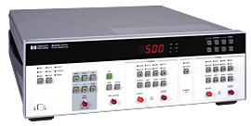

HIGH SPEED PULSE GENERATOR - Hewlett Packard HP8131A

Features:
Timing period: 2 ns to 99.9 ms
Delay: 20 ns to 99.9 ms
Pulse width: 500 ps to 99.9 ms
Double pulse: 2 ns to 99.9 ms
Transition times: <200 ps
Output amplitude: -4.90 V to +5.00 V high level, -5.00 V to +4.90 V low level
Output accuracy: ±3% amplitude
Output resolution: 10 mV
Polarity: pos and neg outputs
HP-IB interface
Output connectors: BNC(f)
100-120/220-240 Vac ±10%; 48-66 Hz operation
Weight: 45 lb; Size: 145 mm (5.7 in)H x 426 mm (16.75 in)W x 525 mm (20.65 in)D

HP8131A.pdf

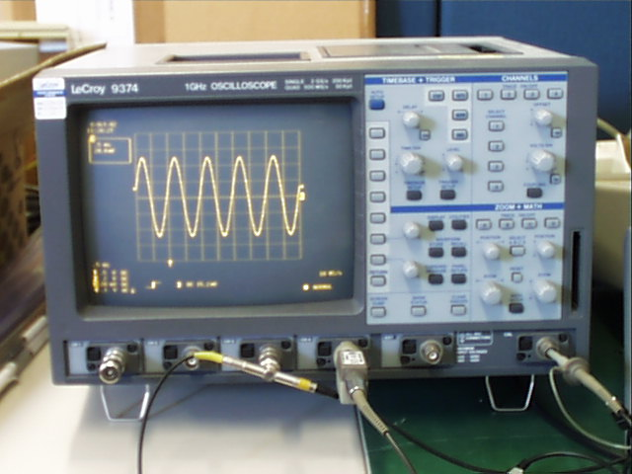

DIGITAL OSCILLOSCOPE – LECROY 9374
Main Features:

1 GHz Bandwidth, 2 GS/s
Up to 8M Point record length
8-bit vertical resolution, 11 with ERES option
Two Channel
Portable Hard Disk (PCMCIA III), Memory Card and DOS Compatible Floppy Disk options
Peak Detect
Glitch, Pattern, Qualified, Interval, Dropout and TV Triggers
Fully programmable via GPIB and RS-232-C
Internal Graphics Printer Option
Automatic PASS/FAIL testing
Advanced Signal Processing

LECROY9370.pdf

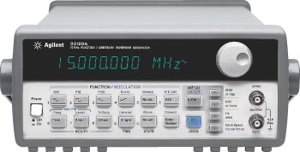

WAVEFORM GENERATOR - Hewlett Packard HP33120A

Main Features:

15 MHz sine and square waves
Sine, triangle, square, ramp, noise, sin(x)/x, cardiac & more
Arbitrary waveforms 12-bit, 40 MSa/s, 16k deep
Direct digital synthesis for 10 µHz or 10-digit resolution
50 mV to 10 V p-p output into 50 Ohms with 3-digit resolution
Linear and log sweeps
AM, FM, FSK, and Burst modulation
GPIB (SCPI) and RS-232 included

HP33120A.pdf

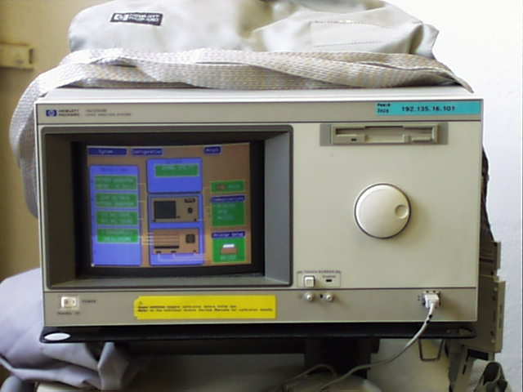

LOGIC ANALYSIS SYSTEM - Hewlett Packard HP16500B

Main Features:

Logic Analysis System Mainframe 16500B

Systems configured to exact requirement
Up to 1000 channels of 100 MHz state OR
Up to 640 channels of 100 MHz timing with 1Mb/channel depth
All data is time correlated
Built-in hard drive with software preloaded
Touch screen, keyboard & mouse user interfaces

Available Modules:
16520A 50MSa/s pattern generator
16522A 200Mvector/s pattern generator
16532A 2 Channel 1GSa/s Oscilloscope Acquisition Card
16550A 102 Channel 100 MHz State/500 MHz Timing Card

16500B user guide.pdf
16500B user references.pdf
16500B settings up.pdf
16500B programmer guide.PDF
16500B upgrades.PDF

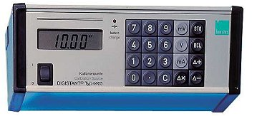

PRECISION CALIBRATION SOURCE - DIGISTANT Model 4405

Main Features:

Micro-processor controlled current voltage source
Voltage range:10 µV to 11.000 V
Current range:2 µA to 22.00 mA
NC-battery with overload and low-discharge protection

BURSTER4405.pdf

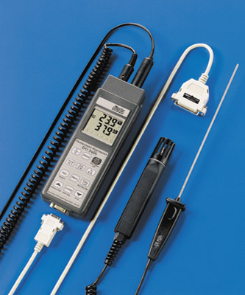

PORTABLE THERMOMETER-HYGROMETER DATA-LOGGER – Delta Ohm DO 9406

Instrument measurements:
% U.R. of relative humidity
D.P. dew point
g/m³ Quantity of water per m³ of air with reference to 0°C and a pressure of 1013 mbar
°C, °F Temperature in °C or °F
REL Relative measurements
MAX maximum value over a given period
MIN minimum value over a given period
MED mean value over a given period.

DO9406.pdf
DO9406 manual.pdf

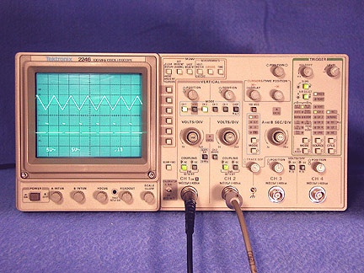

ANALOG OSCILLOSCOPE – Tektronix 2246

Main Features:

100 MHz 4 Independant Channels
Dual 2 nS/div timebase
Delayed Sweep
2 mV/div Vertical Sensitivity
On screen cursor & readout for measurement of Volts & Time

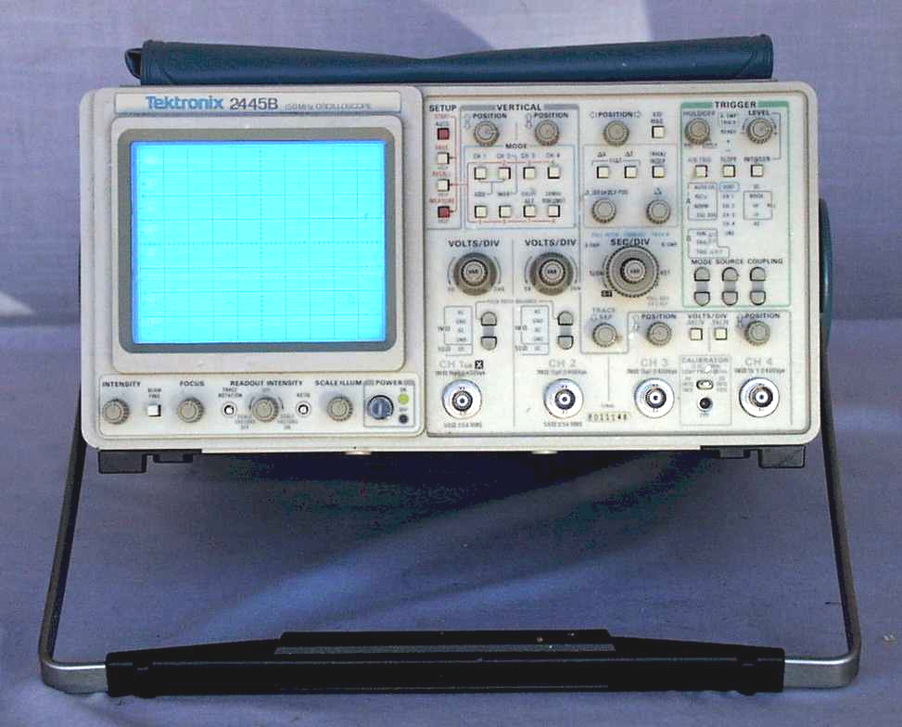

ANALOG OSCILLOSCOPE – Tektronix 2245

Main Features:

150MHz bandwidth at probe tip
1 ns/div sweep rate
2 mV/div vertical sensitivity
250MHz minimum triggering bandwidth
Four independent channels

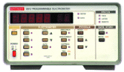

ELECTROMETER - KEITHLEY 6512

KEITHLEY6512.PDF

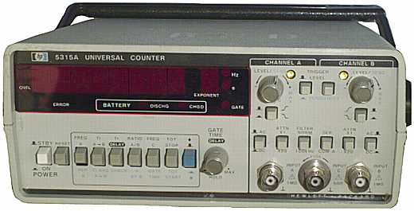

UNIVERSAL COUNTER – Hewlett Packard 5315A

Main Features:

Measurements range: 0.1Hz to 100MHz range.
Measurement Period: 10 ns to 105 Sec
Time Interval: 100 ns to 105 Sec
Time Interval Average: 0 ns to 105 Sec
Time Interval Delay: holdoff, variable delay of nominally 500 µs to 20 ms between START (channel A) and STOP (channel B)
And Ratio: 0.1Hz to 100MHz, both channels.

Agilent 5315A.pdf

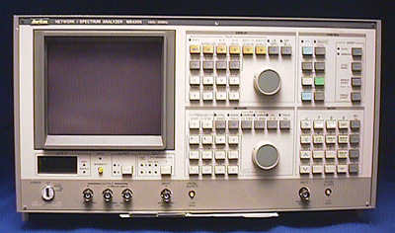

NETWORK/SPECTRUM ANALYZER - Anritsu MS420K

Main Features:

Frequency Range: 10Hz to 30MHz. Resolution: 0.01Hz
Input Channel: 2 channels (R and T) 50 ohm impedance
Wide measurable level range of over 150dB, allowing the measured device to be checked at actual operational levels
High-performance synthesizer to enable high resolution measurements
High-speed measurement of 2ms/point useful for mass production of parts.
High-precision group delay measurements
Logarithmic frequency sweep
Level sweep for non-linearity tests; variable input levels make the instrument suitable for characteristics tests
Built-in GP-IB interface for remote control of front-panel functions
Level calibration by using the output of the test-signal source
External MG440A Synthesizer or MG443B SLG can be connected to check frequency response of conversion loss at different input/output frequencies
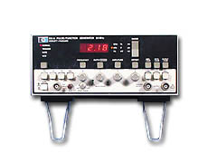
PULSE/FUNCTION GENERATOR - Hewlett Packard 8111A

Main Features:

Sine, triangle, square, and haverfunctions
20 MHz, 32 V p-p for all waveforms
Variable duty cycle or pulse width
Trigger, gate, VCO, and optional burst
Digital display for all parameters
Error recognition

hp8111a.pdf

