Solutions
1.2. s=(3E)²–0=9E²=9(p²+ m²)=88.9 GeV²; m = √s = 9.43 GeV.
1.3. , Γ_{K} = 54 neV, Γ_{Λ} = 2.5 µeV
1.6. Our reaction is. In the CM frame the total momentum is zero. The lowest energy configuration of the system is when all particles in the final state are at rest.
a. Let us write down the equality between the expressions of s in the CM and L frames, i. e.
.
Recalling that , we have .
b. The two momenta are equal and opposite because the two particles have the same mass, hence we are in the CM frame. The threshold energy is given by which gives .
c. .
1.7. a. , hence we have
b. . For a given proton energy, s reaches a maximum for a head-on collision. Consequently, and, taking into account that the energies are very large, . In conclusion
.
c. The attenuation length is
This is a short distance on the cosmological scale, only one order of magnitude lager than the distance to the closest galaxies, the Magellanic Clouds. The cosmic ray spectrum (Fig. 1.10) should not go beyond the above computed energy. This is called the Greisen, Zatzepin and Kusmin (GZK) bound. The AUGER observatory is now exploring this extreme energy region.
1.11. We must consider the reaction
.
The figure defines the CM variables
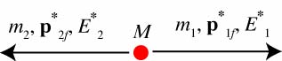
We can use equations (P1.5) and (P1.6) with √s=M, obtaining
.
The corresponding momenta are
.
1.15. When dealing with a Lorentz transformation problem, the first step is the accurate drawing of the momenta in the two frames and the definition of the kinematic variables.
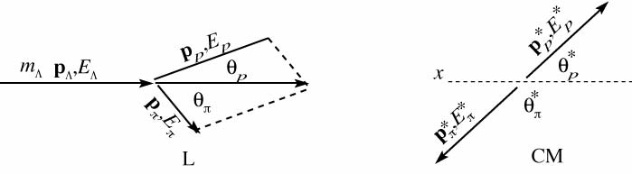
Using the expressions we found in the introduction we have:
a. .
b.We calculate the Lorentz factors for the transformation:
; .
c. We do the transformation and calculate the requested quantities
.
.
.
.
1.17. We continue to refer to the figure of problem 1.15. We shall solve our problem in two ways: by performing a Lorentz transformation and by using the Lorentz invariants.
We start with the first method. We calculate the Lorentz factors. The energy of the incident proton is. Firstly, let us calculate the CM energy squared of the two-proton system (i. e. its mass squared).
. Hence .
The Lorentz factors are and.
Since all the particles are equal, we have
.
We now perform the transformation. To calculate the angle we must calculate firstly the components of the momenta
.
.
.
.
.
.
In relativistic conditions the angle between the final momenta in a collision between two equal particles is always, as in this example, smaller than 90˚.
We now solve the problem using the invariants and the expressions in the introduction. We want the angle between the final particles in L. We then write down the expression of s in L in the initial state, which have already calculated, i. e.
that gives and hence .
We need E₃ and E₄ (and their momenta); we can use (P.1.13) if we have t. With the data of the problem we can calculate t in the CM:
.
We then obtain
.
From energy conservation we have
.
Finally we obtain
.
1.21. The maximum momentum transfer is at background scattering. Eq. (6.25) gives in these conditions Q²=4EE’, where E’ is the energy of the scattered electron. Using Eq. (6.11) we have .
1.25. .
1.27. The equation of motion is . Since in this case the Lorentz factor γ is constant, we can write . The centripetal acceleration is then: . Simplifying we obtain . We now want pc in GeV, B in tesla and ρ in metres. Starting from we have
.
Finally in N.U.: .
1.29. The Lorentz factor of the antiproton is and its velocity . The condition in order to have the antiproton above the Cherenkov threshold is that the index is .
If the index is n=1.5, the Cherenkov angle is given by . Hence .
1.30. The speed of a particle of momentum p=mγβ is , that is a good approximation for speeds close to c. The difference between the flight times is in N.U. In order to have Δt>600 ps, we need a base-length L>26 m.
1.32. Superman saw the light blue shifted due to Doppler effect. Taking for the wavelengths λ_{R}=650 nm and λ_{G}=520 nm, we have . Solving for β the Doppler shift expression , we obtain β=0.22.
1.36
1. The total energy of the deuterons is . The motion of the deuterons is not relativistic. Their momentum is
. This is also the total momentum, which is so small that in this case the L frame is also in practice the CM frame.
The CM energy squared is . The result could be obtained by simply summing the two masses and the deuteron kinetic energy. This because the situation is non relativistic. The total kinetic energy available after the reaction is , which is mainly taken by the lighter particle, the neutron. To be precise
and
2. The flux is .
3. We can calculate the momentum of the neutron non relativistically
, and its velocity
. We need 1 ns time resolution
1.38.
(a) .
The CM energy for the head-on geometry is .
At threshold , that is
(b)
(c) . The mass is zero for any values of the two energies.

2.3. The second gamma moves backwards. The total energy is ; the total momentum is . The square of the mass of the two-gamma system is equal to the square of the pion mass: , from which we obtain . The speed of the π⁰ is .
2.8. Since the decay is isotropic, the probability of observing a photon is a constant . We determine K by imposing that the probability of observing a photon at any angle is 2, i. e. the number of photons.
We have . Hence and .
The distribution is isotropic in azimuth in L too. To have the dependence of θ, that is given by, we must calculate the ‘Jacobian’ .
Calling β and γ the factors of the transformation and taking into account that p* = E*, we have
We differentiate the first and third members of these relationships, taking into account that p* is a constant. We obtain
.
and .
The inverse transformation is , i. e. , giving
.
Finally we obtain
2.13. Considering the beam energy and the event topology, the event is probably an associate production of a K⁰ and a Λ. ⁰ may be one of these two particles. The negative track is in both cases a π, while the positive track may be a π or a proton. We need to measure the mass of the V. With the given data we start by calculating the Cartesian components of the momenta
Summing the components, we obtain the momentum of the V, i. e. .
The energy of the negative pion is . If the positive track is a π its energy is , while if it is a proton its energy is .
The energy of the V is in the first case, in the second case. The mass of the V is consequently in the first hypothesis, in the second. Within the ±4% uncertainty, the first hypothesis is incompatible with any known particle, while the second is compatible with the particle being a Λ.
2.14.
1. The CM energy squared is . The threshold condition is
.
Hence, the threshold condition is , meaning that there is no threshold, the reaction proceeds also at zero neutrino energy.
2. The threshold condition is . The threshold energy is
3. The threshold energy is
.
2.16. The LASER photon energy is .
The electron initial momentum (we shall need its difference from energy) is
The total energy and momentum are
Energy conservation gives
We can eliminate the final energy and momentum of the electron by imposing .
. Hence: . Solving for E_{γf} we have .
. Hence
, and
3.2. Strangeness conservation requires that a K⁺ or a K⁰ be produced together with the K–. The third component of the isospin in the initial state is –1/2. Let us check if it is conserved in the two reactions. The answer is yes for because in the final state we have , and yes also for because in the final state we have . The threshold of the first reaction is just a little smaller of that of the second reaction because (1433 MeV < 1436 MeV). For the former we have
.
3.4. 1. OK, S; 2. OK, W; 3. Violates L_{µ}; 4. OK, EM; 5. Violates C; 6. Cannot conserve both energy and momentum; 7. violates B and S; 8. violates B and S; 9. violates J and L_{e}; 10. violates energy conservation.
3.8. a) NO for J and L; b) NO for J and L; c) YES; d) NO for L; e) YES; f) NO for L_{e} and L_{μ}; g) NO for L; h) YES.
3.9.
; ;
Hence:
3.15. .
3.19.1. C()=(–1)^{l+s}=C(nπ⁰)=+. Then l+s=even. The possible states are ¹S₀, ³P₁, ³P₂, ³P₃, ¹D₂.
2. The orbital momentum is even, because the wave function of the 2π⁰ state must be symmetric. Since the total angular momentum is just orbital momentum, only the states ¹S₀, ³P₂, ¹D₂ are left. Parity conservation gives P(2π⁰)=+ = P()=(–1)^{l+1}. Hence, l=odd, leaving only ³P₂.
3.21. It is convenient to prepare a table with the possible values of the initial J^{PC} and of the final l^{CP} with l=J to satisfy angular momentum conservation. Only the cases with the same parity and charge conjugation are allowed. Recall that and .

 | ¹S₀ | ³S₁ | ¹P₀ | ³P₀ | ³P₁ | ³P₂ | ¹D₂ | ³D₁ | ³D₂ | ³D₃
J^{PC} | 0^{– +} | 1– – | 1^{+ –} | 0⁺ ⁺ | 1⁺ ⁺ | 2⁺ ⁺ | 2^{– +} | 1– – | 2– – | 3– –
l^{PC} | 0⁺ ⁺ | 1– – | 1– – | 0⁺ ⁺ | 1– – | 2⁺ ⁺ | 2⁺ ⁺ | 1– – | 2⁺ ⁺ | 3– –
 |  | Y |  | Y |  | Y |  | Y |  | Y
In conclusion 1. ¹S₀; 2. ³S₁, ³D₁ e 3. ³P₂.
3.23. Λ_{b} is neutral. a) violates charm and beauty, b) and c) are allowed, d) violates beauty, e) violates baryon number.
3.26.
1. The minimum velocity is .
2. The minimum kinetic energy for electrons is
and for K⁺:
3. In the decay , the CM kinetic energy of the e⁺ is
, above threshold
In the decay , the CM kinetic energy of the K is
, below threshold
3.31. The beam energy is enough to produce strange particles but not for heavier flavours. In order to conserve strangeness the V⁰s must be a K⁰ and a Λ. The simplest reaction is .
We calculate the mass of each V⁰ assuming in turn it to be the K⁰ or the a Λ.
If 1 is a Λ,
or M=1.83 GeV not compatible with being a Λ.
If 1 is a K⁰
or M=0.495 GeV compatible, within the errors, with the mass of the K⁰
If 2 is a Λ,
or M=1.11 GeV compatible, within the errors, with the mass of the Λ.
If 2 is a K⁰ .
or M=0.371 GeV incompatible, within the errors, with the mass of the K⁰.
4.3. The ρ decays strongly into 2π, hence G=+. The possible values of its isospin are 0, 1 and 2. In the three cases the Clebsh-Gordan coefficients are , and . Hence I=1.
Since I=1, the isospin wave function is antisymmetric. The spatial wave function must consequently be antisymmetric, i. e. the orbital momentum of the two π must be l=odd. The ρ spin is equal to l. C=(–1)^{l}=–1. P=(–1)^{l}=–1.
4.7. 1. Two equal bosons cannot be in an antisymmetric state; 2. C(2π⁰)=+1; 3. the Clebsh Gordan coefficient .
4.11. It is useful to prepare a table with the quantum numbers of the relevant states
J^{P} | 1– | 1– | 0– | 0– | 1– | 0–
C | – | – | + | + | X | X
I | 0 | 1 | 0 | 1 | 1 | 1
G | – | + | + | – | + | –

. Since G=–1 in the final state, there is only one possible initial state, i.e. ¹S₀
hence .
hence .
hence .
4.13. The matrix element must be symmetric under the exchange of each pair of pions. Consequently:
- if J^{P} = 0–, = constant. There are no zeros.
- if J^{P} = 1–, ; zeros on the diagonals and on the border.
- if J^{P} = 1⁺, ; zero in the centre, where E₁=E₂=E₃; zero at T₃=0, where p₃=0, p₂=– p₁; E₂=E₁.
4.15. A baryon can contain between 0 and 3 c valence quarks; therefore the charm of a baryon can be C=0, 1, 2, 3. Since the charge of c is equal to 2/3, the baryons with Q=+1 can have charm C=2 (ccd, ccs, ccb), C=1 (e.g. cud) or C=0 (e.g. uud). If Q=0, one c can be present, as in cdd, or none as in udd. Hence C=1 or C=0.
4.24. We start from .
In the neighbourhood of the resonance peak the factor 1/E² varies only slowly, compared to the resonant factor, and we can approximate it with the constant , i.e.
.
Setting , we have
.
We find that , obtaining
.
4.30. G=+, because there are overall 4π.
The isospin cannot be 1, because the Clebsch-Gordan coefficient . It may then be I = 0 or I = 2.
C=+ because the two particles are identical. Check: G=C(–1)^{I}=+
The two particles are identical bosons, hence L must be even, L=0, 2, 4,..
The spin wave function must be symmetrical too, hence S=0, 2
It can be
J=0, with L=0, S=0 and with L=2, S=2
J=1 with L=2, S=2
J=2 with L=0, S=2, with L=2, S=0, with L=2, S=2 and with L=4, S=2.
4.34. With a π– beam, to conserve strangeness and charm we need to produce together with one particle containing , say and two containing , say, to conserve also the charge, and . The reaction is . Its threshold is
With a K– beam the initial strangeness is S=+1, hence only one K meson needs to be produced. The reaction is . Its threshold is
With a K^{–+} beam the initial strangeness is S=–1, hence three K mesons must be produced. The reaction is . Its threshold is
.
5.2. Since the speeds are small enough, we can use non-relativistic concepts and expressions. The electron potential energy, which is negative, becomes smaller with its distance r from the proton as –1/r. The closer the electron is to the proton, the better is its position defined and consequently the larger is the uncertainty of its momentum p. Actually, the larger the uncertainty of p the larger is its average value and, with it, the electron kinetic energy. The radius of the atom is the distance at which the sum of potential and kinetic energies is minimum.
Due to its large mass, we consider the proton to be immobile. At the distance r the energy of the electron is
.
The uncertainty principle dictates and we have .
To find the minimal radius a we set , obtaining
, that is the Bohr radius.
5.6. At the next to the three-level order in the t-channel there are the eight diagrams in the figure
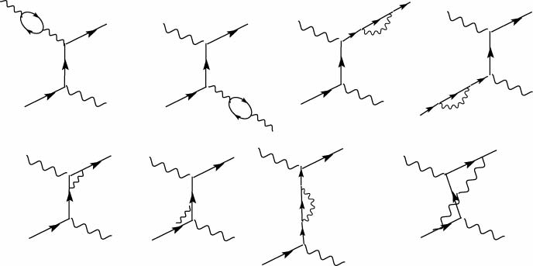
There are as many diagrams in the s-channel. The last one is
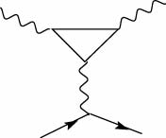
5.14. In the case of the electron the Bohr radius is , which is inversely proportional to the electron mass. To be precise, the reduced mass must be considered. The reduced mass of a system composed by a proton and a particle of mass m the reduced mass is . We have: , , , and , , , .
b) It is 13.6 eV for an electron and is proportional to the (reduced) mass. Hence .
5.17.
(a) or , hence and l_{ππ}=odd, with minimum value =1. The total wave function must be even. Being the spatial part odd, the isospin part must be odd, hence I_{ππ}=1. The isospin violation is ΔI =1.
(b) or , hence and l_{ππ}=even, with minimum value =0. Being the spatial part even, the isospin part must be even, hence I_{ππ}=0 or 2. Electromagnetic interaction has ΔI =0 or 1. Hence I_{ππ}=0 only.
(c) As (b) but with I_{ππ}=0 and 2 both allowed.
A cannot be in: forbidden, allowed, allowed.
6.2. The first case is below charm threshold, hence R(u, d, s)=2; the second case is above the charm threshold and below the beauty one, hence R(u, d, s, c)=10/3=3.3
6.5. From (6.12) with W=m_{p}, follows and then from (6.16) we have x=1. Using (6.11) we then obtain , and then (1.60) because .
6.8. For every x, the momentum transfer Q² varies from a minimum to a maximum value when the electron scattering angle varies from 0˚ to 180˚. From Eq. (6.26) and (6.29) that are valid in the L frame and (6.31) we obtain .
Clearly, we have Q²=0 in the forward direction (θ=0). The maximum momentum transfer is for background scattering (θ=180˚), i. e. .
For E=100 GeV, x=0.2 we have , corresponding to a resolving power of 32 am.
6.11. . (a) violates charm, (b) OK, (c) , charm conserved but electric charge violated, (d) , charm conserved but strangeness violated.
6.13. The colour wave function is , which is completely antisymmetric. Since the space wave function is symmetric, the product of the spin and isospin wave functions must be completely symmetric for any two-quark exchange. The system, uud, is obviously symmetric in the exchange within the u pair. Consider the ud exchange. The totally symmetric combination uud+udu+duu has isospin 3/2 and is not the proton.
The isospin 1/2 wave function contains terms that are antisymmetric under the exchange of the second and third quark, like uud–udu. We obtain symmetry by multiplying by a term with the same antisimmetry in spin, namely (↑↑↓–↑↓↑). We thus obtain a term symmetric under the exchange of the second and third quarks:
.
Similarly for the first two quarks we have
.
and for the first and third
In total we have 12 terms. We take their sum and normalise, obtaining
that is, as required, completely antisymmetric for the exchange of any pair.
6.20
a)
b)
The four-momentum of the initial proton is and the four-momentum transfer and their (invariant) product
and
6.23.
a) The exchanged gluon is ; the colour charges are
b) The exchanged gluon is ; the colour charges are
c) There are two possible gluons to be exchanged: and ; the colour charges are and . In total .
6.26. Being the colour wave function symmetric, the product of the spin and space wave-functions must be symmetric.
The total spin and the corresponding symmetry are: S=0 symmetric, S=1 antisymmetric, S=2 symmetric.
The total orbital momentum can be L=0 symmetric, L=1 antisymmetric
Hence the following combinations are possible S, L = 0,0 or 1,1 or 2,2
Recall that , .
For S=0, L = 0, we have
For S=1, L = 1, we have , and
For S=2, L = 0, we have
For S=2, L = 2, we have , , , , .

7.1. . We start by writing the valence quark compositions of all the particles, i. e. and then draw the diagram [figure a)]. Since it is a strong process we do not draw any gauge boson.
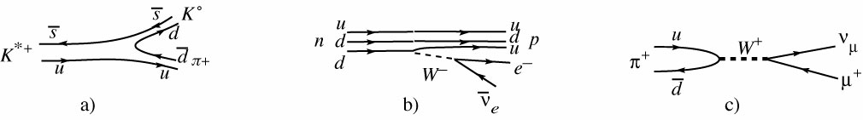
. It is a weak process. In order to draw the diagram we consider two steps: the emission of a W, and its decay . [figure b)]
. We have followed by . [figure c)]
7.9. The quantity p_{Λ} . σ_{Λ} is a pseudoscalar. It must be zero if parity is conserved, therefore the polarisation must be perpendicular to p_{Λ}.
7.18. The decay c→d +e⁺+ν_{e} is disfavoured because its amplitude is proportional to sinθ_{C}. The decay c→s+e⁺+ν_{e} is favoured because its amplitude is proportional to cosθ_{C}. We write down the valence quark compositions: , , , . Consequently the decays of D⁺ in final states containing a K– or are favourite. For example, , , are favoured. D⁺→π–+π⁺+e⁺+ν_{e}, D⁺→π⁰+π⁺ and D⁺→ρ⁰ + e⁺+ν_{e} are disfavoured.
7.20. Being V_{tb} very near to 1, the dominant decay is t→ b W. There are seven diagrams
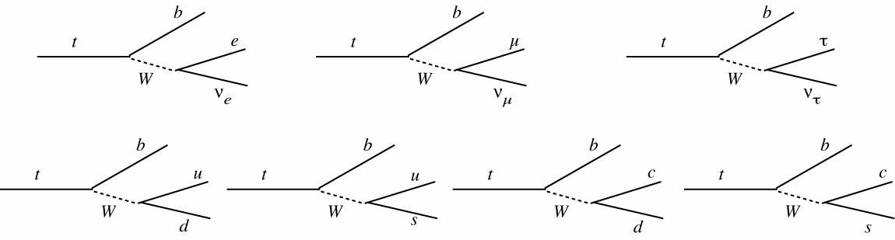
7.23. We start by writing the valence quark contents of the hadrons, we then identify the decay at the quark level and which quark acts as a spectator.
- At the hadron level we have and at the quark level with a spectator . The decay rate is proportional to .
- At hadron level it is and at the quark level it is with a spectator . The decay probability is proportional to ;
- The π⁰ has a and a component. The decay picks up the latter. At hadron level it is and at the quark level it is with a spectator . The decay probability is proportional to .
7.28. There are nucleons per unit volume. Consequently the mean free path is . This distance is smaller than the radius of the supernova core.
7.30. .
.
Notice that is forbidden by energy conservation.
8.4. and ; and .
8.9. We invert the system of equation (8.32), i. e. and the corresponding one for , i. e. , taking into account that is small. We obtain , . The decay amplitudes can be written as
and similarly . We finally obtain
8.12. If CP is conserved, in the decay L=l=0. The spatial wave-function of the dipion is even. The total must be even. Consequently, the isospin wave function of the dipion must be even, hence I_{ππ} =0 or I_{ππ} =2.
In the decay, L=l=odd. The isospin wave function of the dipion must be odd, hence I_{ππ} =1 or I_{ππ} =3.
9.3. In the rest frame of the pion the neutrino energy is .
The Lorentz factors are and .
The neutrino energy in the L frame is . Its maximum, for θ*=0 is . Its minimum for θ*=π is .
We use the Lorentz transformations of the components of the neutrino momentum to find the relationship between the angle θ* in CM and θ in L.
, which gives
.
9.7. For each reaction we check whether charge Q and hypercharge Y are conserved. We write explicitly the hypercharge values.
For we have 0→1/3+0. It violates Y.
For we have 0→1/3–1/3). It conserves Y, but violates Q.
For Z → W–+W⁺ we have 0→0+0. OK. For we have we have 0→1–1. OK.
9.9. .
....
.
9.18. .
.
9.21. The energy squared in the quark-antiquark CM frame is . Assuming, for the sake of our evaluation, , we have . The sea quarks structure functions are about .
The momentum fraction of the Z with longitudinal momentum P_{Z}=100 GeV is . By substitution into we obtain and or, numerically, .
Its solution is . The other solution is negative and therefore not physical.
more than 3 neutrinos. Notice however that the result depends somewhat on the exact values of the widths of Z and W.
9.33. The Z-charges squared of the u and d quarks have been calculated in problem 9.3. The difference now is that antineutrinos have positive helicity, then the factor 1/3 is for the L quarks.
, , , .
The neutrino cross section on an u quark is proportional to
.
and that on a d quark to: .
The cross section on a nucleus containing the same number of u and d quarks (only) is proportional to .
9.36.
a) We start from the results of problem 9.6. The protons contains 2 u quarks and one d quark. Hence its axial Z-charge is .
And that of the neutron is .
b) The axial Z-charge of a nucleus with Z protons and N neutrons is and is dominated by the neutron contribution.
c) The vector Z-charge of the electron is very small (0.04) compared to its axial charge (–0.50)
10.2.
1. Muon neutrinos
2. In the π CM frame energy and momentum of the neutrinos are
The Lorentz factor is
The Lorentz transformations
Hence
.
3. For it is also , and . Hence: .
and
The number of nucleons in M=22.5 t of water is
.
The number of CC ν_{μ} interactions in absence of oscillations would be .
The disappearance probability is
- The ν_{e} appearance probability is
10.6. a) CNGS. The Lorentz factor is
and the decay length .
T2K. ,
(b) The CM momentum, which is also the neutrino energy in the pion decay, is
.
Consider a neutrino emitted at the angle θ* to the beam in the CM frame and let us transform to the L frame
and we have
, for
CNGS:
T2K:
(c) The momentum components of a neutrino at θ*=90˚ are
Transverse component ; Longitudinal component
The angle in the L frame is
CNGS . Beam “radius” @ OPERA
T2K . Beam “radius” @ SuperK
10.10. The number of interaction in one year on N_{t} target protons is , hence the number of free protons needed is
An effective mole of the blend contains
protons/mol. Hence we need
effective mol.
The weighted molar mass is g. The blend mass needed is
10.13. (a) The kinetic energy E_{k,B}<<m_{ν}. Neutrinos are non-relativistic. . Their energy is close to the mass energy
(b) From , we have
(c) We have . The mean free path is then , which is larger than the radius of the universe.

