McBsr user Manual

After an terroristic warning message appear the connection settings dialog
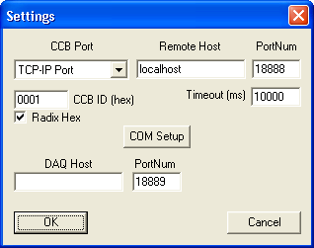
The DAQ Host is the server used during mini-crate production and must be empty.
The Timeout is the mini-crate command timeout.
The Radix Hex check box can be used to set/display CCB ID in hex or decimal value.
If mini-crate is in RunInPorgress the program can’t execute JTAG command, an error is reported.

When program is connect to mini-crate it automatic identifier the mini-crate type and on main window appear some icon that if you double click on it is open the following display dialog:
- FE is a display dialog that show the front-end enabled channels;
- Enable Channels is a display that sow the font-end, BTI and TDC enable channels on three tab control, one for super-layer;
- Mini-crate tree instead represent the JTAG chain of the mini-crate trigger electronics.

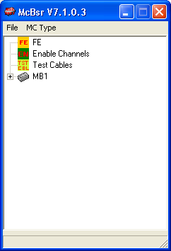
Double click on mini-crate icon open the executable JTAG command dialog
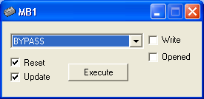

The command are execute at mini-crate level (on all board), and the JTAG command implemented are:
- EXTEST, used for boundary scan;
- SAMPLE, used for boundary scan;
-CONF, for read/write configuration registers;
- TESTIN, for read/write testing registers;
- TESTOUT, for read/write testout registers;
- BYPASS, for bypass;
- SingleChip Set, for execute command manually set on the chips;
- Boundary Scan Chip opened, for execute the sequence necessary to view connection between chips using BSR dialog that show the pins chip.

The Reset check box is used to generate a JTAG reset before executing the command, must be always checked.
The Update check box must be always checked, if not is show on the jtag register the data shifted out by TDO pin and not the actual content of the register.
The Write check box must be checked when you want write the register (conf register for example)
The Opened check box if checked, execute the command only on the chips that have the JTAG register dialog open.

On the first tree level there are the trigger boards contend in the mini-crate.
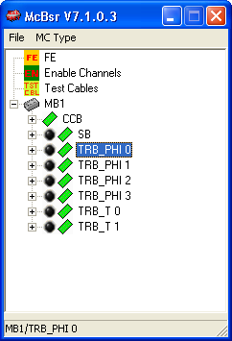
Double click on one board icon open the executable JTAG command dialog at board level, the commands are the same of the previous but the command are execute only on that board, if you use this you can’t test chip connection between two board
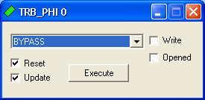

On the second tree level there are the chip content on the board
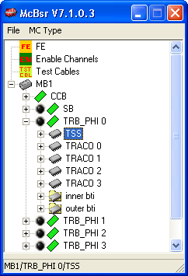

Double chick on the chip icon display the chip register and the JTAG instruction register that is executed when use SingleChip Set command. You can modify the content of the register and take effect after you click on confirm button.
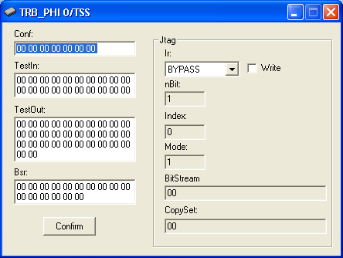

On the third tree level there are the single JTAG register
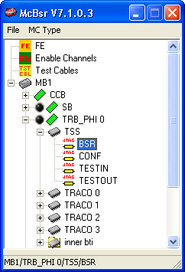

Double chick on the single register icon display a human representation of the JTAG register, or an graphical display of the pins.

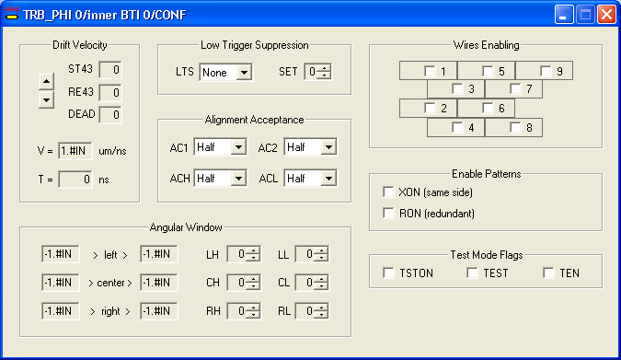

Sequence for manual boundary scan

The first IMPORTANT thing to do before use of the Boundary Scan Chip opened is a SAMPLE command, because is important to capture the default state of the internal three state control bits to prevent short circuit on bidirectional busses, this is the reason for terroristic warning message. If you use opened check box checked on SAMPLE command you must remember to execute SAMPLE any time you open a new BSR chip display.
After SAMPLE you can use the Boundary Scan Chip opened, and you can change the state of the output pin. The dark red are off output , instead dark green are off input.
Take caution to change the three state internal enables.

The second IMPOTANT thing to do before terminate program or if you want terminate a manual boundary test, you must execute a BYPASS command to exit from EXTEST state of the chips, because in this state the chips are not working.
BTI bsr dialog
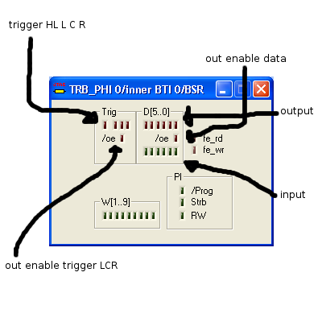
TRACO bsr dialog
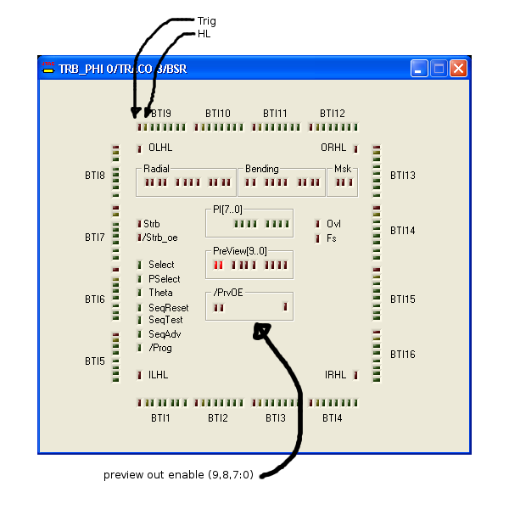
TSS bsr dialog
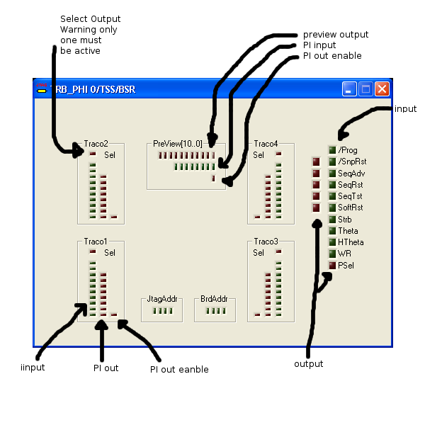
TSM Data bsr dialog
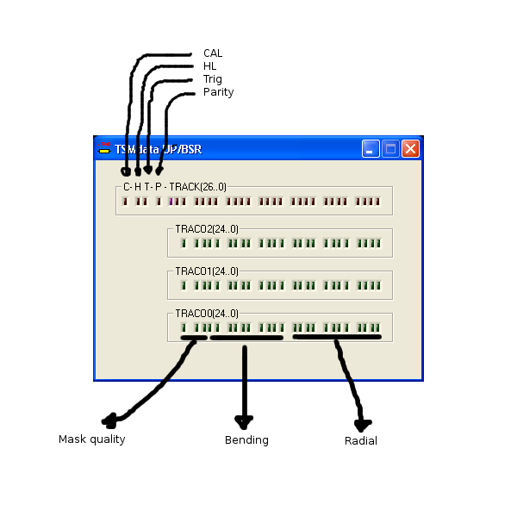
TSM bsr dialog
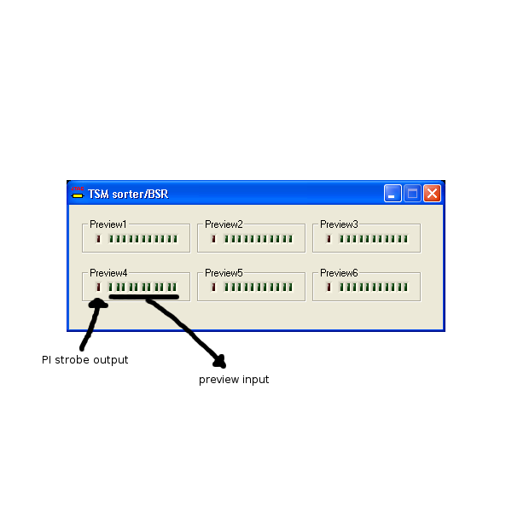
The boundary scan on TTCrx can be done but need particular mini-crate setting because the CK not work and TTCrdy signal is not coherent (TTCrdy is used to switch CPU CK between TTCrx CK an internal free running 40MHz oscillator ), so before use TTCrx bsr you must force mini-crate to use internal oscillator.

TTCrx bsr dialog
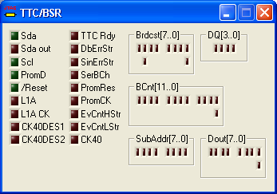

Test Swap Cables

This test enable only one FEB at time and show the hit generated by cosmic or noise on the BTI input, the test can be used to check connection between FEB and BTI input.

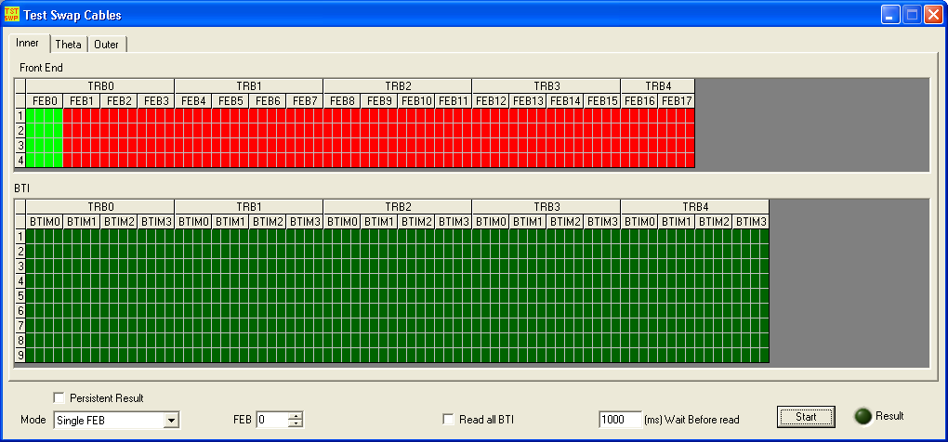

The test can work in three different mode, Single FEB, Range FEB mode, read BTI only.
In single mode you can read all BTI if is checked the corresponding check box, so you can see if the FEB cable under test is swapped, otherwise are read only the BTI connected to the FEB cable under test.
In range mode are read only the BTI connected to the FEB cable and the BTI input are marked red if any hit is not seen.
If Persistent Result check box is checked the BTI result is not cleared when you start new test.

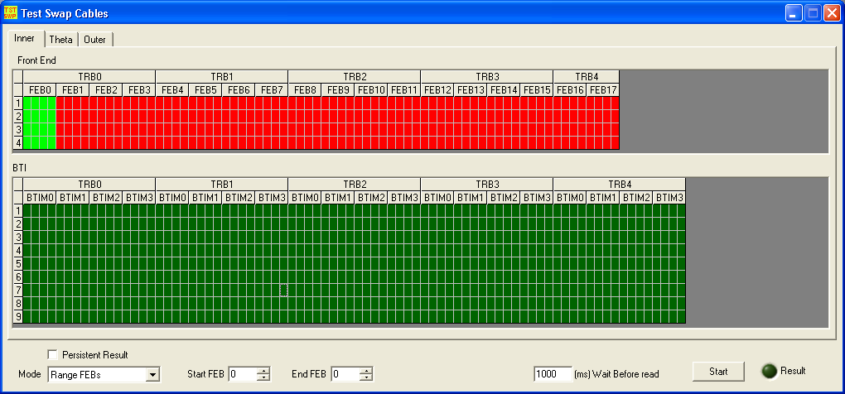

In Read BTI only mode are read all BTI and you can enable FEB channels manually by double click on the FE icon on the main window. In this mode you can see problems on BTI input bounding.
