Extrasolar planets.

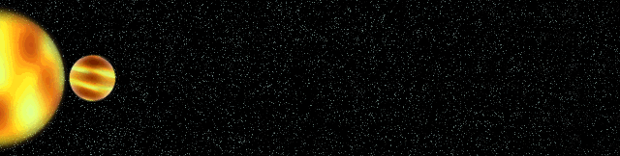
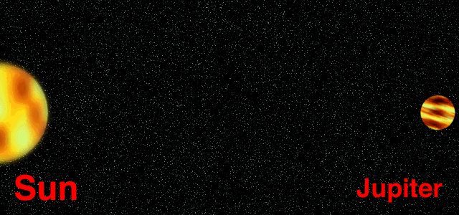
The concept of exoplanets is an old one. Two greek philosophers, Democrito and Epicuro, are reported to discuss about the existance of many other planets in the IV century BC. Giordano Bruno suggested the possibility of an infinite number of planets in his “De la causa, principio et uno” (1400) while William de Vorillon was wondering if Jesus died in other planets to save local beings. In 1926 in New York the magazine “Amazing Stories” was published for the first time marking the creation of Science Fiction. In 1950, the astronomer Peter Van de Kamp announced the discovery of the first exatrsolar planet (even two) around Barnard’s star, a detection that was proven to be fake due to an oscillation in the pointing of the telescope. In 1991, Andrew Lyne announced the discovery of a terrestrial planet around the pulsar PSR B1829−10 with a period equal to that of the Earth around the sun, but he forgot to subtract the Earth motion in the data analysis. The next year, Wolszczan and Frail discovered the first two exoplanets around the Pulsar PSR 1257+12 from the variations in the signal timing. However, the first exoplanet around a main sequence star was discovered in 1995 by Mayor and Queloz of the Geneva Observatory. The planet, named 51 Peg b, is a gaseous giant with a short orbital period of 4.23 days and it was discovered from the Doppler shift of the star due to its motion around the baricenter of the system.

By a twist of fate, a terrestrial planet ()
have been recently discovered around Barnard’s star
(Ribas et al. Nature, 2018) on an eccentric orbit
(e=0.32) and an orbital semi-major axis equal to 0.4
au. At present more than 4000 planets are known and
about 700 are in multi-planet systems. A significant
number of exoplanets are gas giants on close orbits,
which suggest they migrated inwards after forming
beyond the frost line in the circumstellar disk.

Detection methods

1) Radial velocity. The planet is indirectly detected from the motion of the star around the baricenter of the planet(s)-star system. The absorption line regularly oscillate due to the Doppler effect that measures the radial velocity of the star. From the period of the oscillations it is possible to compute the semi-major axis of the planet, from the shape of the radial velocity curve the eccentricity while the amplitude of the radial velocity oscillation gives m sin (i), where m is the mass of the planet an i is the inclination of the orbital plane respect to the line of sight. For
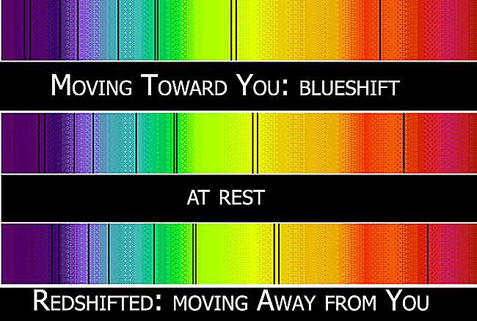
young stars, the method may misinterpret stellar activity for a planet and a photometric study of the star is needed to confirm the planet detection.

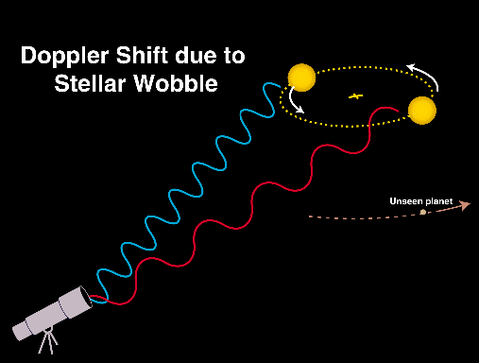

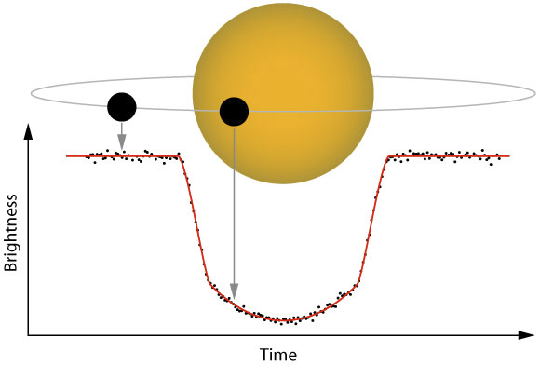
2) Transit: when the planet passes in front of the star, the brightness of the star decreases. There is also a slight decrease when the planet goes behind the star (secondary transit) because its reflected light is switched off. Many space missions have used this technique to detect new planets like COROT, KEPLER, TESS and in the future PLATO. The transit data give the orbital period of the planet and an estimate of its radius from the star dimming, and an eccentricity value from the duration of the transit.

3) Microlensing: survey for microlensing events like MACHO and OGLE can detect planets at large distances from the sun. However, only one observation is available and the mass value may have large errors due to the observation pace and the semi-major axis is estimated assuming a circular orbit.

4) Astrometry: in this case the orbit of the star around the baricenter is computed. by making precise measurements of its position on the sky. New planet discoveries are expected from the space-based observatory GAIA which will perform high precision positional measurements of about 1% of the Galactic stellar population. The astrometric method gives the semi-major axis, eccentricity and mass (with a sin i uncertainty) and preferentially detects planets with large orbits.

5) Direct imaging: this method is efficient for detecting young planets far from the star. Young planets are warm bodies and they emit at infrared wavelengths where the star light is dimmer. The use of coronagraphs blocking the light from the star may help to detect planets also in the visible. This method is efficient for face-on planetary orbits.

In this figure all planets known at in 2012 (fromhttps://exoplanetarchive.ipac.caltech.edu/) are plotted in the mass vs. period diagram with different colors marking different detection methods.

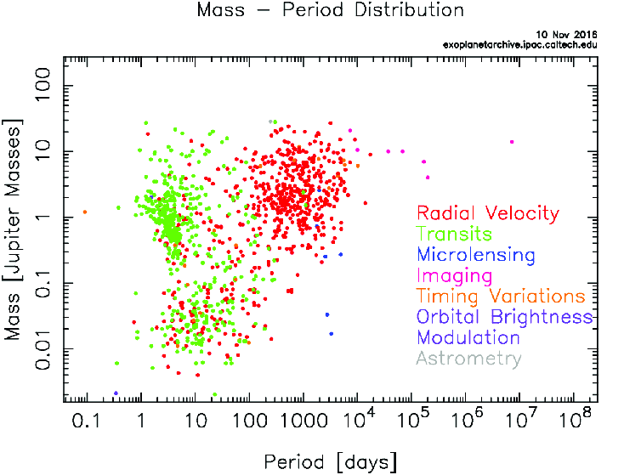
The orbital brightness
modulation method is
based on the change
in the star light due
to the phases of a
bright planet or in the
shape of the star due
to planetary tides.
There are strong
biases related to
the different
methods and an
unbiased sample for
a detailed statistical
study is still
unavailable.

The Rossiter-McLaughlin effect

When a planet passes in front of a star during a transit, its first shades one limb of the star and then the other. The star rotates, so the limbs are affected by Doppler shifts and when the planet transit through the red-shifted limb, the absorption line in the spectrum appears to be blue-shifted and viceversa. This appears in the radial velocity curve as a short blip superimposed to the sinusoidal curve due to the planet orbit, like in figure.

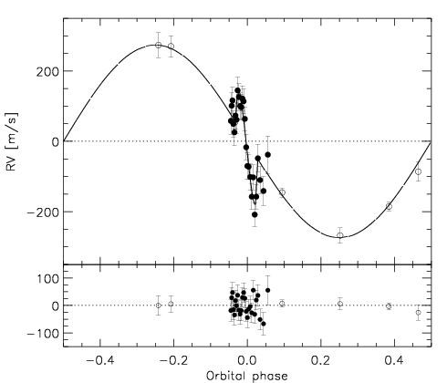
This effect allows to predict a transiting planet from its
radial velocity curve. In addition, it gives clues on its
inclination respect to the star equator because its
shape depends on the orientation of the stellar spin
axis respect to the planet orbit (see figure below)

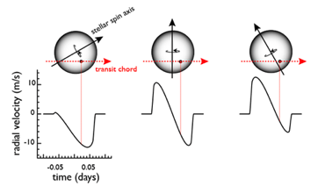

Ohta et al., ApJ 622, 1118, 2005.

Hot/Warm Jupiters

Among the population of exoplanets, a significant number of gaseous giants orbit very close to their stars, with periods of a few to some days. They have been termed Hot/Warm Jupiters because of their proximity to their parent stars so that they are warmer than our system’s gas giants Jupiter and Saturn. By definition, Hot Jupiters have periods shorter than 10 days, while warm Jupiters have periods in between 10-200 days. According to the standard model of planet formation, it is likely that they formed in the outer regions of the circumstellar disk and migrated inward to their current positions.
Some Hot Jupiters have interesting features like HD 209458b. It is a planet with a mass m = 0.69 M_{J}, a radius R~1.42 R_{J} and an expected superficial temperature T ~ 1200 K. Its star is a G0V solar like star with M=10.5 M_{s} and an approximate age of 4-6 Gyr. The planet has a low density (ρ ~ 0.31 g/cm³). It is a warm Jupiter because its orbital period is 3.52 days (a=0.048 au). The low density is expected to be a consequence of its high temperature which inflates the gas component of the planet. An additional evidence for this is the presence of a tail of mass flowing from the planet that has been detected during the transit. Observations with the HST spectrograph have revealed the presence of hydrogen in the tail while the atmosphere contains also O,C, Na (Charbonneau et al., 2003). The mass flow is estimated to be of the order of 3.16 x 10²³ g/Gyr, not large enough to fully erode the planet on timescales of the order of some Gyrs.
Another interesting Hot Jupiter is Kelt-16, a transitingplanet that orbits an F-type star at 0.02 au. Its mass is 2.75 Jupiters and it takes only 1 day to complete one orbit around the star. Due to the dissipation of orbital energy due to the tides the tides raised by the planet on the star, the planet may impact the star on a short timescale. In figure the possible evolutionary history of the planet, under the influence of the tidal interaction, is shown (Oberst et al., 2017). Depending on the tidal coefficient Q (under the assumption of a constant phase lag) the planet may have had a wider orbit (up to 16 R_{star}) and evolved at its present semi-major axis on the stellar age (~3.1 Gyr). In the next future it will impact the star on a timescale ranging from some 10⁵ to 10⁹ yrs, depending on the tidal factor Q.
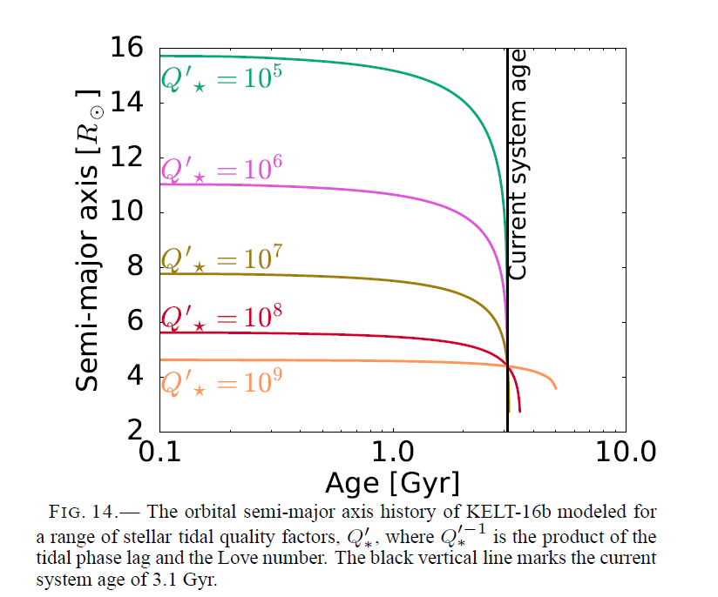

Solar system analogs

Due to the longer orbital periods, giant
planets on orbits similar to that of
Jupiter or Saturn are less frequently
discovered. However, some of them
are known like HD 154345. It is a Jupiter
size planet (m ~ 0.95 M_{J}) orbiting a G8V
star. The semi-major axis is 4.19 au and the
eccentricity is also comparable to that of
Jupiter and it is e=0.044 (Wright et al.,
ApJ L63, 2008). Planetary systems like
this one are very interesting and may
help to understand how frequent is a
configuration with giant planets on
outer orbits and why they did not migrate in close-in orbits like Hot/Warm Jupiters.

Terrestrial planets: Earths and Super-Earths

Thanks to missions like KEPLER and TESS, an increasing number of smaller planets have been discovered with a frequency about 30-50% of all stars. These planets have been termed Earths, Super-Earths (m < 10 M_{Earth}) and Neptune size planets. It is believed they are mostly made of rock, rock+ice, rock+ ocean, rock+atmosphere. There is no correlation with the metallicit of the centrla star (contrary to giant planets), many are hot planets orbiting close to the star and they may be found on highly eccentric orbits.
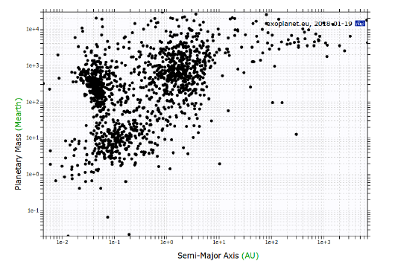
Frequently, they are
grouped in multiplanet
systems and they are
called STIPS (Systems
of Tightly-packed Inner
Planets). Some of these
systems are shown in the
bottom figure:

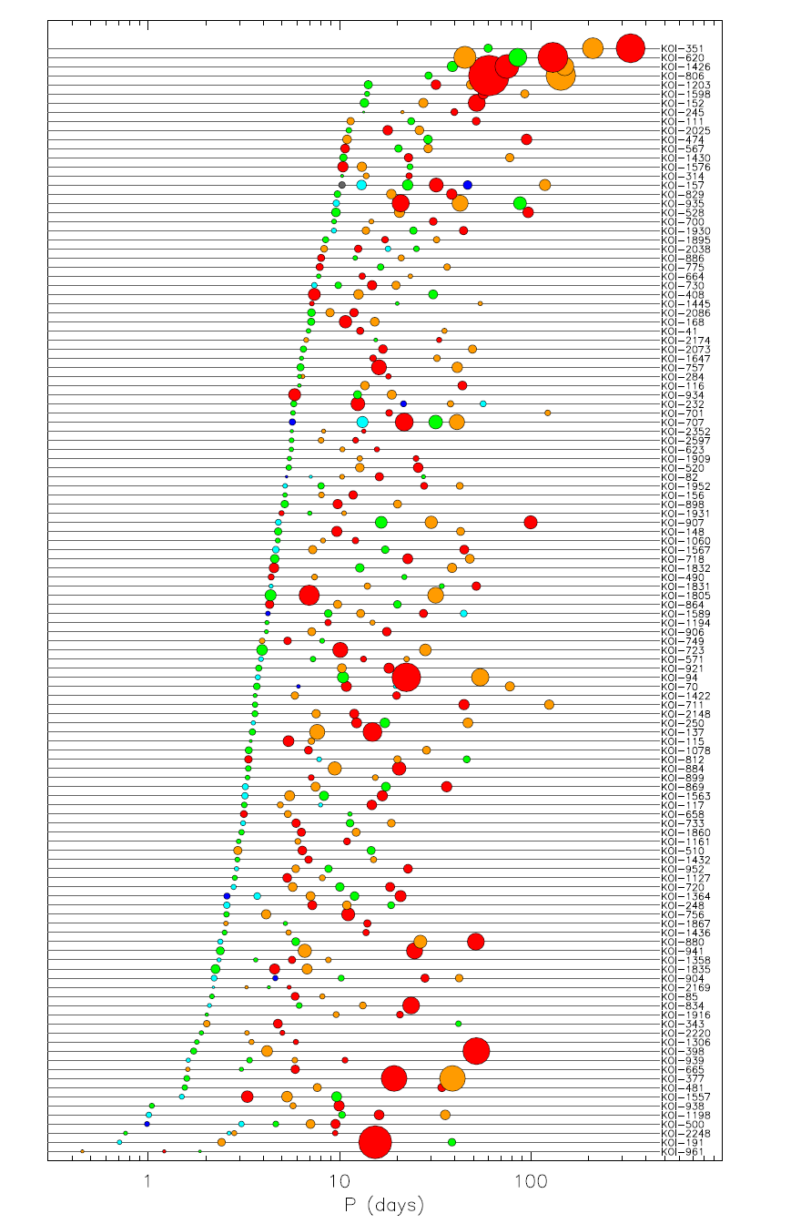
A famous example is
the Trappist system with
7 planets orbiting a red
dwarf star with M=0.08 M_{sun}
and a superficial temperature
T ~ 2500 K. The masses of
the planets range from
0.39 to 1.37 M_{Earth} while the
semi-major axes are from
0.011 to 0.062 au. The are
all transiting planets with a
density from 4.4 to 5.4 g/cm₃.
Due to the low star
temperature, three of these
planets are in the habitable
zone.
One major problem with
these kind of planets is
to determine their composition
and structure since they have
a wide range of densities.
In the bottom figure the known
values of bulk densities are
plot against the planet masses.
Very different density values are
observed and this is a clear
indication of different
compositions in terms of
core, mantle, crust, liquid
ocean, atmosphere.

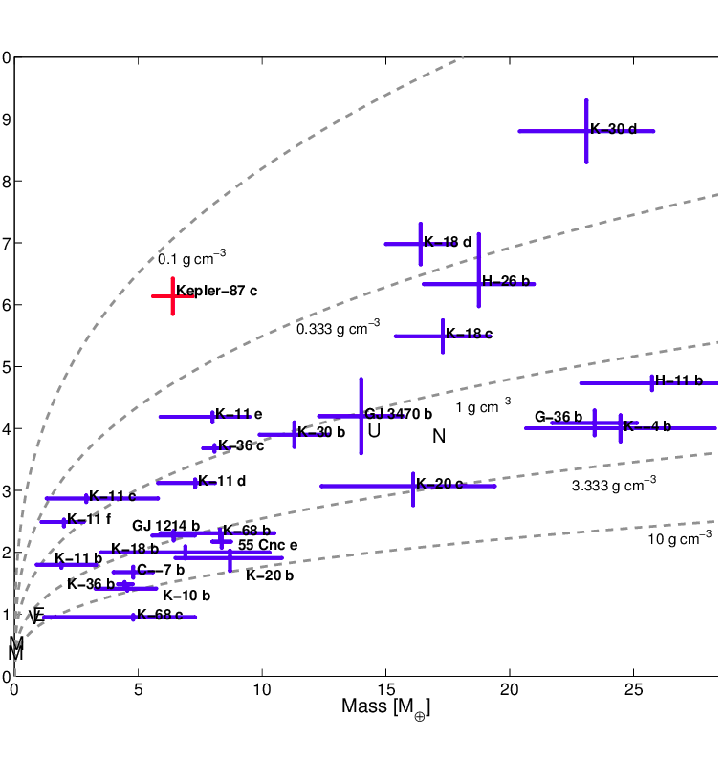

For a given density value, different
compositional configurations are
are possible, as shown in the ternary
compositional plot shown below (see
for example Van Grootel et al, ApJ 786,
2014). It is difficult to have a unique answer
from the density value without additional
informations like the potential atmosphere
composition.

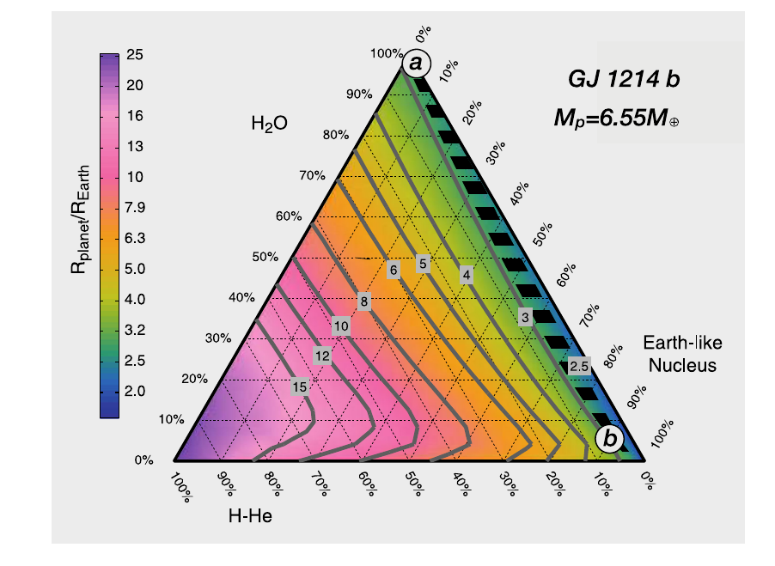

Debris disks

Debris disks are tenuous disks mostly composed by dust even if in some cases a residual gas component can be detected. They are found around about 20% of main sequence stars and they are thought to be a natural byproduct of planet formation. They cannot be promordial because the dust lifetime, due to radiation forces, is short compared to the disk lifetime. They are usually explained as the outcome of collisional erosion of a population of large planetesimals whose evolution did not lead to the formation of a planet, in analogy with the Main asteroid belt and the Kuiper belt in the solar system. The dust radial distribution not necessarily overlaps with that of the parent planetesimal population since collisions and radiation forces significantly affect the orbits of dust particles spreading them around the location of the planetesimal belt.
The presence of a planet in a debris disk can be inferred either by the presence of clumps and over densities or by warping in the case of disks seen edge-on.
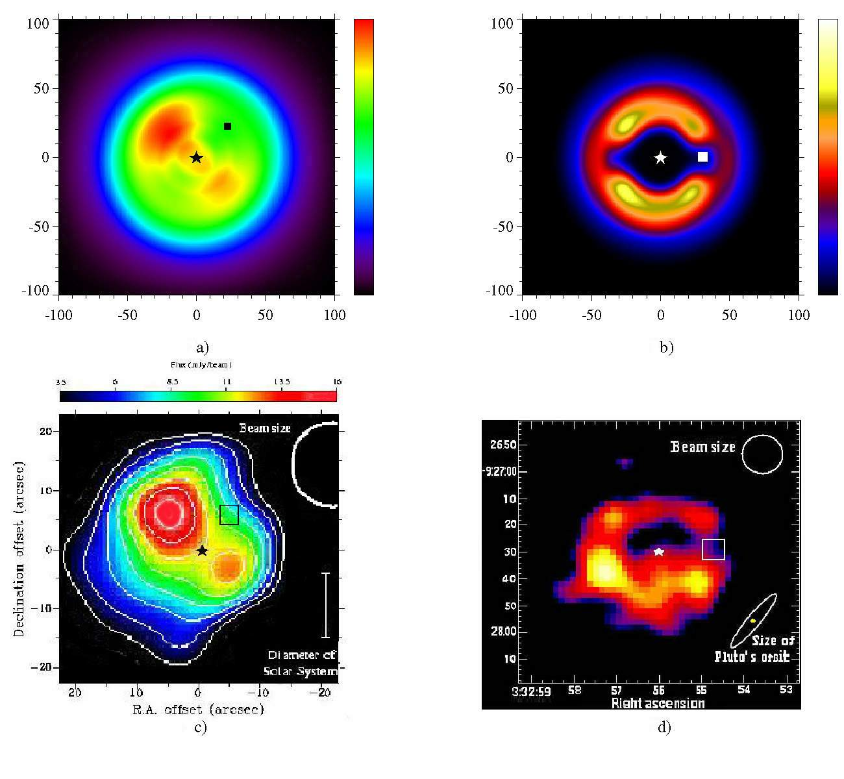
In the figure, the disk around Vega
(bottom left, observed data) and
Epsilon Eridani (bottom right) are
compared to model where a planet
has been added to the system. The
synthetic images show clups due to
the planet gravitational pull that
resembles those seen in real images.
Around the star AU Mic (GJ 803), an
M dwarf star with a mass 0.5 M_{sun} and an
age of ~ 22 Myr, an asymmetric debris
is observed. In the infrared image taken
at Keck, with the star obscured with a
coronograph, a warping is observed
possibly due to the presence of two
transiting hot Neptunes (a₁ = 0.065 au,
a₂=0.11 au, Martioli et al., 2021).

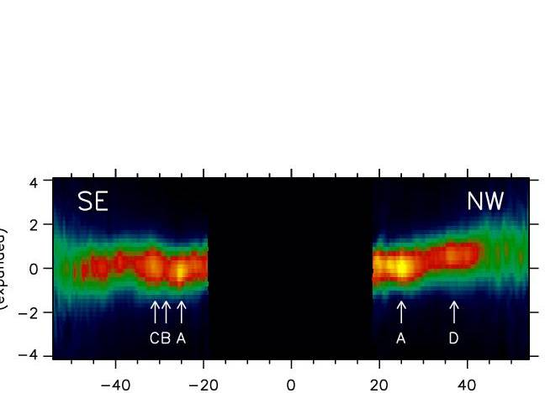

Dynamics of exoplanets: migration and P-P scattering

Why there are Hot/Warm Jupiters when giant planets are supposed to form beyond the frost line which, for solar like stars, is normally beyond 3-4 au? Why many planets have very high eccentricities if they formed from a disk which should give origin to planets on circular orbits, like in the solar system? To include these findings in the standard model for planet formation, developed to explain the solar system, additional dynamical mechansims must be included. These are planet migration by interaction with the gaseous disk, periods of dynamicla instability characterized by close approaches between the planets (P-P scattering), tidal interaction between the planet and the star, mean motion and secular resonances.

Planet migration by interaction with the gaseous disk

Planet migration induced by the exhange of angular momentum between the planet and the circumstellar disk is divided into two regimes: type I and type II migration. Type I migration is typical of small size planets (~lower than the mass of Saturn) and in most cases it forces an inward migration of the planet. The combination of the perturbations on the gas at the location of Linblad resonances generate a wake (a one-arm spiral wave) in the disk. The inner part of the wake exters a positive torque on the planet forcing its outward migration. The outer wakes, on the other hand, exerts a negative torque slowing down the planet and causing inward migration. For reasonable disk density profiles, the two torques are unbalanced and the outer one wins causing a fast inward migration on timescales of the order of a few 10⁵ yr. An additional contribution to type I migration comes from the horseshoe region where gas particles perform some horseshoe orbits before moving to the region inside the planet. This orbits are characterized by u-turns close to the planet in a rotating reference frame moving with the planet. The exchange of angular momentum between the gas and the planet due to these orbits (corotation torque) may lead to outward migration and in general it slows down the inward migration due to Lindblad resonances.

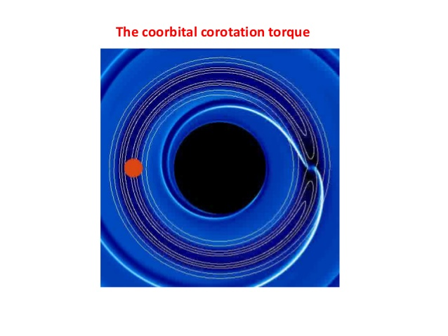
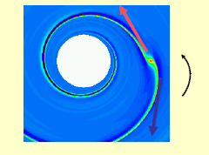

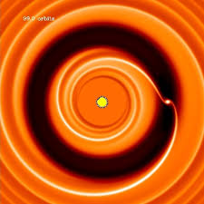
More massive planets open a gap in the disk and the inward migration is due to the distant interaction between the gas of the disk and the planet. The gaseous disk is moving inwards due to the viscous accretion and it drives the planet with it (the wake and corotation torques are negligible because the gas has been pushed out of the gap). In this case the timescale for migration ranges from some 10⁵ to 10⁶ yrs. Migration by interaction with the disk leads to circular orbits since small eccentricity variations are damped by the gas.
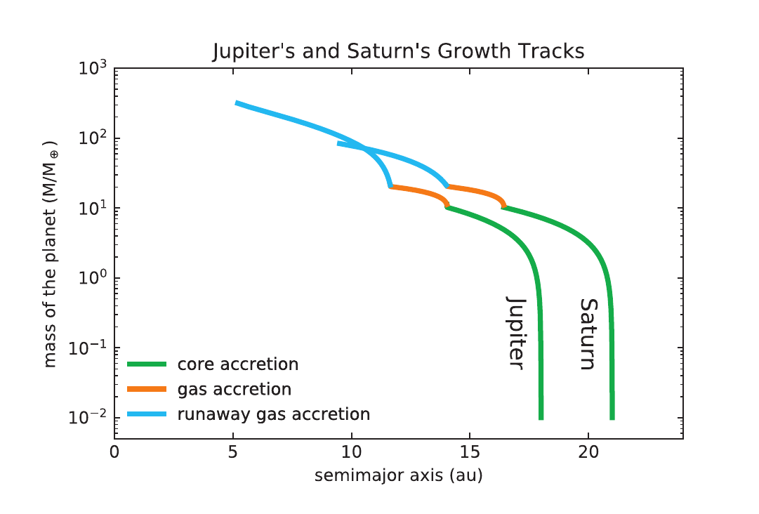
If planets migrate, why Jupiter and Saturn are on orbits which are far from the star? There are three possible explanations: 1) They formed at the end of the circumstellar disk life while it was dissipating and they did not significantly migrate in radial distance 2) They formed in the outer region of the circumstellar disk, they underwent an extended migration while growing in mass, stopping when the disk dissipates (Bitsch et al., A&A 582, A112, 2015) as shown in the figure 3) The planets migrated inwards but they were trapped in a mutual mean motion resonance. After the capture, their migration occurs outwards (Masset, F. & Snellgrove, M. 2001, MNRAS, 320, L55; Walsh, K. J. at al. 2011, Nature, 475, 206, D'Angelo and Marzari, ApJ 2012, 757 50). The radial U-turn of the planets is due to the formation of a common gap in the gas due to the resonance. The perturbation on the inner disk is due to Jupiter, the outer to Saturn, but Jupiter is more massive than Saturn the inner part of the disk dominates in terms of torque on the planet pair so that they migrate outwards.

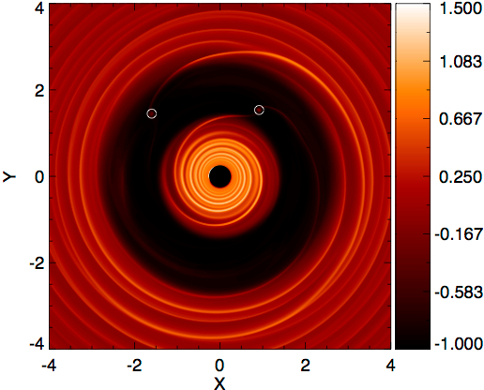
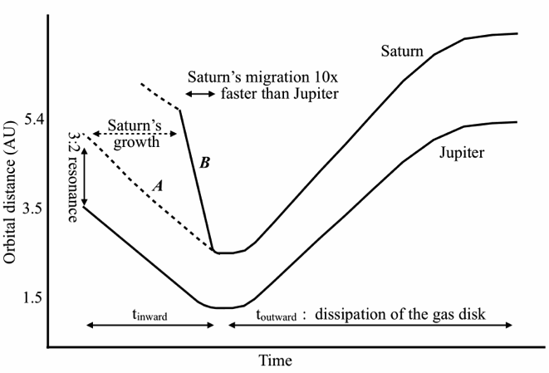

Planet-planet scattering and the eccentricity excitation

When two or more planets, giant or smaller, form within the disk, their eccentricities are kept low by the gas perturbations. After the gas dissipation, the multi-planet system may become unstable. This instability may develop on a short timescale (a few throusands years) or long (Gyrs) depending on the initial mutual distance between the planets. When the system becomes unstable, the eccentricities grow and the planets have close encounters leading to a period of chaotic evolution. The instability ends when one (or more) planets are ejected out of the system and the surviving planets are in stable non-intersecting orbits (Weidenschilling and Marzari, Nature, 384, 619-621, 1996; Rasio and Ford, Science, 274, 954, 1996). In the figure, an example of P-P scattering involving three planets is illustrated.

‏
2
3
1

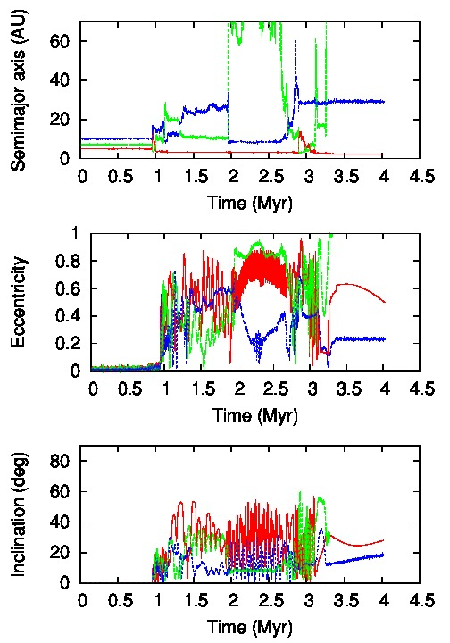
In the following figure it is shown the outcome of the numerical integration of the equation of motion of three giant planets (1 Jupiter mass) around a solar-type star evolving only under their mutual gravity. After a short period of
stability, the planets strongly interact
during close approaches and the orbital
elements show steep changes. At the end,
one of the planet (green line) is ejected
on a hyperbolic orbit. Since this trakectory
has positive energy, for conserving the
total energy of the system the inner planet
is injected on an orbit closer (respect to
the initial one) to the star. The final
eccentricities are high and this explains
why many exoplanets show high
eccentricity values. For the conservation of
energy, at the beginning

and, at the end, most of the negative energy
is in the closer planet so that

P-P scattering, when coupled to tidal
interaction with the star, can also explain
Hot/Warm Jupiters. If the inner surviving planet has a high eccentricity, it passes very close to the star causing a strong tidal interaction that leads to the circularization of the orbit to twice the initial pericenter of the planets. The pericenter is p=a (1-e) and if the eccentricity is initially, for example, 0.9, the final semi-major axis a of the orbit will be much smaller than the initial one. This is shown in the following figure taken from Nagasawa et al., ApJ, 678, 498-508 (2008). The lines represent the smi-major axis (middle), apocenter (outer) and pericenter (inner) during the orbital evolution of the system.
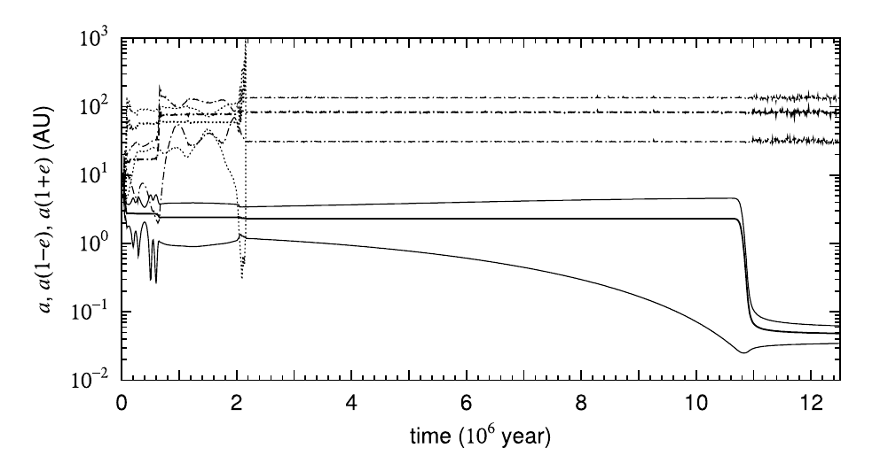
One planet is ejected from the system (dotted line), one is left on an outer orbit (dash-dotted line) while the inner one, once injected on an inside orbit, is tidally driven to a close-in orbit typical of a Hot Jupiter. In theory, P-P scattering is capable of producing most of the observed close-in planets without invoking planet migration by interaction with the disk. The influence of the tidal interaction can be seen in the semi-major axis vs. eccentricity plot for exoplanets. A substantial decreasing is observed in the eccentricity of all exoplanets for orbits close to the star, indication of tidal damping of the eccentricity.
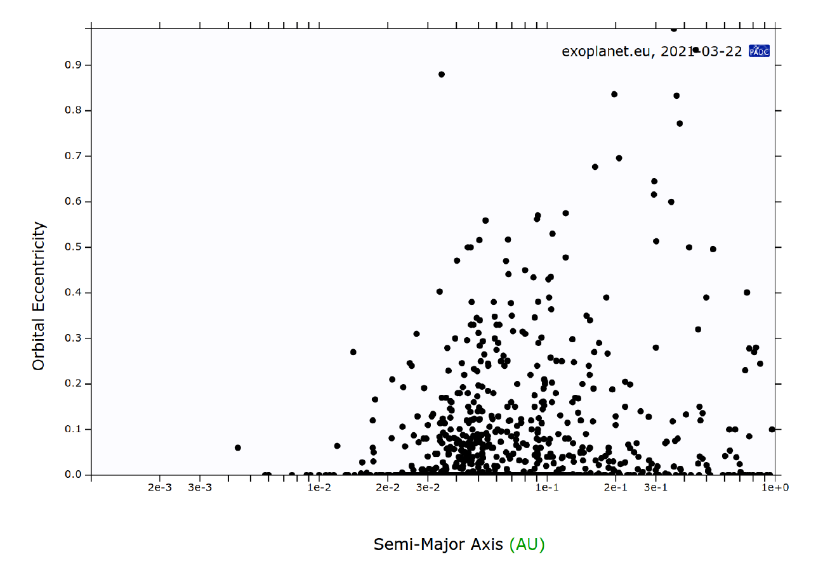
Additional dynamical mechanisms can cause a change in the orbital elements of a planetary systems like: 1) planetesimal scattering which has probably caused an outward migration of Uranus and Neptune which has affected the dynamical structure of the Kuiper Belt 2) within a stellar clusters, in the first 20-50 Myr, fly-bys with other stars may alter the planet orbital elements 3) the presence of a binary companion.

Synthetic population models.

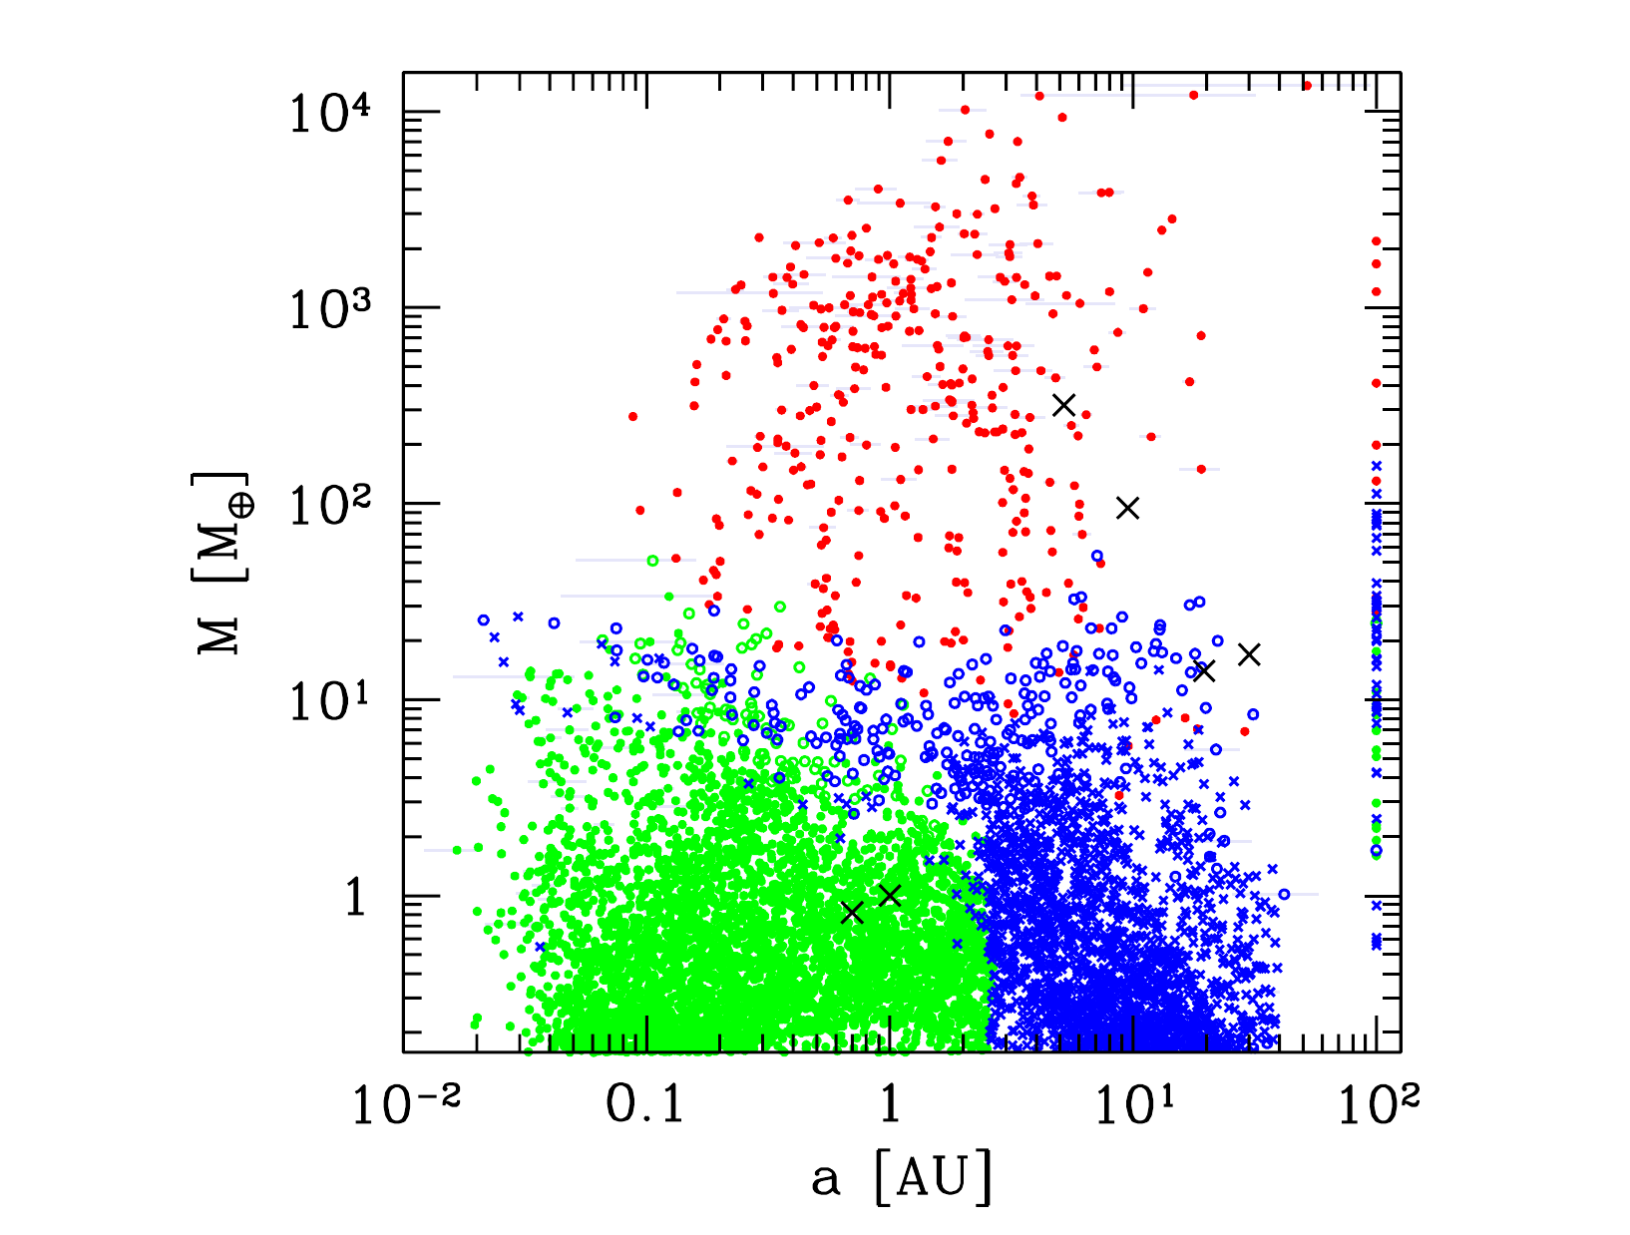
Recently, numerical codes which model the growth and dynamical evolution of planetary systems have been developed. These models include 1. The structure and evolution of the protoplanetary gas disk (density and temperature profiles etc..) 2. The structure and evolution of the disk of solids (dust, pebbles, planetesimals) 3. The accretion of solids leading to the growth of the planetary solid core 4. The accretion of H/He leading to the growth of the planetary gaseous envelope 5. Orbital migration resulting from the exchange of angular momentum with the circumstellar disk (type I and II) 6. N-body interaction among (proto)planets (for a review see Mordasini,Planetary Population Synthesis, Handbook of Exoplanets, H. J. Deeg, J. A. Belmonte (eds.), Springer). These models give the final orbital and mass distribution of a large number of putative planets, as shown in the figure.

The red points are giant planets, the green symbols show planets which accreted rock, while blue symbols show those which accreted ice beyond the frost line. The crosses indicate the solar system planets. All symbols at 100 au indicate planets ejected out of the system by P-P scattering. These models can also predict the fraction of planets present around star as shown in this table (Mordasini):

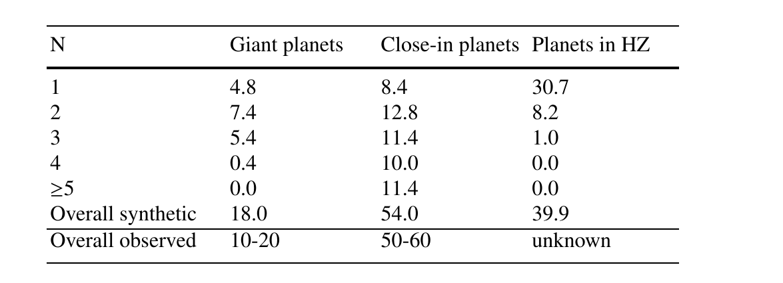

N is the number of planets for each star, the percentages predicted by the synthetic models are compared to those observed (last line of the table). The mass and orbital distribution must also be compared to the observed ones taking into account the strong biases in the observational data. In this first figure the mass vs. semi-major axis distribution is compared to the observed one. It seems like the synthetic model predicts a too large number of small planets close to the star. However, this is due to the fact that the mass is obtained by Radial Velocity measurements which prefer massive distant planets. This is why in the observed data the peak at the giant planet size is dominant, there is a smaller peak at intermediate masses and the peak at terrestrial planets, predicted by the synthetic models is missing.

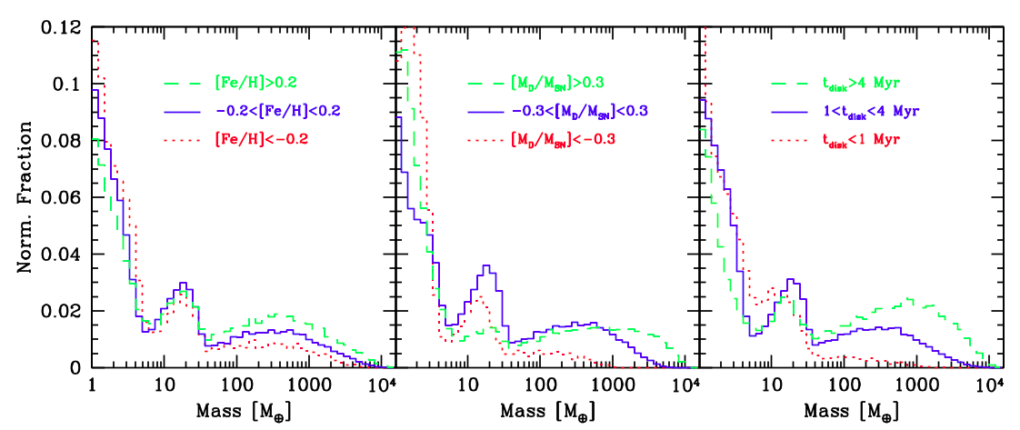

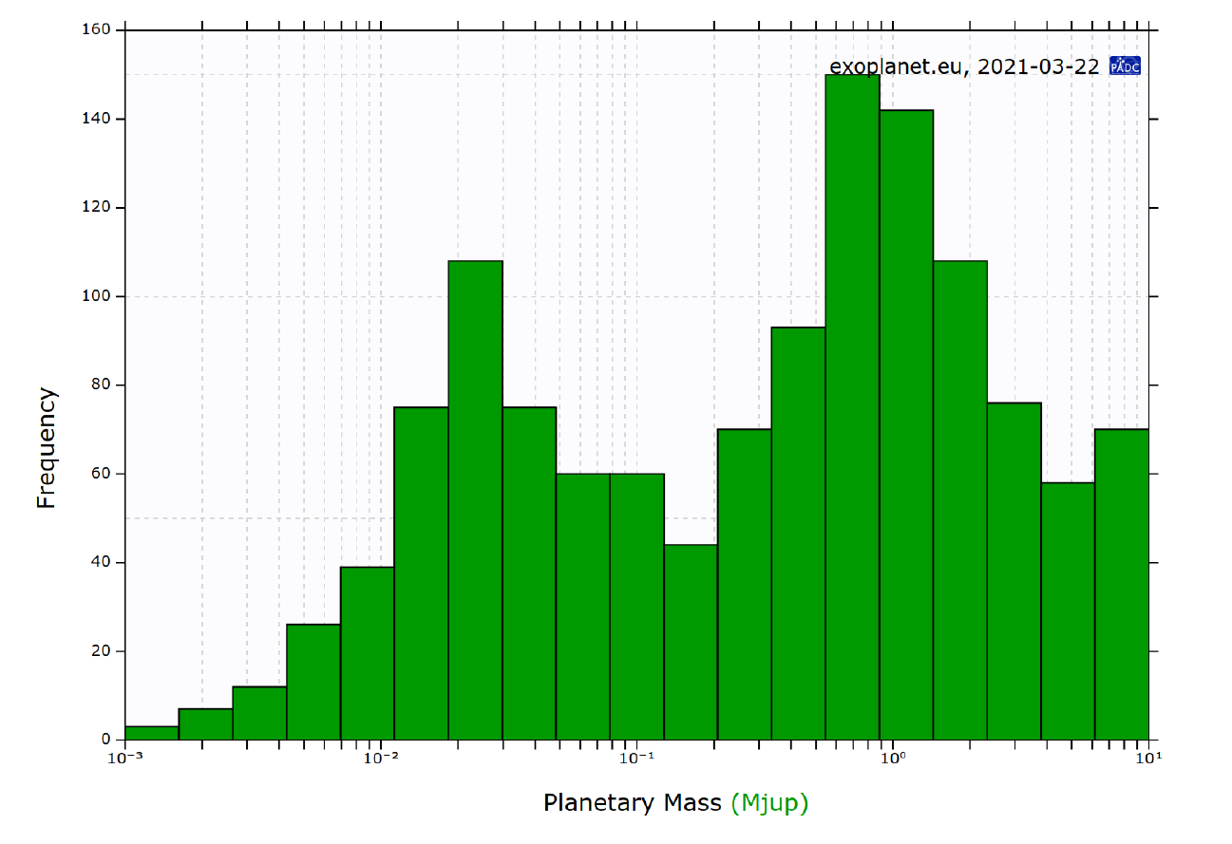

However, if instead of comparing the synthetic models with RV surveys, we compare them to the transit data (Kepler, COROT, TESS etc…) we find a good agreement at small sizes and we retrieve the strong peak at Earth-size planets predicted by the synthetic models.



