The 3-body problem

In general, the three body problem consists in determining the motion of 3 point masses which attract each other according to some kind of force for any initial conditions. We will focus here on the gravitational and hierarchical 3-body problem where the force is the Newtonian gravity and one body is significantly more massive than the others which orbit around it. The equation governing the motion of the three bodies in hierarchical form (the more massive body is at the center of the reference frame ) is

If we concentrate on the scenario in which one of the 3 bodies has a mass negligible respect to the other 2, we can assume that its mass is 0 and deal with the restricted 3-body problem. The equation governing the motion of the third mass is in this case

The problem is complicate enough not to be handled analytically. However, a simplified version of it can been described with analytical tools. If we assume that the orbits of the two lighter bodies occur on the same plane and the the orbit of the second mass m₂ is circular, then we deal with the restricted, planar, circular 3-body problem. To simplify the analytical treatment of the problem, we switch to normalized units. We set and where a is the semimajor axis of body 2. Being the orbit circular, a is also the radius of the orbit.
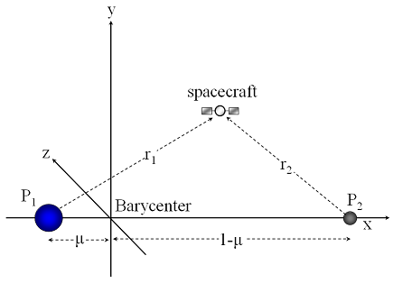

Fig. 1: geometry of the restricted 3-body problem.

In these normalized units, we can define the mass ratio so that the mass of the central body is while that of the secondary body is simply . The mean motion of body 2 around body 1 is given by . The distance of body 1 to the center of mass of the system is while that of the second massive body is . Since the orbit of m₂ is circular respect to m₁, it will be circular also respect to the center of mass of the system. We can describe the motion of the system in a reference frame rotating with frequency around the barycenter. In this reference frame, the position of bodies 1 and 2 will be fixed along the x-axis and we can write in a simplified form the equations of the motion of the third massless particle

where and . The coordinate x,y lie on the orbital plane of body 2 respect to body 1. The second term on the left is the centrifugal force while the third is the Coriolis force, both due to the use of a rotating and then non-inertial reference frame. Re-writing the above equation in the coordinates we obtain the Hill's equation

where is the pseudo-potential which includes a centrifugal term in addition to the gravitational attraction of the two massive bodies. From now on, we concentrate on the x,y plan (planar problem) and neglect the motion along the z-axis. In this way the problem becomes bi-dimensional. Under this condition, while The system admits an integral of motion, the Jacoby constant C. If we multiply the Hill's equation by the corresponding velocity components we get

We can add up the two equations in a single one obtaining

This differential equation can be integrated respect to time giving

The integrals respect to time can be solved

and the above equation reduces to

where C is the Jacoby constant. It is possible to construct curves in the plane on which the velocity vanishes. If such a zero-velocity curve is closed, then the particle cannot escape from the interior of the closed zero-velocity curve once it is placed there with the constant of the motion equal to the value used to construct the curve. The only way to escape is to use an external force (like a rocket engine for a spacecraft). The curves are obtained setting to 0 the velocity term so they are determined uniquely by the pseudo-potential. In figure we show the curves for different values of the Jacoby constant.
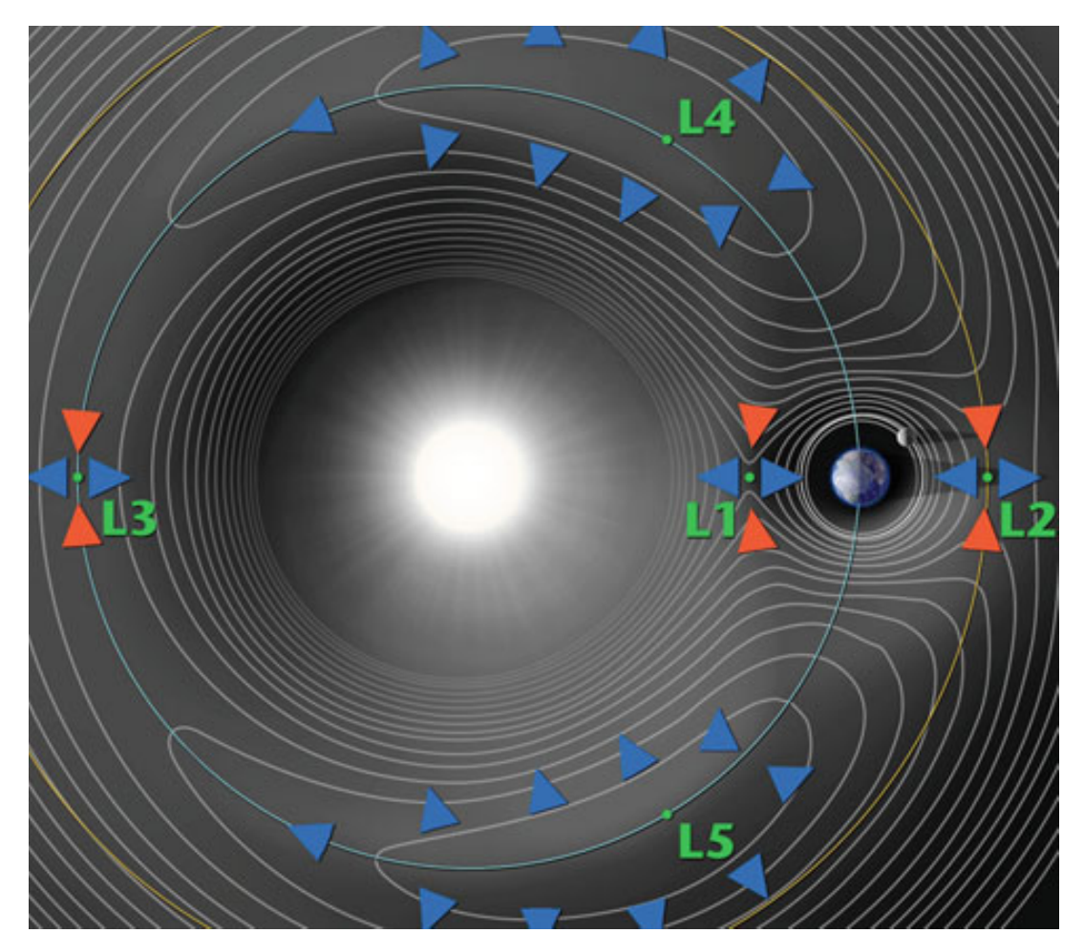
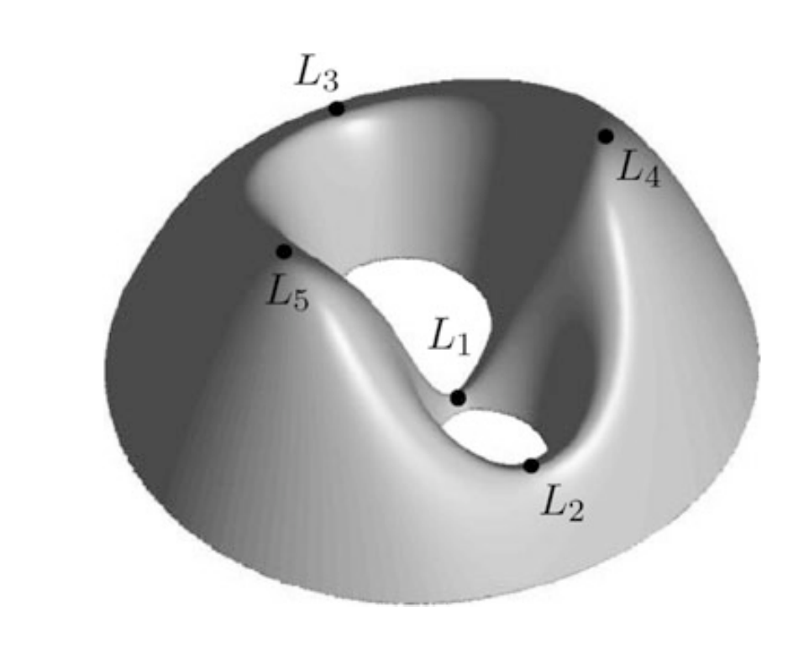
Fig. 2: Equipotential lines (left) and effective potential in 3D (From Astronautics, Walter, Springer, 2018)

The Jacoby has an additional meaning, it is the Hamiltonian of the system. The Hill's equation can be easily derived from the following Lagrangian

The system must obey the Lagrange equations which, after the insertion of the above expression for L, give back the Hill's equations. From the Lagrangian, we can derive the Hamiltonian function

The generalized momenta are

The Hamiltonian then reads

This expression reduces to

The Hamiltonian has then the same expression of the Jacoby constant (with a factor 2 difference). This is an alternative proof that C is constant since H is the energy of the system which, in absence of external and dissipative forces, is conserved. The equations of motion can be easily retrieved from the definition of Hamiltonian and the Hamilton equations

Lagrangian equilibrium points

The stationary points of the system in the x,y plane are obtained imposing the condition that both the velocities and accelerations are 0. By inspecting the equations of motion

we find that the necessary condition is that . From the definition of V we get

recalling that

we have the following identity

Inserting this relation in the equation for the equilibrium, the equation for finding the stationary points becomes

Grouping the terms in and we obtain

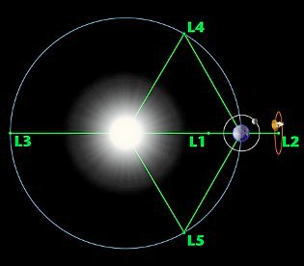

Two easy solutions are given by . These are the equilateral Lagrangian points L₄ and L₅, stable equilibrium points located at the vertices of an equilateral triangle as in figure. Their coordinates are

Fig. 3: location of the Langrangian equilibrium points
in the rotating reference frame.

To go back to physical units, the coordinates must be multiplied by the semimajor axis of the perturbing planet. The other 3 stationary unstable points are again solutions of the stability equation, all lie on the x-axis and are labeled L₁, L₂ and L₃. Their coordinates are given as series expansion in the following way

L₁, L₂ are located on both sides of the perturbing body (the planet) while L₃ is located on the other side of the massive body (the star) .
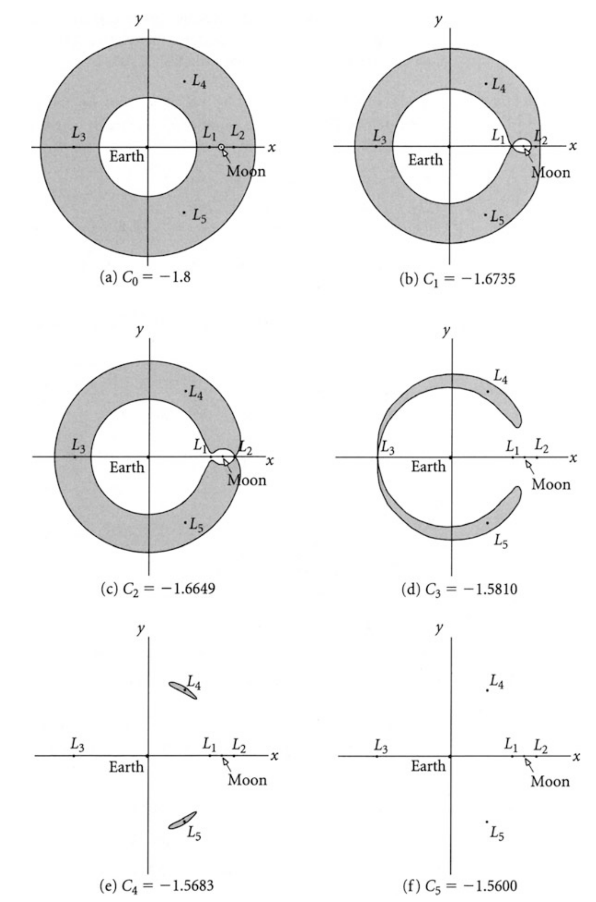

Fig. 4: Zero-velocity curves for increasing Jacoby constant in the case of the Earth-Moon system (from Astronautics, Walter, Springer, 2018) .

Trojan asteroids

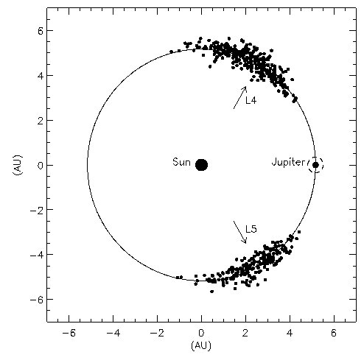

Around the equilateral L₄ and L₅ points, stable periodic orbits are possible. A consistent population of asteroids have been found around the two Lagrangian points of Jupiter while a potentially comparable population is inferred for Neptune. Mars is known to posses a few Trojans while recently a Trojan asteroid for the Earth has been found. More than 4000 Jupiter Trojans are presently known and they are named after Greek and Trojan heroes. The largest body, 624 Hektor, is an irregular body with dimensions 370 km×195 km×195 km. Two main theories have been proposed so far to explain the formation and evolution of the Trojans. Trojans might have been local planetesimals trapped in tadpole (Trojan type) orbits in the final phase of Jupiter growth when its mass increased from a few Earth masses to its present value (~318 Earth masses) on a very short timescale by gas infall. In alternative, the so called 'Nice model' predicts that Trojans were bodies formed in the outer part of the solar system, trapped by Jupiter during its evolution through a 2:1 resonance with Saturn.

A special class of orbits which surround both the L₄ and L₅ points and, in addition, the L₃ point are called horseshoe orbits. As shown in figure, the body moves back and forth from the planet with a trajectory (in the rotating reference frame) that encloses the three Lagrangian points. This kind of trajectory is unstable on the long term and it is a gate towards Trojan type orbits. This kind of orbit is shown in light blue in figure with the body moving from A, B etc... These kind of trajectories are relevant in planet migration since gaseous mass from disk crosses the planet orbit from outer regions of the disk into inner regions through these kind of trajectories. They can cause significant effects on the migrating planet orbit changing the direction of migration from outward inward and viceversa.
Fig. 5: location of Jupiter Trojans (from Moldovan &
Matthews, Canadian Undergraduate Physics journal,
VI, 2008).

Trojan capture mechanisms

At present, about 7000 Jupiter Trojans, 29 Neptune Trojans, whose population might overcome that of Jupiter Trojans, and 9 Mars Trojans are known. The Trojan orbits of Saturn and Uranus and Venus are known to be unstable (Marzari et al., ApJ 579, 905, 2002; A&A 410, 725, 2003; AJ 130, 2912, 2005). There are static and dynamic mechanisms for the capture in Trojan orbits. The static mechanisms include 1) capture in horseshoe orbits because of orbital decay due to gas drag (Yoder, Icarus 40, 341, 1979), 2) trapping of fragments of collisions occurring close to the Trojan region (Shoemaker et al. in Asteroids II; Proceedings of the Conference, University of Arizona Press, 1989, p. 487-523. 1989) and 3) capture by the widening of the Trojan region during the mass growth of the planet (Marzari & Scholl, Icarus 131, 41, 1998). Dynamic trapping can occur 1) during the migration of the planets if there is mean motion resonance superposition and chaotic evolution (Morbidelli et al., Nature 435, 462, 2005) 2) during a steep jump in the semi-major axis of the planet due to a planet-planet scattering event (Nesvorny’ et al., ApJ 768, id. 45, 2013) and 3) by the mass growth of the planet during its migration by tidal interaction with the circumstellar disk (Pirani et al., A&A 623, id. A169, 2019). These last two mechanisms explain also why there are more L4 Trojans than L5. However, while the model with the planet jump can produce either more L4 or more L5, the mechanism related to migration is not symmetric and inward migration leads to a larger L4 population.
To understand the capture of Trojans during migration or mass growth, an hamiltonian model can be developed. The Trojan motion can be described in a simplified way by the following equation:

where nP is the mean motion of the planet and φ the difference between the longitude of the body and that of the planet +/- π/3. This equation can be re-written in Hamiltonian form:

where the libration frequency of the angle φ is given by

It is the typical hamiltonian of a harmonic oscillator and the time evolution of the angle φ is then

where A is the libration amplitude around L₄ (π/3) or L₅ (-π/3). When we change either the mass of the planet or its semi-major axis, we can compute how the libration amplitude varies. We can introduce an adiabatic invariant taking advantage of the ‘fast’ motion related to the libration of the critical angle (respect to the possible variations in the mass and semi-major axis of the planet) and compute the adiabatic invariant from the integral on a closed path

of the action-angle variables related to the libration motion:

so that the hamiltonian is .
It is an adiabatic invariant if in one libration period the properties of the planet i.e. a_{p} and m_{p} do not significantly change. The integral on a closed path (0-2π) becomes:

since then the integral becomes

The conservation of J in presence of adiabatic variations of a_{p} and m_{p} leads to

This equation implies that if the planet migrates inward or it grows in mass, the libration amplitude decreases (from Fleming & Hamilton, Icarus 148, 479, 2000) . As a consequence, when a body is in the Trojan region and the semi-major axis or mass of the planet decreases/increases, the libration amplitude diminishes leading to a stronger trapping into the Trojan region.

Hill's sphere

An additional definition following the computation of the stationary Lagrangian points is that of Hill's sphere. In figure, it is the approximately circular shape encompassed between L₁ and L₂ surrounding the planet. According to the definition of 0 velocity curves, bodies that move within this region cannot escape, they are under the influence of the planet gravity field. The approximate radius of the Hill's sphere is given by the difference between the x coordinate of L₁ and L₂ along the x-axis.

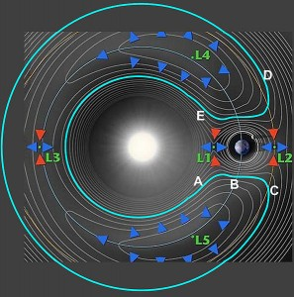
Fig. 6: same as Fig. 2, location of L₁ and L₂.

which, translated to physical units, becomes

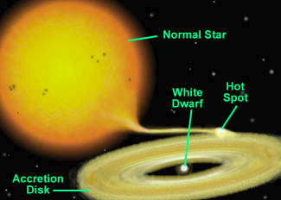
Ad example, the for Jupiter while it is for the Earth. The Hill's radius is relevant in asteroid satellite search since the smaller body must orbit within the Hill's sphere of the asteroids. It is also important in the explanation of the evolution of cataclysmic variables. They are binary star systems having a white dwarf (primary star) with a normal star companion. Their orbit is small with periods ranging from 1 to 10 hours. The companion star transfers mass to its compact companion and this interaction gives rise to a rich range of behaviour, of which the most noticeable are the outbursts of luminosity that give the class its name. Because of conservation of angular momentum, the infalling gas from the companion can't plunge directly onto the surface of the white dwarf. In systems where the white dwarf doesn't have an appreciable magnetic field, the infalling gas forms an accretion disk with the white dwarf at its center. The gas in the disk spirals down towards the white dwarf, radiating its gravitational potential energy away as it goes. The temperatures on this disk ranges from 5000 to 10000 K and can be as high as 10⁵-10⁸ K in the inner border, emitting in the UV and X. The resulting accretion process gives significant changes in brightness with outbursts. From this the name of cataclysmic variables. The transfer of mass begins when the secondary star fills its Hill's sphere and material begins to escape through L₁ into the primary star with disk.

Fig. 7: pictorial view of a cataclysmic variable
binary star system.

The Tisserand invariant

This invariant is used to distinguish between asteroids and short period comets. It is expressed in heliocentric orbital elements. To derive it, we have to move from the reference frame centered on the barycenter and rotating with frequency n to a non-rotating reference frame centered on the star. We neglect the difference between the location of the barycenter respect to the center of the sun and we focus on the computation of the velocity in the fixed reference frame. The body velocity is then given by where v is the velocity in the velocity in the rotating reference frame, V is the velocity in the fixed one centered on the star, and is the instantaneous velocity of the rotating reference frame. This velocity is given as where X,Y are the coordinates of the massless body in the fixed reference frame. The relation between the velocity coordinates in the two reference frames are

Adding up the three equations we get

The above equation can be re-written as

where is the z-component of the orbital angular momentum. To derive the last equation we recall also that since the rotating and fixed reference frame are assumed to have the same origin . Recalling the definition of the Jacoby constant we obtain

that gives

This relation holds in the fixed reference frame and it is a consequence of the invariance of C in the rotating reference frame. If we use the relations and from the 2-body dynamics, we can rearrange the above equation in the following form

since n is the mean motion of the planet with semimajor axis a_{p}. We can neglect the term which is small compared to those depending on so finally we obtain

T is called the Tisserand invariant and it allows to recognize the orbital elements of a body after it had a close encounter with a planet (like Jupiter for short period comets). While the orbital elements will undergo significant changes due to the hyperbolic passage close to the planet, the value of T will be the same.

