Modeling accretion disks.

Basics of fluid dynamics

Fluid dynamics concerns the flow of a large number of particles like in the case of a liquid or gas, not having any rigidity property. The validity of the continuum description typical of fluid dynamics depends on the ratio between the collisional mean free path of the particles and the macroscopic length scale of interest. If the mean free path is small than it is reasonable to use the term fluid. We will derive the Euler equations for a fluid writing conservation equations in a volume V enclosed by a surface S with n the outwards-pointing normal to S. The time derivative of the mass within V is equal to the flux of mass across the surface S

where u is the velocity vector of the fluid element and r is the bulk density. The application of the divergence theorem leads to the following equation that describes the conservation of mass in the fluid

This equation is independent from the assumed volume and we can derive from it a differential equation of the form

A little more work is needed to derive the equation for momentum conservation. In this case we assume that the volume V moves with the fluid at the velocity u. In this situation there is not flux in and out of V, the mass within V is constant and the momentum is

On the volume element V, 2 different kinds of forces can act: distance forces and contact forces. Distance forces, like gravity, cause a change in momentum according to the formula

Contact forces like pressure, perpendicular to the surface S (we neglect for the moment viscous forces), introduce a term of the type

The equation for the momentum conservation in a frame comoving with the fluid is then

The problem is how to homogenize the two equations given that for the conservation of mass is expressed in a fixed reference frame and that for the momentum conservation is derived in a comoving frame. To accomplish this task we introduce the concept of material derivative. Let's assume that is any physical quantity related to the fluid (ad example the temperature ). At a fixed position r, respect to an inertial frame, the variation of f is . Ad example, the temperature changes from one place to another. On the other hand, in a reference frame comoving with the fluid, the change in f is due to the local variation plus that due to the motion with the fluid. Typical example is a stationary fluid (the velocity u is constant for any given r) for which in a fixed reference frame . However, if we sit on a comoving frame as we move from a region where the velocity is, ad example, lower towards a region where the velocity is higher. In this case, the change in u depends on the gradient of the velocity vector in the direction of motion.
The gradient of a vector is a Jacobian (or a second order tensor) whose trace is the divergence of the vector:

and is the scalar product of the

vector u by the gradient.

When we consider the momentum equation, the time derivative is indeed a material derivative because the conservation is derived in a comoving reference frame. The equation can be re-written as

At this point we can transform this equation into one on a fixed reference frame. The time derivative can be switched with the integral at the first member to get

The last expression is derived taking into account that is constant as we are moving with the fluid so that mass is conserved (no flux). Finally, we can rewrite the momentum conservation equation and transform it into a differential form through the following steps

Equating the arguments of the integrals we get

We are left with 4 equations for the 4 variables but in order to have a closed system we need to know the pressure P which is related to the Temperature T via a state equation like the ideal gas equation

The temperature T is linked to the internal energy U of the gas , with for monoatomic gas, for biatomic gas etc.., so we need and equation for the energy conservation of the gas to solve the system. This equation can be derived in a similar way as the momentum equation. We compute the material derivative of the total energy (mechanical ½ u² plus internal U) within a volume V. The changes are due to the work done by surface forces (we concentrate on pressure here) and heat sources

The first term on the right is the work done by pressure, the second is related to the work done by external forces, is a possible energy source within the volume V, is the heat flux through the surface S (radiative). We can derive separate equations for the mechanical and thermal energy by deriving the equation for the kinetic energy of the fluid from the equation of momentum conservation

Taking the dot product of both terms with the fluid velocity u yields

This equation (the mechanical energy equation) gives the variation of kinetic energy in a comoving system (we are moving with the fluid) . Subtracting this equation from that of energy conservation we get

There is a pressure term in both equations since pressure either changes the mechanical energy contrasting ad example gravity in a disk, or it causes compression with changes in the internal energy.
In the first case the term depends on the gradient of the pressure, since this is the force that tends to dislocate matter, in the second case the term is proportional to the gradient of the velocity, since this is the one leading to compression.

Application of fluid equation: shape of nozzle.

Engines of space rockets give thrust by expelling gas from the nozzles. The shape of the nozzles, as the one shown in figure used for the space shuttle engine, influences the efficiency of the engines. This can be shown starting from the Euler equations, i.e. the equations of conservation of mass and momentum for a fluid.

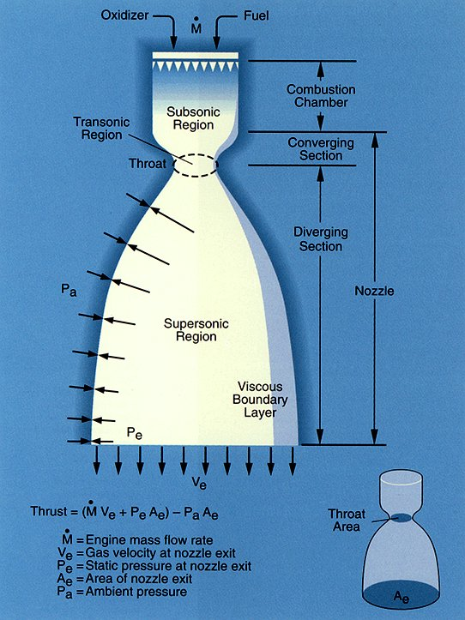
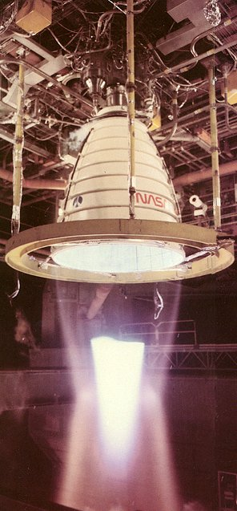

In the above figures the shape of nozzles for rocket engines is shown. On top the area shrinks to increase the ejection velocity (and then the thrust). This is an expected result and common practice in water pipes. However, when the ejection velocity is larger than the sound velocity (supersonic region) the area increases. This can be understood by deriving Bernoulli's equation and applying it to the flow within the nozzle.

From Euler's equations, reported hereafter

where we assume that the force f is conservative and can be written as the gradient of a potential V, we can derive Bernulli's theorem. Let's assume that our fluid is in stationary motion (), inviscid (0 viscosity) and barotropic (the pressure depends only on the density ) . The second Euler equation becomes

From calculus we know that

Rearranging this equation we get

In order to collect all terms on the right side under a single gradient, we need to introduce the thermodynamic function specific enthalpy h (enthalpy per mass unit) defined as where e is the specific internal energy. For barotropic fluids the state equation is simplified to and h is related to pressure and density directly through the equation where the integral is performed along a streamline (steady flow). In many cases this integral can be easily solved. Ad example, for a relation of the kind (where g is the specific heat ratio) we get . From the definition of specific enthalpy we get since

and

since as is computed for constant x within the integral. When we exchange the pressure gradient with the enthalpy gradient we get to a single gradient on the right hand side

By multiplying both members for u, the following equation is obtained

Since u is tangent to the streamline the above equation implies that must be constant along streamlines since its gradient is perpendicular to the streamline tangent. This is the formulation of Bernoulli's theorem for a stationary and barotropic flows. If we focus on the flow through a nozzle, we can use both Bernoulli's theorem and the mass conservation to derive the properties of the flow. Let's assume that we now the cross section of the nozzle and we neglect the effects of gravity as a first approximation. The flow motion occurs along the x-axis which is the only variable of the problem. The two equations then read

The second equation derives from that leads to . Hereinafter the velocity u is a function of x only. Deriving the first equation we get

taking only the differentials we obtain

recalling that we finally get

We introduce the sound speed so that the equation becomes

and defining the Mach number we arrive at the following expression

Is the variations of density respect to those in velocity are negligible. On the other hand, is (supersonic fluids) the variations of u produces compressions and dilatations. A final step is needed to understand the flow through a nozzle. The initial system of two equations can now be cast in the following form

since

then

and and the first equation becomes

This equation allows us to understand the design of the nozzle. When (subsonic flow) if u increases then A must diminish. This is why at start the nozzle has a shrinking shape. We want to increase u by reducing A. On the contrary, when (supersonic flow) to increase u the cross section A must increase! Only if the flux diverges there is an increment of the flow velocity.

Parker’s solution for unmagnetized plasma

The corona is the sun's outer layer which reaches temperatures of about 10⁶ K. The kinetic energy of the gas particles is so high that the sun's gravity cannot hold them and they flow away from the star forming the solar wind. Parker’s model of the solar wind expansion is based on Euler equations. The basic assumptions of this model are that the gas of the corona expands with a flux which is spherically symmetric, non-rotating, isothermal and unmagnetized. The momentum equation, in static conditions (we neglect the time derivative) reads:

The isothermal approximation implies that

with c_{s} sound speed. The momentum equation becomes:

From the mass conservation equation we can derive:

where A is the area. Since it is a spherical flux, the area is 4πr² and the term . If we multiply both terms by c_{s}² we get:

or

recombining the terms we finally obtain:

This equation is very similar to that of the nozzle and the solution is

with C integration constant. In Fig. 1 the different solutions as shown for different C values.

Fig. 1: the five classes of solutions of the equation for Parker’s wind (Parker, AJ 128, 664, 1958)

The solution representing Parker’s model for the solar wind (Fig. 1) is solution V for which C=-3.

Protostellar disks.

The evolution of collapsing, rotating protostars leads to the formation of protostellar (circumstellar, protoplanetary...) disks around the core. These disks accrete onto the central object and grow radially, due to angular momentum transport, because of viscosity. They are made of gas and dust which accumulate forming larger bodies like planets, asteroids and comets.
The evolution of protostellar disks is studied numerically solving the fluid dynamics equations with suited state equations. An analytical solution can be found by adopting some simplifications. To describe the disk cylindrical coordinates are usually employed because of the intrinsic symmetry of the problem. The equation for the momentum

in cylindrical coordinates becomes

We start describing a thin axis-symmetric disk so that and . The velocity of the fluid is defined as and we introduce a gravitational potential V for the central object . With these approximations the equation for the radial component becomes

If is small, then and the rotation is Keplerian. We assume hereinafter that Ω depends only on r while u may depend on t.

We now introduce two important quantities: the sound velocity in isothermal approximation and the scale height. An isothermal approximation is valid for a gas when an efficient heat exchange eliminates temperature fluctuations. Since the disk is mainly made by rarefied gas, the state equation is that of a perfect gas where m is the mean molecular weight and c_{s} is the sound speed. If T is constant, then also c_{s} is constant. In the vertical direction, the disk density declines as an exponential due to the hydrostatic equilibrium equation

leading to

The solution of this equation is

where is the scale height of the disk. Since the isothermal sound speed is smaller than the Keplerian velocity since H is smaller than 1.

We will now derive a diffusion equation for the superficial density of the disk that will tell us as the disk evolves with time. This evolution is driven by viscosity that will be introduced later on. The superficial density is defined as

We define the shear A as

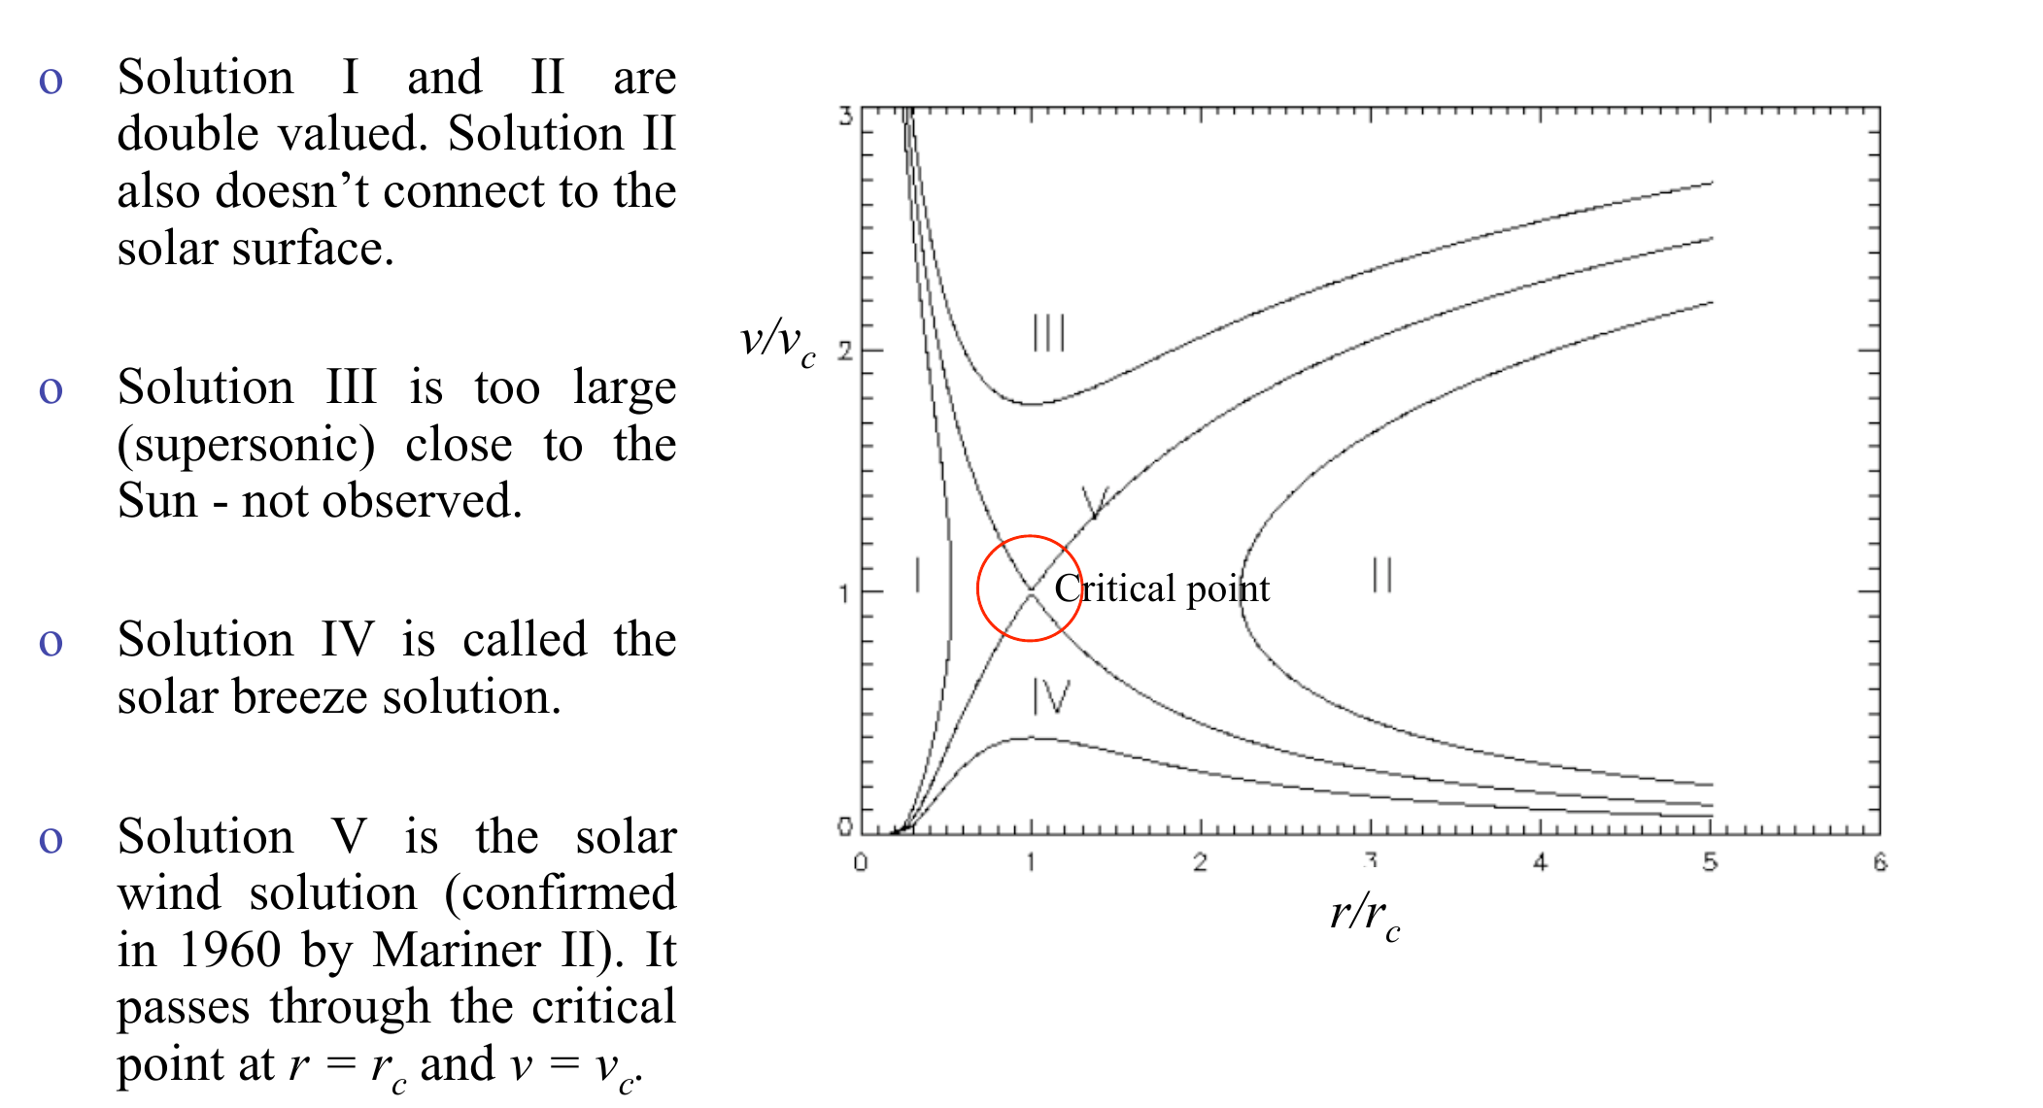
where the last term on the right is the shear in the Keplerian case. We also introduce the specific angular momentum J (angular momentum per mass unit)

The total derivative of the specific angular momentum is

This because the specific angular momentum depends only on r and not on t (remember that Ω depends only on r). The change in J depends on the radial velocity u and on the radial gradient of J. While the latter depends on the type of force (if gravity, then ), the first depends on the effects of viscosity.

At this point we introduce the concept of viscosity. Let's turn to the component φ of the momentum equation and write it as

we have neglected the term , since the pressure is along r, and non-radial components of the force (see the expression for V due to a central body). The force f is a viscous force (per mass unit) that acts to slow down the rotation of the gas. Its origin is not yet clear even if recently magneto-rotational instability is invoked to explain it. The above equation can be written in terms of the specific angular momentum as

since (remember that we use u for u_{r}) and recalling that

How can we model the viscous effects and then give an expression for f? We assume that the viscous force is proportional to the shear A: . This is a natural choice since the faster two surfaces move one respect to the other the higher is the expected friction. If we consider two adjacent rings, one at r-dr and the other at r+dr , the viscous force acts on the internal ring by accelerating it, while it decelerates the outer one

The total torque is

The mass within the ring is so that T per unit mass is

The equation for the specific angular momentum becomes

We turn now to the mass conservation equation integrated along z

In cylindrical coordinates

since for the axis-symmetric nature of the problem and since . The mass conservation equation is then

We now combine all equations in a system

and look for an analytic solution for Σ as a function of time. The first and last equation have the same right hand side so

then

this term can be substituted in the second equation of the system to get

recalling that for Keplerian motion we get finally

This first order differential equation (Pringle, ARAA 19, 137, 1981) can be solved and it gives the evolution of the disk. In figure the evolution of an annulus is shown as a function of time due to viscosity.

The above equation is an over-simplification of the evolution of a protostellar disks working in 1 dimension. Additional effects must be included, among others the cooling due to radiation emitted from the dust, heating of the outer layers by the central star (irradiated disks), the perturbations due to a growing planet etc.. Numerical models are used in these cases to compute the evolution of a disk in 2 or 3 dimensions like grid or SPH codes.

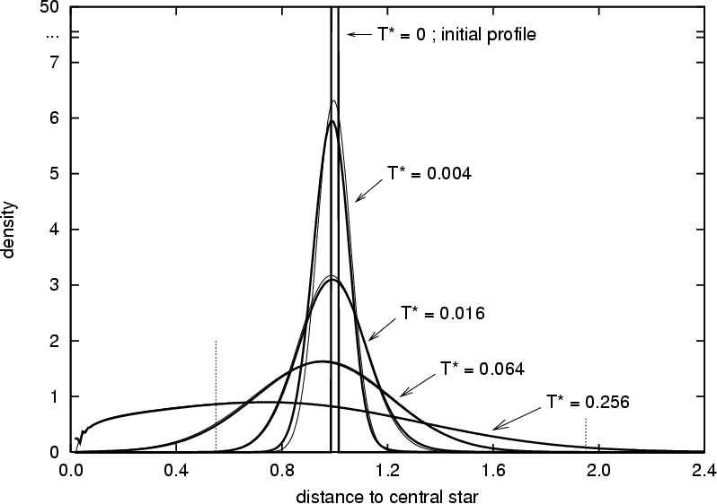

Fig. 2: viscous spreading of a ring of initial mass m. On the y-axis there is where Σ is the superficial density of the gas and it is plotted as a function of the dimensionless radius x = R/R₀, where R₀ is the initial radius of the ring. The time is defined as with ν the viscosity. (figure taken from Crida et al., A&A 461, 1173, 2007)

Viscous mass accretion rate on the star

As shown by the ultraviolet excess, the disk inner regions fall onto the star due to the loss of angular momentum related to viscosity. It is possible to relate the mass accretion rate to the viscosity value in the disk by using the Navier-Stokes equations. Let’s consider a 2D annulus of the disk with radius r and width dr. The mass conservation equation leads to

Fig. 2: viscous spreading of a ring of initial mass m.

where Σ is the superficial density of the disk. By multipling both terms of the equation by we obtain:

The angular momentum of the annulus is:

The change in L due to the mass flux from the outer and inner border is given by:

where u(r), the radial velocity, is negative. As a consequence, the flux from outside gives a positive contribution to L, while the flux exiting from r gives a negative contribution. The equation becomes:

In addition to the previous term related to the mass flux there is a viscous term in the angular momentum change:

(see equation for T , without dividing by the mass, in the previous section). We can look for stationary solution of this equation where the local superficial density Σ is assumed constant. The goal will be to compute the value of the mass accretion rate (i.e. u) as a function of ν. To derive the stationary solutions we set to 0 the time derivative and we are left with the following equation:

within this equation we have to find the mass accretion rate which is defined as:

Inserting this expression in the previous equation, we get

Integrating this equation from the radius of the star r_{s} , which we assume to be the inner limit of the disk, to the radial distance r, we obtain:

that, once integrated, leads to

where in the constant there are all values computed at the star surface. Since on the star surface the term because, as a first approximation, the star rotates as a rigid body, the only term different from 0 in the constant terms on the right is

Finally:

regrouping the terms we arrive at:

In the limit where r>>r_{s} , i.e. in the majority of the disk apart from a small interval close to the star surface, the mass accretion rate is given by:

where ν is the kinematic viscosity. Following the parametrization given by Shakura-Sunayev, this viscosity is given as a function of a constant parameter α in the following way:

where h is the scale height and c_{s} the sound speed. The parameter α is constant all over the disk and adimensional with values ranging from 0.1 to 10⁻⁴.

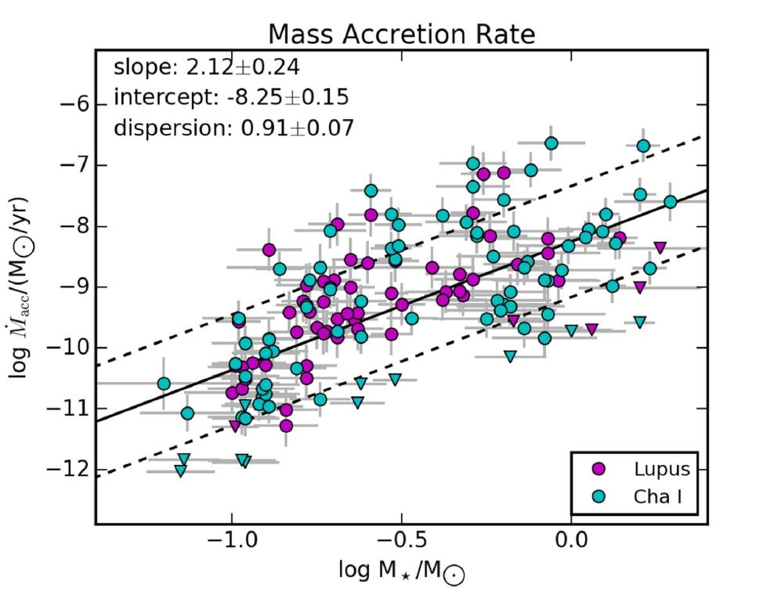

Fig. 3: observative values of the mass accretion rate as a function of the star mass for the combined Chamaleon and Lupus
star forming regions (from Pascucci et al. ApJ 847, 31, 2017)

According to Fig. 3, there is a significant dependence on the mass of the star which suggests that more massive stars have heavier disks with a stronger mass accretion rate. However, the mass accretion rate due to viscosity is too slow to explain the lifetime of circumstellar disks.

Photoevaporation

Photoevaporation of a disk is driven by high energy radiation (UV and X-rays) heat the disk surface to
temperatures of the order of 10³-10⁴ K and the heated gas becomes gravitationally unbound and is dispersed. The irradiation can be external i.e. from the hottest stars in the cluster, or internal i.e. from the central star. There are three radiations which can cause significant photoevaporation: EUV (Extreme UV) with energies ranging from 13-100 eV, FUV (Far UV) with energy in between 6-12 eV, and X-rays (E~ 0.1-10 Kev) which are produced in particular during the T-Tauri phase. Typically, FUV and X-rays dominate yielding most of the mass loss. Photoevaporation is an important disk-clearing mechanism that can lead to the following evolution of a disk:

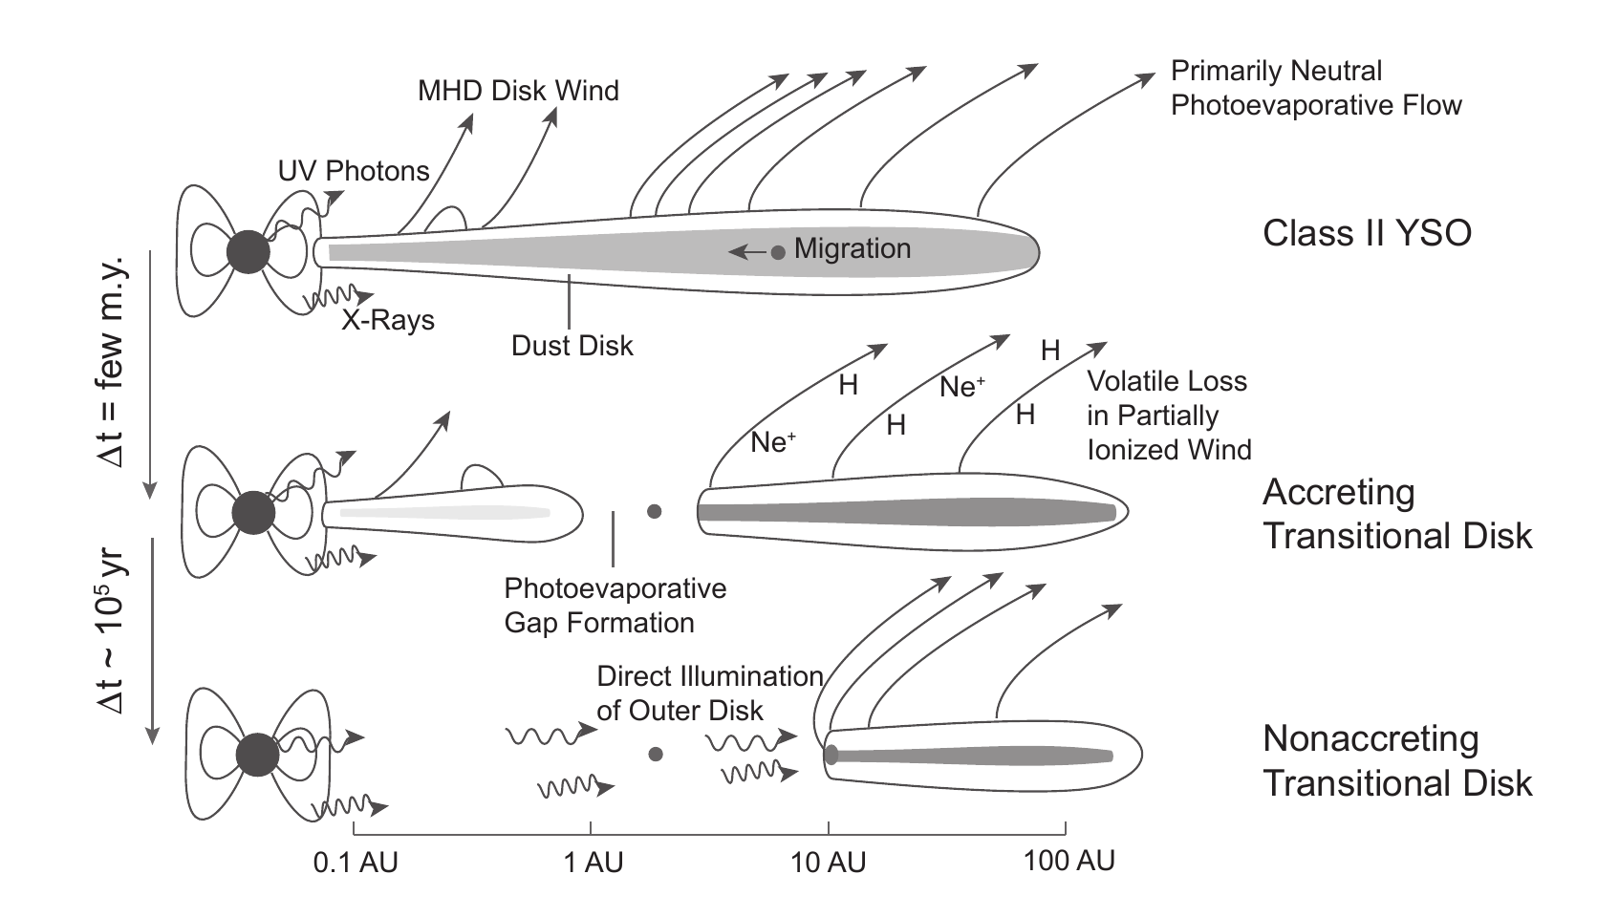

Numerical models can be developed to include the photoevaporative term in the following way:

Example of models with photoevaporation are shown in Fig. 4:

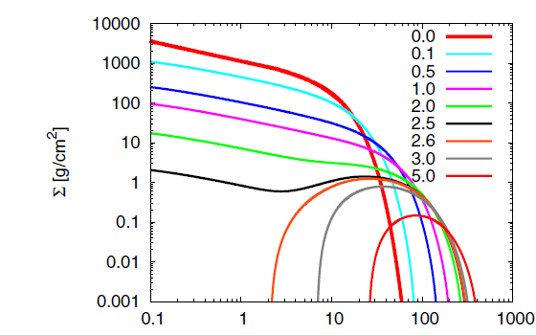

Fig. 4: 1-dimensional
simulation of the
evolution of the
superficial density
of a disk at different
times (in Myr). From
D’Angelo & Marzari,
ApJ 757, id. 50, 2012

At a given radius (about 1-10 au) the mass inflow due to viscosity is slower than the mass loss due to photoevaporation. The inner disk is not refilled and a hole develops in the inner region. This leads to a transition disk like those shown in Fig. 5.
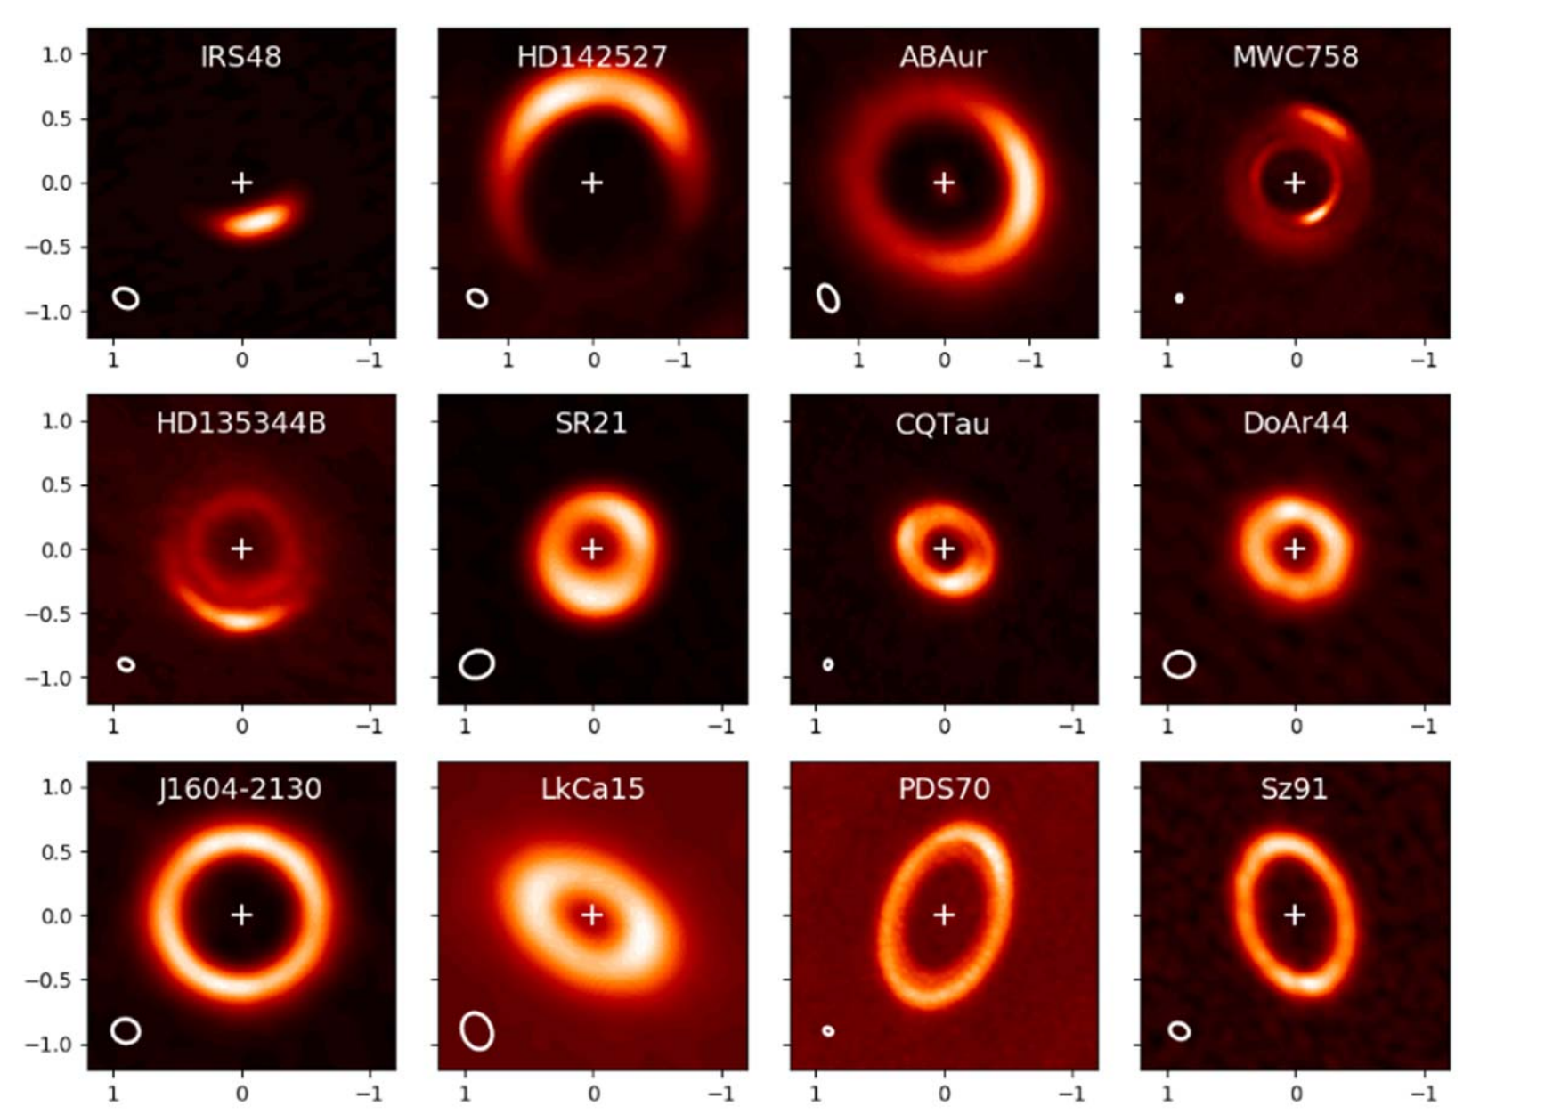

Fig. 5: gallery of ALMA continuum images of gapped disks (from van der Marel et al, AJ 161,
2021).

Appendix A: Sound waves in a fluid

The speed of sound in a fluid can be easily computed from the Euler equations. We assume a stationary fluid with ρ₀, P₀ constants and u₀ = 0. If we apply a small perturbation to the fluid in the form of

then the Euler equations can tell us as the perturbation propagates. The first equation becomes:

ρ₀ is taken out of the nabla since it is constant. Se second equation leads to:

were second order terms in Δu are neglected. Assuming a baratropic equation of state (like the isothermal one), the pressure is only function of the density ρ i.e. P(ρ). We can then compute the term with the pressure variation as:

Finally

We not take the first equation (conservation of energy) and derive it respect to time, while at the same time we multiply the second one (momentum equation) by . We get:

In the second equation, by exchanging the derivative order, we obtain:

we can now combine the two following equations

in a single wave equation in the density variation

the speed with which the density ripple propagates is . This is the speed of sound in a baratropic fluid. The solution to this equation is:

If we insert this solution back into the wave equation, we get

leading to the dispersion relation:

Appendix B: Relativistic formulation of Euler equations:

The energy momentum tensor in normalized units (i.e. c=1, otherwise there would be ρ + p/c² instead of ρ + p) is:

where η^{μν} is the Minkowski tensor. The conservation law for the tensor T is:

This equation is the relativistic version of the Euler equations. For example, we can derive the first in the non-relativistic limit where . Rewriting the conservation equation in the form

in can be contracted by multiplying both members by and obtaining:

Since and

which derives from

we get

In the non-relativistic limit the equation is:

which is the first Euler equation, that deriving from the mass conservation. The equation for the momentum comes from the projection of the derivative of T along a direction perpendicular to U. In GR the partial derivative must be changed to covariant derivative and the Minkowski tensor to the metric tensor.

