Dust particles in circumstellar disks and planetary systems

Dust particles are ubiquitous, they are found in circumstellar disks here they are the building blocks of planets, they are produced in minor bodies collisions forming debris disks and rings around planets, they populate the galactic environment as interstellar dust. Dust grains move under the influence of the local gravity field, but they can be perturbed also by non-gravitational forces like radiation pressure and Poyting-Robertson drag and they may be dragged by the gas in circumstellar disks. To understand how non-gravitational forces act on dust grains we need to know, at least approximately, how they interact with the radiation field they are embedded in.

Absorption and emission of light

A (idealized) black body emits radiation at different wavelengths λ with an amount of energy which depends on both the body temperature and λ itself according to Planck's formula

where h is Planck' constant (6.62606896(33)×10⁻³⁴ J s), c is the speed of light (299792458 m/s), k is the Boltzmann constant (1.380 6504×10−23 J K⁻¹) and T is the body temperature. The above equation can be integrated over all wavelengths to get the Stefan-Boltzmann equation

where E is the total energy emitted by the body and σ is a constant (5.67×10⁻⁸ W m−2 K−4). Another law is Wien's law giving the wavelength at which the maximum energy is emitted

with b = 2.8977685(51)×10⁻³ m K.
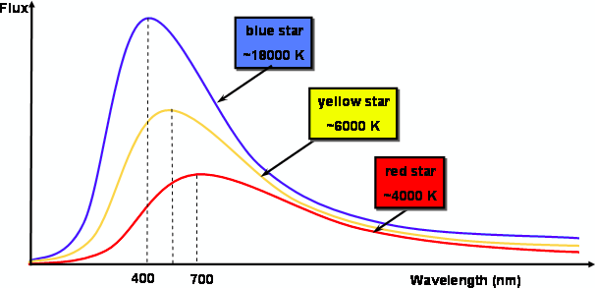

T (K) | λ_{Μ} (m) | Radiation
30-4000 | 0.01-7 ×10⁻⁵ | infrared
4100.-7400 | 7 – 4 ×10⁻⁵ | visible
7300-3×10⁶ | 4 ×10⁻⁵ - 10⁻⁷ | ultraviolet
3×10⁶ − 3×10⁸ | 10⁻⁷-10⁻⁹ | x-rays

A body absorbs energy (radiation) until it reaches an equilibrium temperature at thermal balance where it emits as much energy as it absorbs. To compute the temperature of a body in open space one has to compute the absorbed radiation energy. In the solar system, to derive the energy of an asteroid or space probe at a distance r from the sun the amount of solar irradiation must be known at the object distance. Usually, the solar constant W is used which is defined as the quantity of solar energy (W/m²) at normal incidence outside the atmosphere at the mean sun-earth distance whose mean value is 1367.7 W/m² . The temperature is then computed as

where r is the body radius (assuming it is spherical) and R is the distance from the sun in AU.

Dust particles around a star

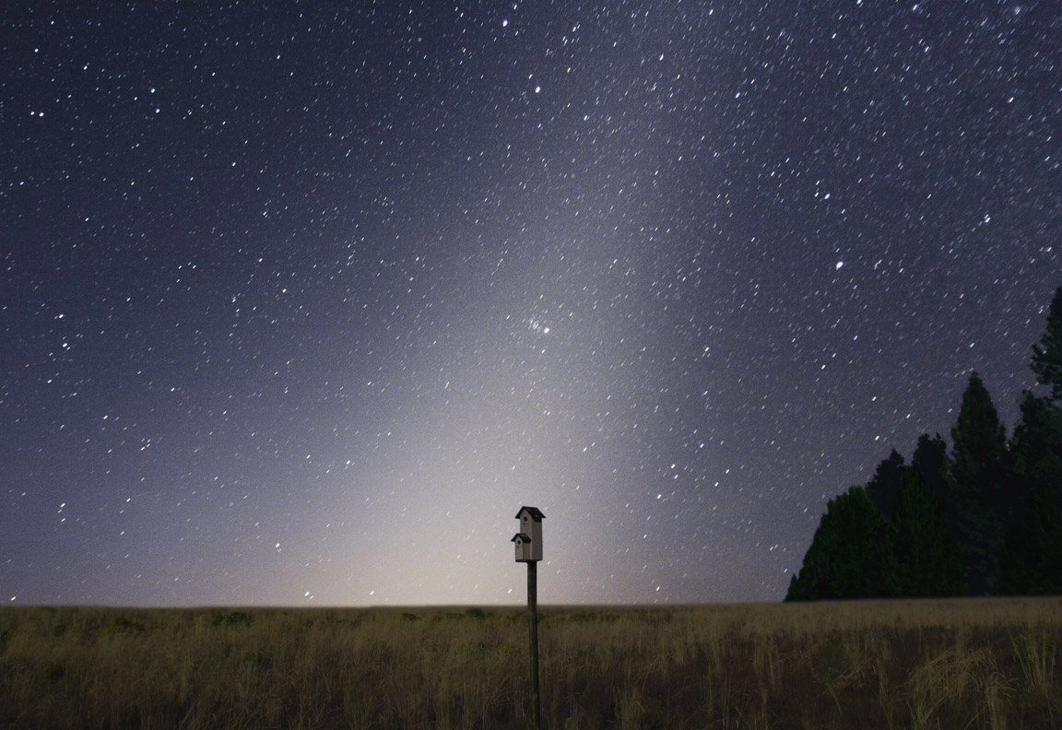
Circumstellar disks are made of gas and dust whose ratio depends on the distance on the local temperature and then on the distance from the star. Silicates can condensate very close to the star so in the terrestrial planet region we expect rocky grains. Beyond the frost line where the disk temperature drops beyond the value that allows ices to condensate (located around 3-5 AU from a solar type star), more solid material is available and dust grains are made of a mixture of ice and rock. From dusty grains bigger bodies can accumulate (planetesimals) and planets can form. After the dissipation of the gas in a disk dust rings can be observed either as remnant of the accumulation process or constantly produced by collisions between larger bodies like asteroids and comets (debris disks). A minor fraction can also come from outside the star gravitational reach directly from the galactic environment. The dust populating our solar system can be seen in clear nights (zodiacal light). It is mostly composed by grains having typical sizes of 10-100 μm and they can be observed at 5-50 μm wavelenght. The
distribution of dust is modeled with the following formula (Giese et al. 1986) where the dependence on the radius is separated from that on the latitude angle

where r is the distance from the sun, β is the helioecliptic latitude (latitude respect to the ecliptic plane), is the dust density at the Earth's orbit (). The value of the parameter α, as derived from photometers on board of missions Helios 1 and Helios 2 is about 1.3 (Grun 1985). The function f(β) is approximated in the so called ellipsoid model in the following way

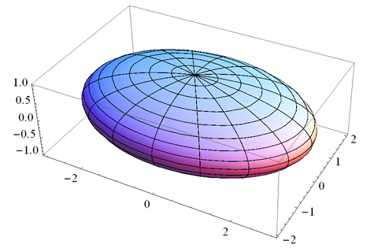
where with a and b semimajor and semiminor axes of an oblate ellipsoid (a=c>b with a and c on the ecliptic plane), respectively. Most of the dust is concentrated within about 3 AU in the ecliptic plane and 1.5 AU off the plane even if dense dust rings are observed in the asteroid belt due to asteroid collisions.
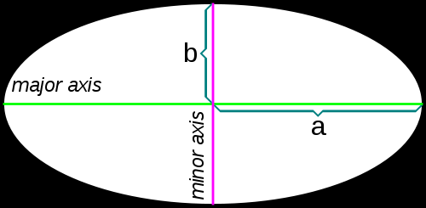

Together with the ellipsoidal component, there are additional reservoirs of dust in the solar system, and possibly in all planetary systems, which include dust bands in the asteroid belt and cometary dust trails. From the data of IRAS satellite numerous dust bands where identified in the asteroid belt (sykes 1988), possibly due to rings of dust outcome of catastrophic disruption of an asteroid.

Radiation pressure and Poynting-Robertson drag.

A dust particle with area A will absorb radiation from the star which depends on its distance from the source. We call S the flux of radiation whose value is the solar constant W. If the particle is on an eccentric orbit, it has a radial component of velocity and, as a consequence, the flux is modulated by the Doppler effect . The particle absorbs an energy per unit of time equal to . This energy is in the form of photons carrying a momentum equal to . The total pressure felt by the particle because of the momentum released by radiation is

where s is a versor in the antisolar direction. With a semi-classical reasoning, we can also derive the force on a grain due to the radiation re-emission (usually in the infrared). The amount of energy emitted by the dust particle must keep thermal balance and it is equal to the absorbed energy. This energy is re-emitted radially with spherical symmetry in the infrared. Since the particle moves in space (respect to the star) with a velocity v, we can imagine that the whole re-emitted energy is equivalent to a mass ejected with the same velocity of the particle v along the same direction. As a consequence, the particle is affected by a recoil force equal to

This force is called Poynting-Robertson drag, it tends to slow down the particle and it is direction in the opposite direction respect to the particle velocity. The total force felt by a dust grain lighted by a star is then

assuming that is a small number. This is the original derivation of the Robertson's formula. The formula can be proved more rigorously using special relativity.

Particle properties: absorption and reflection coefficients.

Of the total energy S striking a particle, a fraction f S is absorbed while a fraction g S is reflected with g+f=1. A new coefficient is introduced which usually is indicated with Q_{pr} and it is given by . A perfectly absorbing particle has Q_{pr =1} while a perfectly reflecting particle (assuming that the radiation is scattered backwards) has Q_{pr} =2. The situation can be complicated by the presence of light diffusion, but, as a first approximation, we assume that the light is scattered back towards the sun.

Relativistic derivation of Robertson's formula

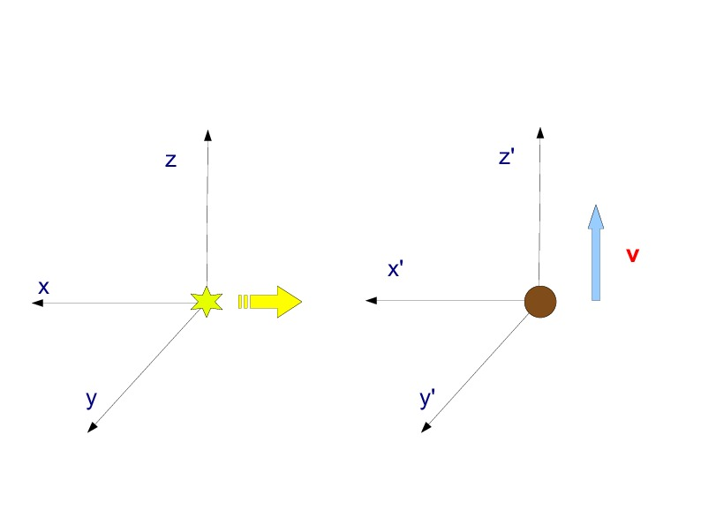
Let's assume that a dust grain is moving respect to the star on a circular orbit (no radial velocity component) with velocity v. The configuration is illustrated in the bottom figure where the velocity of the grain v is directed along the z'-axis which is parallel to the z-axis of the reference frame centered on the star. A flux of photons leaves the star radially and part of the flux will meet the particle after traveling in the antisolar direction -x. At any instant of time we can assume that the reference frames are inertial with the frame attached to the grain moving with constant velocity along . This is a good assumption since the absorption and re-emission of energy occurs on a short timescale compared to the circular motion frequency and we do not have to worry about the accelerated circular motion of the grain. We also neglect the fact that both the reference frame are not inertial because that centered on the star is moving under the effect of the dust gravitational attraction. However, the acceleration is so small that can be safely neglected.

The radiation flux of photons can be described by the momentum 4-vector

where we take into account the relation between energy and momentum of a photon . The minus sign is due to the antisolar direction of the photon flux. In the reference frame centered on the particle, where absorption and reflection occurs, is computed by using a Lorentz transformation

where and . Now that we have the photon flux in the moving reference frame of the dust grain, we can compute the momentum absorbed and reflected by the particle. The coefficient gives the amount of radiation reflected by the dust particle which is described by the 4-vector

It is noteworthy that the 0-term of is not multiplied by . The reason is that includes the contribution from the re-emitted radiation. This radiation is re-emitted isotropically in the reference frame of the particle. This implies that the total 3-momentum of the re-emitted flux is 0 in this reference frame since for any photon emitted in one direction, there is one emitted in the opposite direction. The re-emitted energy is instead equal to the absorbed energy multiplied by the coefficient f . This energy must be added to the energy of the reflected photons that is so that the energy that appears as fourth component of is . We can transform back to the reference frame centered on the star so that from the difference between the initial four momentum and that after the interaction with the dust particle we can compute the force acting on the grain. We apply the inverse Lorentz transformation to get

By collecting similar terms we arrive a the following expression for

Note that the 0-component is larger than the initial value E/c and this is due to the loss of kinetic energy of the particle, in favor of the radiation field, because of the recoil effect produced both by reflecting and re-emitting photons. Finally, we can evaluate the force acting on the dust particle because of its interaction with the radiation field of the star. The recoil force will be given by and its expression is the following

We can outline the single components along the radial direction (x-axis) and along the direction of the velocity vector of the particle (z-axis)

We have retrieved the formulas for the radiation pressure () and for the Poyting-Robertson drag (). The proof for a particle on an eccentric orbit is similar but more complex and there will be a Doppler effect term on the energy E.

* Burns, Lamy and Soter, Icarus 40, 1-48, 1979

Effects of radiation pressure on the orbit of dust particles

Radiation pressure force has a dependence hidden in the radiation flux S and, as a consequence, its effect is that of weakening the gravitational attraction of the star. The ratio between the gravitational attraction and radiation pressure leads to the definition of the coefficient β

where S₀ is the radiation flux at 1 AU from the star and r is measured in AU. The central force felt by the dust particle is then given by

ing the sun, the value of β can be approximated as where the radius s and the density ρ of the particle are in cgs units.

For spherical particles orbit

If the dust particle is on a given orbit, its orbital elements will be constants but the orbital period will be longer and the orbital velocity slower. If instead the dust particle is emitted from a body on a given orbit (like a comet because of outgassing) then the orbital elements of the grain can be significantly different from those of the parent body and the grain can also be ejected on a hyperbolic orbit. Let's assume that the dust grain is ejected when the comet is at perihelion by a comet with semimajor axis a and eccentricity e. When the grain is part of the parent body, its orbital energy (which must be negative to be tied to the star) is given by:

where a(1-e) is the periastron distance r_{p}. When the particle detaches from the comet its orbital energy is given by

The orbital velocity does not significantly change at ejection (the ejection velocity is negligible respect to the orbital velocity) while the potential energy is different because of the radiation pressure. If the term becomes larger than 0 because of the presence of β then the particle escapes the gravitational attraction of the star. The condition for escape can be given as a maximum value of β beyond which escape occurs

This condition becomes

at aphelion. Clearly, escape from the star's gravity field occurs more easily when the dust is emitted at perihelion. The condition on β can be transformed in one for the radius of the particle so that only particles smaller than

Effects of Poynting-Robertson drag on the orbital evolution of dust grains.

Averaging over many orbits the drag force due to radiation re-emission, the orbital elements of the grains change with time. The average (over the mean anomaly) changes in orbital semimajor axis, eccentricity and perihelion longitude are given by:

with . The net results is in a decrease of the semimajor axis and a circularization of the orbit. The larger is the eccentricity of the orbit, the faster is the inward migration because the semimajor axis derivative depends quadratically on the eccentricity. For almost circular orbits, we can derive a decay rate given by and a decay time around the sun with given in yrs, r in AU and s in .

APPENDIX A: summary of special relativity concepts.

Coordinates:
Interval (invariant):
Proper time (invariant) i.e. time measured by local clock:
Four velocity:

The scalar product of U with itself is:
The four momentum of a particle is
where
The modulus of the momentum is
For the photon: where . Since for the photon, we get and the whole 4-vector becomes

where the + or – sign depends on the propagation direction.

APPENDIX B: Tetrads
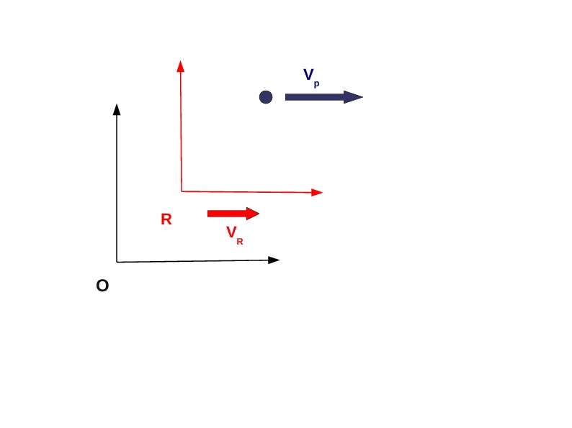

In the classical formalism, if we want to compute the four components of the velocity of P respect to an inertial frame centered in R, knowing their value in the frame centered in O, we have to perform a Lorentz transformation. We call the 4-velocity of P respect to O, while will be the 4-velocity of P respect to R, is the 3-velocity vector of P measured respect to O, while is the 3-velocity of the reference frame centered in R respect to that centered on O

If we apply the Lorentz transformation to we get the components of.

Let's now turn to the tertrad formalism. A tetrad is a set of axes (usually orthonormal) attached to a point in space-time. We assign to the observer centered in R a tetrad so that the components of will be computed as projections (scalar product) of over . To find the tedrad attached to R we first note that the 4-velocity is parallel to . In effect, the 4-vector , once computed in the reference frame of R, has component (c,0,0,0) so it can be related directly to trough the identity

From and the orthogonality relation between versors, we can compute

and lead to .

The remaining versors can be chosen parallel to those of the observer centered in O. Once found the tetrad of the observer R, the components of can be derived by projecting (with the scalar product) the 4-vector on the tetrad vectors

The value of is the same as that obtained with the Lorentz transformation but with the opposite sign. This because in the scalara product the metric tensor is involved and the scalar product of any vector u with . The x-component of is

This, again, is equal to the value obtained with the Lorentz transformation. With tetrads we can compute the components of a 4-vector in any reference frame attached to an observed if we now his 4-velocity. We compute its tetrad and project the 4-vector of interest on the tetrad.

Another example (Misner, Thorne and Wheeler, Gravitation) is the uniformly accelerated motion. Let's assume that an observer is on a rocket moving with constant acceleration equal to g . The 4-velocity U is always perpendicular to the 4-acceleration a since and

In the reference frame comoving with the observer (an inertial frame moving with the instantaneous velocity of the rocket or that for which ) we can determine more easily the components of the 4-vectors. In particular, the 4-velocity is given by (in the comoving frame) and, as a consequence, (we assume hereinafter for simplicity that c=1). The other components of the acceleration are . The component along x (which we suppose to be the direction of the accelerated motion) is then . In the comoving frame the observer measures an acceleration since the comoving frame is locally inertial. In conclusion, and then . These relations, being between 4-vectors, hold true in any reference frame, also for an inertial observer that watches the rocket moving along the x-axis. From the definition of 4-velocity and 4-acceleration we can write

The solution to this system is given by

Taking also into account the definition of 4-velocity and 4-acceleration the solution become

The equations of the rocket position in the 4-space parametrized by an inertial frame are therefore

which have the solution

This is the trajectory of the rocket in space-time parametrized by the proper time τ. We can derive the dilatation of time for the accelerated observer noticing that. The interval of time measured by the accelerated observer is than . At this stage we con build up the comoving tetrad for the accelerated observer

where are the versor of the inertial observer computing the motion of the accelerating rocket, while are the versors of the comoving tetrad. The versor can be computed from the orthonormality conditions since it must be perpendicular to so it must be parallel to the 4-acceleration a and its expression is . The tetrad is then defined as

