Operating System
Technical Guide to Remote Installation Services

Microsoft Product Support Services White Paper

Abstract
This white paper discusses how to install, configure, and troubleshoot Microsoft Windows 2000 Remote Installation Services (RIS). This document covers the following areas: Pre-Boot Execution Environment (PXE), installation and deployment of RIS, customizing Client Installation Wizard (CIW) screens, and an overview of the Single Instance Store (SIS) feature.

The information contained in this document represents the current view of Microsoft Corporation on the issues discussed as of the date of publication. Because Microsoft must respond to changing market conditions, it should not be interpreted to be a commitment on the part of Microsoft, and Microsoft cannot guarantee the accuracy of any information presented after the date of publication.
This White Paper is for informational purposes only. MICROSOFT MAKES NO WARRANTIES, EXPRESS OR IMPLIED, IN THIS DOCUMENT.
Complying with all applicable copyright laws is the responsibility of the user. Without limiting the rights under copyright, no part of this document may be reproduced, stored in or introduced into a retrieval system, or transmitted in any form or by any means (electronic, mechanical, photocopying, recording, or otherwise), or for any purpose, without the express written permission of Microsoft Corporation.
© 2000 Microsoft Corporation. All rights reserved.
Microsoft may have patents, patent applications, trademarks, copyrights, or other intellectual property rights covering subject matter in this document. Except as expressly provided in any written license agreement from Microsoft, the furnishing of this document does not give you any license to these patents, trademarks, copyrights, or other intellectual property.
Microsoft, Active Directory, IntelliMirror, Jscript, Win32, Windows, and Windows NT are registered trademarks or trademarks of Microsoft Corporation.
Other product or company names mentioned herein may be the trademarks of their respective owners.
Microsoft Corporation • One Microsoft Way • Redmond, WA 98052-6399 • USA

Introduction 1
Contents
RIS Client/Server Components 3
Pre-Boot Execution Environment (PXE) 5
PXE Overview 5
PXE client/RIS Server Interaction 8
Installing RIS 11
Hardware Requirements 11
Server Requirements 11
Adding the RIS Server Component 11
Running Risetup.exe 12
Authorizing RIS Servers 17
Installation of RIS Servers by Non-Administrators 18
Installing RIS in Multiple Manufacturer Environments (BINL) 20
Remote Install Directory Structure 22
Deployment and Placement of RIS Servers 24
Router and DHCP Server Configuration Changes 24
Remote Installation Services 28
Client Installation 29
RIS Components 32
Risetup.exe 32
Client Installation Wizard (Oschooser) 33
RIS Administration 38
Pre-staging Client Computers 42
Permissions Clients Need to Install Computers 48
Clients Can Create Their Own Machine Accounts (Non-Pre-Staged) 48
Clients Can Install Their Pre-Staged Systems 48
RIS Boot DISK 49
Single Instance Store (SIS) 50
SIS Overview 50
How matching files are found by the groveler 52
How files are made into SIS links 52
Backing Up and Restoring SIS Volumes 53
How backup programs handle SIS linked files 53
Backup/Restore of the RIS Volume 54
RIS Template files 55
[Data] Section 55
[SetupData] Section 56
[RemoteInstall] Section 56
[Oschooser] Section 56
Image Types 58
CD-ROM-Based Images 58
Riprep-Based Images 58
Riprep Rules and Restrictions 60
Customizing Client Installation Wizard (CIW) screens 61
Appendix A 69
Adding Debug Information to BINL 69
Configuring RIS for Normal Debug Mode 69
Configuring RIS for Full Debug Mode 70
Appendix B 72
Troubleshooting/Tips for Remote Installation Services 72
Known issues 72
Trouble Shooting RIS client issues (PXE) 73
Trouble Shooting RIS Server Issues 75
Appendix B 78
OSCML/CIW Tags 78
Brief Summary of the Supported Tags 78
Appendix C 84
Client Installation Wizard (“OSC”) Variables 84
Appendix D 86
BINL Service Registry Parameters 86
For More Information 88

Deploying a new operating system (OS) in your organization can be a costly process. Currently, this process involves months of planning the installation and distribution of the new OS, and possibly physically visiting each computer. If new computers arrive from the manufacturer with an OS already installed, you may have to uninstall any programs or software and reinstall the OS with your company’s configuration before you can deliver the computer to the end user. All of these steps can increase the Total Cost of Ownership (TCO).

Introduction
You can use Remote Installation Services (RIS) for Windows 2000 to install a local copy of the OS throughout the organization from remote locations. Using existing network technologies, personal computers can simply start up, contact a Dynamic Host Configuration Protocol (DHCP) server for an Internet Protocol (IP) address, and then contact a boot server to install the OS. Using RIS, you can send personal computers directly to an end user or staging area and install an automated, customized version of Windows 2000. The following diagram shows an overview of this process.

- Client A starts and sends out a DHCP Discover packet requesting an IP address and a RIS server. In this same packet, the client also sends out its Globally Unique Identifier (GUID). If the DHCP and RIS servers are on the same computer, all of this requested information is provided in the initial reply.
- If DHCP and RIS are on separate computers, the client sends out another DHCP Discover broadcast to contact a RIS server.
- The RIS server (using the Boot Information Negotiation Layer (BINL) service) contacts the Active Directory™ service to see if the client is a “known” client. Known clients are computer systems that are pre-staged to Active Directory. The process of pre-staging client computers is covered in the “Pre-Staging Client Computers” section of this white paper.
- Active Directory then checks the client settings to see if the RIS server can install this client. If the RIS server can service the client, it sends the client the necessary files to begin the boot process.
- After the boot process begins, the CIW screens are downloaded and the installation begins.
When the CIW runs (this process is covered in further detail later in this white paper), you must log on to the domain before beginning the installation of the OS. At this point, you can select the image you want installed on the computer.
RIS uses PXE/DHCP–based remote boot technology to remotely install the OS on the local hard disk of a client computer. The RIS server contains the OS you want to install using either a CD-ROM–based or Riprep-based image format. You can contact the servers by enabling the network card as first in the boot order of the system’s BIOS, or by using a remote boot disk for pre-NetPC/PC98 computers. When a network boot is requested, the client computer does the following:

RIS Client/Server Components
- Obtains an IP address from the DHCP server.
- Obtains the IP address of a boot server using PXE (if the boot server is not the DHCP server).
- Contacts the boot server and downloads the CIW.
The following diagram shows the minimum components needed to run RIS.

The components can be broken down as follows:
- RIS server. Any Windows 2000-based computer running RIS. RIS installs and starts the following services: Boot Information Negotiation Layer (BINL), Trivial File Transfer Protocol (TFTP), and Single Instance Storage Groveler. The Single Instance Storage (SIS) filter driver is also installed.
- Remote Installation client. This computer can be a NetPC, or a new personal computer that has a PXE-enabled network card. Older personal computers (for example, computers previous to the PC98/99 design specification) that can run Windows 2000 can use a remote boot disk to emulate PXE for the network card.
Active Directory is also required for RIS to function. During RIS Setup, a query is made to make sure Active Directory is running. If Active Directory is not detected on the network, Setup does not continue. The RIS server does not have to be the Domain Name System (DNS)/DHCP server or a domain controller for the domain, but it must be a member of a Windows 2000 domain to function.
Because PXE uses the network to boot, you must first understand how PXE starts up and interacts on the network. Personal computers that conform to the PC98 specification include built-in network cards that have this capability. For older personal computers that do not follow these specifications, a PXE boot emulator disk is provided.

Pre-Boot Execution Environment (PXE)
PXE is defined on a foundation of industry-standard Internet protocols and services that are widely deployed in the industry (namely TCP/IP, DHCP, and TFTP). These protocols standardize the form of the interactions between clients and servers. To ensure that the meaning of the client/server interaction is standardized, certain manufacturer option fields in DHCP protocol are used, which are allowed by the DHCP standard. The operations of standard DHCP or Bootp servers (that serve up IP addresses or NetBIOS protocols) are not disrupted by the use of the extended protocol. Clients and servers that detect these extensions recognize and use this information, and those that do not recognize the extensions ignore them.

PXE Overview
In brief, the PXE protocol operates as follows: The client initiates the protocol by broadcasting a DHCP Discover packet containing an extension that identifies the request as coming from a client that implements the PXE protocol. Assuming that a boot server implementing this extended protocol is available, the boot server sends an offer containing the IP address of the server that will service the client. The client uses TFTP to download the executable file from the boot server. Finally, the client initiates execution of the downloaded image.
The initial phase of this protocol piggybacks on a subset of the DHCP messages to enable the client to discover a boot server (that is, a server that delivers executable files for new computer setup). The client may use the opportunity to obtain an IP address (which is the expected behavior), but is not required to do so.
The second phase of this protocol takes place between the client and a boot server, and uses the DHCP message format simply as a convenient format for communication. This second phase of the protocol is otherwise unrelated to the standard DHCP services. The next few pages outline the step-by-step process during PXE client initialization.
NOTE: The following information on PXE is taken from the PXE specification 1.0b.
Step 1. The client broadcasts a DHCP Discover message to the standard DHCP port (67). An option field in this packet contains the following information:
Figure 1
- A tag for the client identifier (if the client identifier is known).
- A tag for the client network interface identifier.
- A tag for the client computer architecture.
Step 2. The PXE proxy DHCP service responds by sending a PXE proxy DHCP Offer message to the client on the standard DHCP reply port (68). This packet contains the address of the PXE proxy DHCP service. The client IP address field is null if the boot server is not also running the DHCP service.
At this point, other DHCP services and Bootp services also respond with DHCP offers or Bootp reply messages on port 68. Each message contains standard DHCP parameters — an IP address for the client and any other parameters that an administrator might have configured on the service. If DHCP is installed on the RIS server, the DHCP service reply from the installation server also contains standard DHCP parameters (in particular, an IP address for the client).
The timeout value for a reply from a DHCP server is standard. The timeout for rebroadcasting to receive a DHCP Offer packet with PXE extensions (or a proxy DHCP Offer packet) is based on the standard DHCP timeout value, but is substantially shorter to allow reasonable operation of the client in standard Bootp or DHCP environments that do not provide an Offer packet with PXE extensions. The PXE timeout value for rebroadcast is as follows:
4, 8, and 16 seconds (which yields three broadcasts and a timeout after 28 seconds)
The PXE timeout value for rebroadcast is 4 seconds after receiving an Offer packet without PXE extensions but with a valid “bootfile name” option.
Step 3. The client records the following, from the DHCP Offer(s) that it receives:
- The client IP address (and other parameters) offered by a standard DHCP or Bootp service.
- The RIS server IP address of the BINL service from the Siaddr field in the PXE proxy DHCP Offer packet.
Step 4. If the client selects an IP address offered by a DHCP service, it must complete the standard DHCP protocol by sending a request for the address back to the service, and then waiting for an acknowledgment from the DHCP service. If the client selects an IP address from a Bootp reply, it can simply use the address.
Step 5. The client sends a DHCP Request packet to the BINL service on port 4011. This packet is exactly the same as the initial DHCP Discover packet in Step 1, except that it is coded as a DHCP Request packet and now contains the following information:
- The IP address assigned to the client from a DHCP service.
- All of the PXE option fields received from the selected DHCP Offer packet that contained the PXE options.
Step 6. The BINL service on the installation server sends a DHCP Acknowledge packet back to the client, also on port 4011. This reply packet contains the following information:
- Boot file name and location.
- The client Universally Unique Identifier (UUID) or GUID option in the PXE proxy DHCP offer packet.
Step 7. The client downloads the executable file using standard TFTP. The file is downloaded and the placement of the downloaded code in memory is dependent on the client’s CPU architecture.
Step 8. The PXE client initiates execution of the downloaded code. The way in which the downloaded code is executed depends on the CPU type of the client. For Intel architecture NetPC computers, the client code executes a Far call to the first location in the code.

PXE client/RIS Server Interaction
The following diagrams show how the PXE client and RIS server interact.
The following figure is an example of the DHCP interaction between the PXE client, the DHCP server, and the Windows 2000 RIS server.
The following figure is an example of the PXE client sending out a DHCP Discover packet looking for both a DHCP and PXE boot server.
The DHCP server responds with an offer to the client that contains an IP address and any other DHCP options. The RIS server (which is on the local subnet) also responds, offering the PXE client’s IP address as a PXE boot server. Because the client does not yet have an IP address, the client ignores this packet. The PXE client initially looks for a DHCP packet that contains either an IP address or an IP address and a PXE boot server. Because the RIS server can only fill in the boot server information, the client ignores this packet.

The PXE client and DHCP server complete the process much like any other DHCP client. The client now has an IP address but still needs a boot server from which to start.
After the client has an IP address, it can look for a RIS server (Bootp). This exchange is shown in the following diagram.
The PXE client sends out another DHCP Discover packet looking for a PXE boot server.
NOTE: In the example above, a RIS server already responded with an Offer. Remember that the client discarded this packet because PXE is looking for either a packet containing both the IP address and RIS server address, or a packet containing only the IP address.
The DHCP server responds again with the same IP offer (offers the same IP address). Because the client already has an IP address, this packet is ignored. The RIS server responds with a DHCP Offer packet that contains a boot server.
The client and the RIS server complete the process. The Ack packet that the RIS server sends to the PXE client contains the address to the RIS server, the name of the RIS server, and the first file to which the client should send a TFTP request to start the boot process.
If DHCP and RIS are installed on the same server, this conversation is shortened because the RIS server adds its information to the initial DHCP Offer packet back to the client, as shown in the following exchange:
- DHCP Discover packet from the client (asking for an IP address and PXE boot server).
- DHCP Offer packet from the DHCP/RIS server (offers IP address and boot server).
- DHCP Request packet from the client to the DHCP server (requesting an IP address and boot server).
- DHCP Ack packet from the DHCP server (contains the IP address and the RIS server IP, the name of the RIS server, and the first file to download).

To install RIS, use the Add/Remove Programs tool in Control Panel, and then run Risetup.exe. You can automate the installation of the RIS component using unattended Setup parameters.

Installing RIS

Hardware Requirements
Ensure that both your server and client hardware meet the minimum installation hardware requirements for Windows 2000.

Server Requirements
- Personal computer with Pentium or Pentium II 200-MHz or faster processor (Pentium 166 minimum).
- 64 megabytes (MB) of RAM (96-128 MB if additional services such as the Directory service, DHCP, and DNS are installed).
- 2-gigabyte (GB) disk drive for RIS server’s folder tree.
- 10 MB/second network adapter (100 MB/second recommended).
- CD-ROM drive or access to a network share containing the Microsoft® Windows® 2000 Professional operating system.
You need to have at least two partitions available — one for booting the server’s OS and another to hold the RIS images. This is because you cannot use SIS (which is discussed in the “Single Instance Store” section of this white paper) on the server’s boot/system partition. The drive that holds the RIS images must be formatted with the NTFS file system. RIS does not support the Encrypting File System (EFS).

Adding the RIS Server Component
When you install the RIS server component using the Add/Remove Programs tool, the files and services necessary to support RIS are installed. You must first add RIS using the Add/Remove Programs tool, which can be done during graphical user interface (GUI) mode or after Setup is finished.
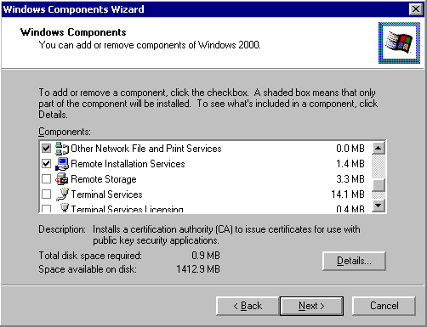
Selecting the RIS component installs the SIS filter driver and creates a directory under the Windir\System32\Reminst directory that contains the files necessary to run Risetup.exe. After you install the component, restart the computer and run Risetup.exe from the Start menu or a command prompt. If you install the component after Setup, you need to restart the computer to install the SIS NTFS filter. When you first start or restart the computer, click Finish Setup in the Configure Your Server dialog box. This starts the Add/Remove Programs tool. In the Set up servers area, click Configure Remote Installation Services to run Risetup.exe.

Running Risetup.exe
You can run Risetup.exe in one of two ways:
- From the Configure Your Server screen when you restart the computer after you install the component (as discussed in the previous paragraph).
- By clicking Start, clicking Run, typing risetup.exe, and then clicking OK.
Risetup.exe completes the installation by:
- Locating a suitable NTFS volume.
- Creating the directory structure.
- Copying over the files required for a Windows 2000 Professional installation.
- Copying the Client Installation Wizard (CIW) screens.
- Configuring the RIS services.
- Starting all of the services required for RIS (BINL, TFTP, and the SIS Groveler service).
- Creating a share named Reminist that shares out the root of the RIS directory structure.
- Creating the appropriate IntelliMirror™ management technologies Service Control Point (SCP) object in Active Directory (this is a child object to the server’s computer account object in Active Directory).
- Creating the SIS Common Store directory and related files that are needed for SIS to be operational on this volume.
After Risetup.exe is started, a number of dialog boxes are displayed. The first dialog box (shown below) is a welcome screen that lists the components required to use RIS.
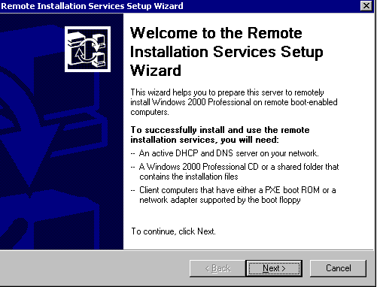
The next dialog box (shown below) prompts you for the location of the RIS installation image files that you want to use to install your clients. Risetup automatically locates the first available NTFS volume that does not contain the system or boot files. You can select any NTFS volume on your computer other than the system volume (the volume where the Boot.ini file is located) or the boot volume (the volume where the Windir directory is located).
The directory name must not contain any non-ASCII characters. This directory can, however, be located on a mounted volume, provided the mounted volume is NTFS and is not the system or boot volume.
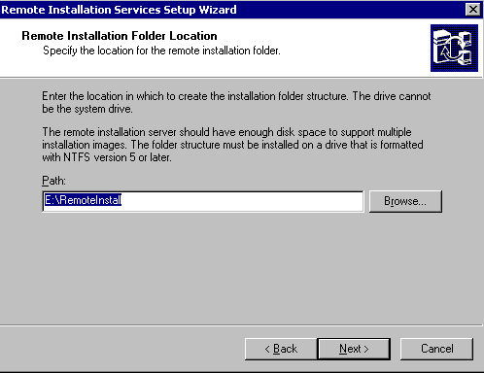
On the following screen (shown below) you can determine whether or not the server answers service requests. You can further limit the responses to all PXE-enabled clients or only those that you have pre-staged in Active Directory.
For example, you can use this setting when you only want the servers to respond to known client computers. A known client is a system that has its Machine Account Object (MAO) created in Active Directory (local forest). When the PXE client contacts the RIS server, it sends its GUID (a unique ID similar to a media access control (MAC) address), which is compared against the MAO to see if it matches. This is useful in secure environments (not any client can boot up and install Windows 2000) and also provides load balancing across all RIS servers in an organization. This is also useful when another remote boot manufacturer is located in your organization.
NOTE: These settings only apply to the DHCP conversation of the RIS server and the RIS client. If a RIS client obtains the IP address of a RIS server from another source (such as a referral RIS server) and the client requests to boot from this RIS server, it is allowed to do so.
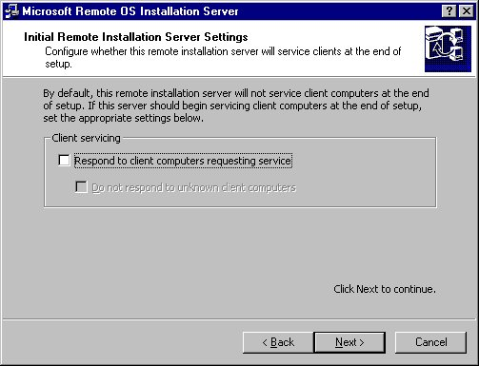
The next dialog box (shown below) prompts you to specify the folder in which you want to store the files for the image that Risetup copies. This folder name can only contain letters and numbers. Spaces or non-ASCII characters are not permitted.
NOTE: The folder name is limited to 39 characters or less.
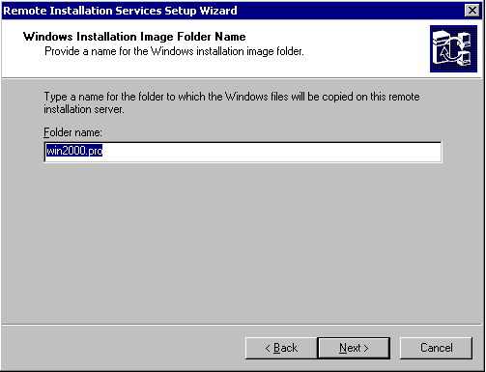
On the following dialog box (shown below), you can type a description describing an available OS that is displayed in the CIW. You can also type customized help desk information at this stage. This information is placed in the [Oschooser] section of the Rstndrd.sif file located in the Templates subdirectory of the image.
When you complete this screen, you are prompted for the distribution media and Risetup.exe creates the directory structure, copies the files, and starts the appropriate services. At this point, RIS server Setup is completed with one image of Windows 2000 Professional that you can silently install with the default settings. You must now authorize the server so that it can begin to service clients.
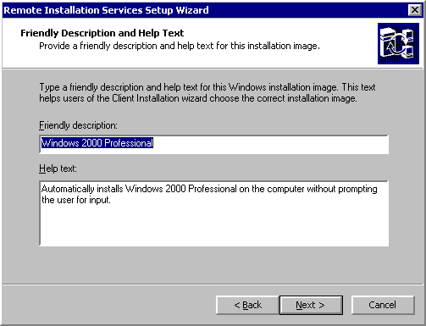

Authorizing RIS Servers
You must authorize each RIS server in the Active Directory tree before RIS can service or respond to client requests. This keeps someone from accidentally bringing up a rogue RIS server on the network that may intercept client requests, especially if all clients are pre-staged to specific RIS servers.
NOTE: This action only applies to the DHCP conversation between the RIS server and the RIS client. If the client is referred to a non-authorized RIS server, the non-authorized RIS server still installs the client.
To authorize a RIS server in Active Directory, use the DHCP Microsoft Management Console (MMC) snap-in on any DHCP server in the same Active Directory and add it as an authorized server. After you add the server, check the application event log on the RIS server. An Event ID is posted from source BINLSVC (the service that RIS uses to communicate with client computers) that the server is authorized in the domain.
NOTE: You are not required to run the DHCP server on these systems to get RIS to service clients. If the server on which you want to install RIS is already running the DHCP service for Windows 2000 with an active scope (for example, the server is handing out client IP addresses), the authorization happens automatically.
If you only want to authorize a RIS server, follow the instructions below.
NOTE: Do not install the DHCP service, if you are only doing so to authorize a server.
If the server is not running the DHCP service, you need to install the Administrative tools so you can gain access to the DHCP MMC snap-in to perform these steps. To install the Administrative tools on a computer running Windows 2000 Server or Windows 2000 Professional, run adminpak.msi from the Windows 2000 Server CD-ROM.
Only members of the Enterprise Administrators group have the necessary rights to authorize RIS servers. If you want to give other users or groups this ability, use the following steps:
- Start Active Directory Sites Manager.
- On the View menu in the MMC console, click Show Services Node.
- Expand the Service key, and then locate the NetServices key.
- Right-click this item, and then click Properties.
- In the Security box, enable the Read, Write, and Create All Child Objects rights for the appropriate user or group.
- Click Advanced.
- In the Access control Settings for NetServices dialog box, click the user or group you just added.
- On the View menu, click Edit.
- In the Apply onto box, click This object and All Child Objects.
NOTE: This permission allows a user or group to authorize DHCP servers in Active Directory.
If you do not want to install the Administrative tools on the computer, use the following steps to load just the DHCP Manager MMC snap-in:
- Expand the Dhcpsnap.dl_ file from the server CD to the Windir\System32 directory.
- Expand the Dhcpmgmt.ms_ file from the server CD to the Windir\System32 directory.
- Run regsvr32 dhcpsnap.dll.
- Run dhcpmgmt.msc.
After you perform these steps, you can run the snap-in and authorize the server in the Directory service if you have the necessary permissions. However, you should install the Administrative tools so that you can gain access to other tools such as the Active Directory Users and Computers MMC snap-in.

Installation of RIS Servers by Non-Administrators
In certain situations, you may want to delegate the installation and administration of the RIS servers to non-administrative personnel. To do this, you must give certain permissions to the user or group installing or administrating these systems. To install a RIS server, a user must be a member of the server’s local Administrator group and must have rights to create the IntelliMirror objects under that particular machine account. One way to do this is to place all of the RIS installation servers in one organization unit (OU). In this model, you can create a group in the domain (for example, RIS-Admin) and give this group Full Control on this container. This way, the RIS-Admin group is able to join the system to the domain using his or her credentials and also have the rights to create the IntelliMirror subobjects.
NOTE: Please make sure that you give the user or group the appropriate rights by applying permissions to This object and all Child Objects. To do this, use the following steps:
- Right-click the OU that contains the servers, and then click Properties.
- On the Security tab, click Add, and then add the appropriate user or group.
- After you make the appropriate additions, click the newly added user or group. In the Permissions box, click to select the Full Control check box, and then click Advanced.
- In the Access Control Settings box, find the user or group you just added. If you click to highlight the user or group, the Permissions box has Full Control and the Apply to column is set to This object Only. This means that the user or group can create the MAO, but does not have the necessary permissions to create the IntelliMirror subobjects when running Risetup.exe.
- To remedy this situation, click View/Edit. In the Apply to box, change the setting from This object Only to This object and all Child objects.
- Click OK to accept all dialog boxes; the permissions are applied.
If you do not want to give the user or group Full Control of the OU and all child objects contained, you can apply specific permissions to allow the user or group to complete the task. For example, you may want to place RIS servers in the OU that they service so that a logical view of your company is represented. The permissions required for a user or group to install and administer a RIS server are listed below.
NOTE: You can apply these permissions on the computer account object (CAO) or the OU that contains all the RIS servers. The example below places the permissions on the CAO but can be changed to apply to the OU. Also, this action does not give the user or group the permissions to create the CAO — this action must be performed by a user with permissions for this OU or you must give the user or group the Create/Delete Computer Objects right.
- Logging on as an administrator of the domain, run the Active Directory Users and Computers snap-in.
- When the snap-in initializes, click Advanced features on the View menu.
- Find the OU that contains the MAO for the RIS server. Right-click the OU, and then click Properties.
- On the Security tab, click to select the appropriate user or group (if the user/group is not displayed, click Add, and add the user/group).
NOTE: You can grant the user or group Full Control permissions on this page, which allows the user or group to complete the task. If you choose to do this, you can stop here. If you only want to give the user or group permissions to add the RIS server, continue on with the next step.
- In the Security dialog box up, click Advanced. In the Access Control Settings for OU_NAME area, click Add, and then click the user or group to which you want to grant permissions.
- When the Permission Entry for OU_NAME box is displayed, add the following permission:
Apply to: This object and All Child Objects
Permissions to allow: List Contents
Read All Properties
Read Permissions
Create Intellimirror Service Objects
Delete Intellimirror Service Objects

- When you are finished, click OK.
- In the Access Control Settings for OU_NAME area, click Add, and then click the same user or group you selected in the previous steps. When the Permission Entry for OU_NAME box is displayed, add the following permission:
Apply to: Intellimirror Service objects
Permissions to allow: Full Control

- When you are finished, click OK.
After you perform these steps, non-administrator users can install and administer the RIS servers in the domain. The method you choose depends on how your organization models its Active Directory structure.

Installing RIS in Multiple Manufacturer Environments (BINL)
Other manufacturers provide support for remote booting/installing client systems using the PXE architecture, so you may need to make configuration changes depending on how your clients are installed and if the servers exist on the same local area network (LAN).
Microsoft RIS servers have a ResponseDelay parameter that defaults to a value of 0 seconds. This value tells the BINL service how many seconds to wait before answering the client. This value is based on how long the client is started. In this situation, you may have to adjust the value of the ResponseDelay parameter, depending on the capability of a non-Microsoft BINL server. When the client initially starts, the client may have items that include a MAC address, a GUID, and an IP address. The PXE client is not aware of the differences between the two servers, so it uses the server that responds first. In this situation, you may want to set the ResponseDelay parameter to a higher number, depending on your configuration.
If you pre-stage your clients, you should check with the manufacturer of the third-party BINL service to see if the manufacturer has a similar value to configure how fast the server responds to clients. If you can set the non-Microsoft BINL server to “Answer only Known Clients” or some other setting with similar functionality, this may be the solution to follow.

Remote Install Directory Structure
When Risetup.exe is run, one of the items it performs is to create the directory structure on the volume that was chosen during the Risetup wizard. Listed below is the directory structure that is created and what information it will contain:

RemoteInstall
Admin
Oschooser
Setup
Tmp

RemoteInstall - This is the root directory of the Remote Install tree structure. This folder is shared out as Reminst and is the listed as the TFTP root. When a PXE client connects and requests files to download in order to boot, this is considered the root folder. No files are stored at this level of the directory structure.

Admin – This folder contains all of the utilities that come with RIS (actual directory structure is admin\i386\….). The following utilities are contained in this folder:
- Riprep.exe – Creates Sysprep like images of Windows 2000 Professional (and any necessary support files such as Imirror.dll and Setupcl.exe).
- Rbfg.exe – Remote Boot Floppy Generator. Utility used to create a boot floppy to use with network cards that do not ship with PXE boot ROMS

Oschooser – This folder contains the files that the PXE client needs to boot and start the Client Installation Wizard (CIW) along with all the CIW screens. This directory, at a minimum, has two subfolders: I386 and %language% where this is set to the language type of the server such as English. First lets take a look at the i386 folder:
I386 – This folder contains the following files:
- Startrom.com – first file the client downloads to begin the boot process
- Ntldr – Executable that starts the CIW (actually %windir%\system32\reminst\oschoice.exe copied over as ntldr).
- Startrom.F12 – Serves same function as Startrom.com but automatically causes F12 to be pressed. Using this file (renaming it to Startrom.com) will cause the PXE client to always boot into the CIW.

%language% - This folder contains all of the screens that are presented to the user during the CIW. If you wanted to customize the CIW screens specific to your organization, you would need to modify the files located in this directory.

Setup – This folder contains the files for your images kept on the RIS server. When the client finishes the CIW and begins to install the OS it is copying files from this directory The complete path is \setup\%language%\Images\%directory_name% where %directory_name% is the name of the directory that contains the image.
Tmp – This folder contains a copy of the template (SIF file) that is being used to install the system. It will be kept in the directory, using the GUID from the client as a filename, until the text mode portion of setup is complete. This is done so that if the client ever has to restart setup, the information used to install the client is still present.

The deployment and placement of RIS servers depends on your network configuration and topology. If you only have a LAN that does not have any routers, you can place the RIS server in almost any location on your network. If your network is more complex with many different subnets and slow links (wide area networks) to other braches or offices, placement of these servers can become crucial in terms of performance and bandwidth usage. You do not want clients installing an OS over slow links because of the increased installation time and decreased performance for other users/services using the wide area network (WAN) link.

Deployment and Placement of RIS Servers
With more complex networks, you may need multiple RIS servers in your organization to service clients and maintain optimal performance. For example, a client in a New York branch office should not perform an installation from a RIS server located in the Atlanta office. In this case, you may want to add a RIS server for each office to service the local clients. However, if the RIS server in New York is currently unavailable and a PXE client is trying to locate a RIS server, the client may get the server in Atlanta if the router is forwarding DHCP requests across the WAN link. In this case, you can either pre-stage all of the clients or change your routers so that they do not forward DHCP requests across the WAN link. However, if your DHCP servers are centralized (all clients receive IP addresses from New York), you may not be able to disable the forwarding of DHCP requests across the WAN because it affects other clients.
You can easily estimate the traffic generated from a RIS server. When clients perform installations, they can generate a fair amount of network traffic because the client has to download about 500 MB of files. When the servers are idle, they generate very small amounts of network traffic.
As the example above shows, the placement of these servers depends on the structure of your organization. You should determine the needs of the clients and the structure of your network before deploying RIS servers.

Router and DHCP Server Configuration Changes
You do not need to make any changes to your existing DHCP servers when you install and use RIS in your company’s environment. RIS works with most DHCP servers, including Microsoft Windows NT® 4.0–based computers and third-party manufacturer solutions. However, depending on your network configuration, you may have to make some changes to your routers.
In the example above, the PXE client is located on subnet 10.0.1.0 and the RIS server is located on 10.0.3.0. For this scenario to work, you must add a helper address to the router that separates the 10.0.1.0 and 10.0.2.0 subnets. Any clients on the 10.0.2.0 subnet also need this IP helper address added to their router, but PXE clients on subnet 10.0.3.0 (local to the RIS server) do not need any changes to the router.
This example shows RIS and DHCP on the same server. This is not a requirement; you can locate DHCP and RIS on separate servers. If the DHCP server is on subnet 10.0.2.0, the routers for both subnets most likely already have IP helper entries for the clients, but you also need to add entries pointing to the RIS server for the server to answer the clients.
Depending on the client load (and if you are using Microsoft DHCP servers), the entries for the routers are already in place. You can upgrade the existing DHCP servers to Windows 2000 and install RIS on these servers, as long as they meet the hardware requirements. This solution is workable only if you do not have a large number of clients to install and you have enough existing DHCP servers to meet the demands of the clients. However, this solution is only recommended in small environments or where you are sure the servers are overloaded. Also, if you enable the “Answer all Clients” feature on the servers, you should not combine DHCP and RIS onto one server. This could cause the server to become overloaded if the PXE client obtains an IP address from that server. The following diagram shows an example of this behavior.
In the example above, the PXE client boots and broadcasts a DHCP Discover packet looking for an IP address and a boot server (BINL). The packet is forwarded to the subnet 10.0.3.0 because the router has an IP helper listed as 10.0.3.20. Because this packet is broadcast, RIS server 10.0.1.2 also responds to the client with its address. The PXE client must have an IP address first, so it discards the packet from the 10.0.1.2 RIS server because it only contains information for the BINL server. In the meantime, RIS server 10.0.3.20 responds with both an IP address and a BINL server. The PXE client accepts this packet and uses the RIS server for the installation. A PXE client is looking for a packet that contains either an IP address or an IP address and a RIS server. After the PXE client has an IP address, it only accepts a packet that contains RIS server information; it does not accept a packet that contains both the IP address and RIS server information.
In this example, the RIS server 10.0.1.2 never services any clients if all servers have the “Answer all Clients” feature enabled. If you started out with DHCP and RIS on the same computer and you add RIS servers that are not combined with DHCP to offset the load, you may want to disable the RIS server on that computer. By doing this, the DHCP server only responds with an IP address and the PXE client sends out another DHCP Discover packet for a RIS server. In the example above, if all clients are pre-staged and assigned to specific RIS servers, the DHCP/RIS server refers that client to the appropriate server.
If you install a large number of clients at one time (or many clients in different phases) you may want to add more RIS servers than DHCP servers because each client downloads 500 MB or more of files. This means that you must configure the RIS servers with static IP addresses and add their address to the IP helper tables of the routers.
NOTE: Static IP addresses are not required, but if an address changes (for example, the DHCP server is unavailable near the RIS server’s renewal time, the address is not available, and so on), you must change your router to point to the new address.
If you do not want to change your routers, you can place a RIS server on each local subnet. If you are servicing a large number of subnets, this action could increase TCO.
The following services are installed on the RIS server after you complete Risetup:

Remote Installation Services
The Boot Information Negotiation Layer (BINL) Service. This service listens for DHCP requests and CIW requests. The BINL service directs the client to the files needed to start the installation process. This service also checks Active Directory to verify your credentials, to see if it should service the client and to create a new CAO or to reset an existing CAO on behalf of the client. The BINL service also performs Plug and Play enumeration of the network card, enumerates all the templates available on the RIS server, and creates the SIF that results from the options you chose using the CIW.
Trivial File Transfer Protocol (TFTP). RIS uses this service to download the files to the client. This includes the CIW and all files needed to start Windows 2000 Setup. For more details about how TFTP is used, refer to the “PXE Overview” section of this white paper.
Single Instance Store (SIS). This is an NTFS filter that acts on the volume on which the RIS images are kept. SIS reduces the storage requirements needed to store these images by combining duplicate files. For more details, refer to the SIS Groveler Service topic below.
SIS Groveler Service. When the system is idle, the Groveler service scans the SIS volume looking for files that are identical. When it detects two or more files that appear to be identical, they are noted and a stronger test is placed on the files to make sure they are identical. After the files are determined to be identical, the files are copied to an area on the volume reserved by SIS and a link is placed in the original location of the files (reparse point) that points to their new location. When the file is requested, NTFS opens the file (reparse point) and is redirected to the SIS store for the file data. If a SIS file is later modified or overwritten, the file reverts back to a standard file.

After you install the RIS server, you can begin client installation. To initiate a client installation, the following conditions must be met:

Client Installation
- PXE-enabled personal computer with a minimum PXE revision of .99c or later, or a personal computer with a remote installation floppy disk compatible network card.
- Computer must be configured BIOS load boot order to have the network card boot before the hard disk. In other words, make sure the system boots the network before booting from the hard disk.
- Active DHCP server on the network so the client can acquire an IP address. It can be a Windows NT 4.0 DHCP server.
- Users must have the right to add CAOs to the container that holds their computer account.
NOTE: On secure networks, you do not need to give this right to users. In this case, you need to pre-stage the computer account for the average user to initiate an installation.
When these conditions are met, the system is powered on. The network boot option is selected, the MAC address of the client is displayed, and the system begins to negotiate for an IP address and locate a boot server. When a server is found, the user is prompted to press F12. The user has 4 seconds to do so before the next item in the boot list is used.
On some systems, you can configure the PXE negotiation so the user must press F12. In this case, the user must press F12 twice — once to activate the PXE negotiation and a second time when the RIS server responds. If your clients all support the F12 capability, you can replace the Startrom.com file in the Oschooser\I386 directory with Startrom.n12 (No F12) to skip the need to press F12 the second time.
After you press F12, TFTP starts and downloads the first file supplied by the RIS server, which is Startrom.com. This action starts the download of CIW (which is renamed NTLDR) from the same location as the Startrom.com file. The first CIW screen (Welcome.osc) is requested by the client and displayed to the user. The logon screen (Login.osc) is displayed next. Screens are transferred as appropriate, depending on the action the user takes.
After the user logs on with a valid domain account, a screen with the following choices is displayed. (You can control the options and the OS images that are displayed on the screen using Group Policy.)
- Automatic Setup: Sets up the client with the default unattended settings only, prompting users for the image they want to use for installation. You can customize the Setup Information File (SIF) used to automate Setup to fit your organization’s needs. This automatically generates a computer name and uses the administrator’s selected OU for the computer account. If an account already exists in the Active Directory forest, Setup reuses this CAO.
NOTE: If a duplicate GUID is detected in Active Directory when you select Automatic Setup, an error message is displayed. Setup does not continue until you remove the duplicate GUID.
- Custom Setup: Allows users to type a computer name and to specify an OU in which to place the newly created computer account object. If these fields are left blank, the default settings from the RIS server are used (just like automatic Setup).
NOTE: If the name and location typed in the custom screen match the name and location of an existing CAO, and the GUID of this client matches the GUID of the existing CAO, the existing CAO is reused. If only one of the fields among the GUID, name, and location match, a “duplicate name” or “duplicate GUID” error message is displayed.
- Restart a previous Setup attempt: If the computer problems occur before GUI mode Setup is reached (for example, a power outage occurs, network connectivity is lost, and so on) you can restart Setup using this option so that the user does not have to continue through all of the screens again.
After Setup is started, the answer file that is used to start Setup is placed in a directory on the volume that contains the remote installation images (the directory is the Tmp directory in the Remote Install tree). The file name is the name of the GUID of the system performing the installation (or the MAC address prepended by 24 zeros in the case of a client that is started with the PXE boot disk) followed by a .sif file extension.
- Maintenance and Troubleshooting: Provides access to diagnostics and maintenance tools created by third-party manufacturers. This offers items such as system BIOS updates and possible remote control software.
A list of OS images from which you can select is displayed. If only one OS image is displayed, that image is automatically selected and Setup continues. Next, a message is displayed, warning you that the local hard disk will be formatted and all data on the hard disk will be lost, unless the SIF that supports the OS selection you made contains the entry to not repartition the hard disk. (The entry that controls this functionality in the SIF file is Repartition = Yes|No. If you set the value to No, the disk is not reformatted and the warning screen does not appear.) When you press ENTER to continue, the following information is displayed on the last screen:
- The CAO that is created
- The GUID
- The server name that is supporting this computer (RIS server from which the image is being copied)
If you are only pre-staging the computer for users, you can turn off the computer at this point. Using this method, you only have to take the computer out of the box, start it to create the CAO (the CAO is created in a reset state), and then deliver the personal computer to the user. This helps prevent mistyping of the GUID for the CAO. The RIS server detects that the GUID is associated with that particular CAO name and uses the information in the CAO to complete the installation.

Risetup.exe

RIS Components
Risetup.exe configures the RIS server after you choose Risetup.exe from the Optional Components screen in the Add/Remove Programs tool or during Windows 2000 installation. To summarize, running Risetup does the following things:
- Locates a suitable NTFS volume (NTFS required).
- Prompts you for image properties such as directory name, description, help text, and so on.
- Creates the RIS directory structure.
- Copies over the files required for a Windows 2000 Professional installation.
- Copies the default CIW screens.
- Configures the RIS services.
- Starts all of the services required for RIS (BINL, SIS, and TFTP).
NOTE: You can only use Risetup to add CD-ROM–based images to the computer. To add Riprep-based images, you must run Riprep.exe from the configured client.
Risetup supports the following command-line switches:
- –check. Runs only the server portion of Risetup. This resolves most problems related to a broken RIS server.
- –add. Installs a new CD-ROM–based image of Windows 2000 Professional on the server.
You can configure both of these items from the Configure Your Server dialog box, but are just listed here as an alternate method. The first time you run Risetup on a server, you must run it without any command-line switches.
When you run Risetup for the first time and it first starts, the Setup program prompts you to type a suitable volume for running or storing the image. This volume must not contain system or boot files (for example, contains the Windir directory or the Boot.ini.file), and must be formatted with the NTFS file system. The volumes should be at least 2 GB in size. Depending on how many images your RIS server holds, you may be able to get by with less space.
After a suitable volume is typed, the directory structure is created. The directory’s structure is shown in the following diagram.
Description of the folders in the example above:
- Admin folder: Contains Remote Boot Floppy Generator (Rbfg.exe), Riprep.exe, and other files needed for client image support.
- Oschooser folder: Contains the CIW screens.
- Setup folder: Contains the images of the OS (CD-ROM–based and Riprep-based images).
- Tmp folder: Holds the generated .sif files of installations that are currently being performed by client computers
After Risetup is finished, then all files are copied, the BINL and TFTP services are started, and SIS is enabled on the RIS volume.

Client Installation Wizard (Oschooser)
The CIW is what you first see after successfully connecting to the RIS server. The CIW is composed of the CIW screens and a program called Oschooser that displays the screens. The CIW screens guide you to the point that which Windows 2000 installation begins. This includes customization of the installation and access to troubleshooting and maintenance tools. You can customize (as well as control, using a Group Policy on the domain) what is displayed on the screens.
When you install RIS and run Risetup.exe, a default set of the CIW screens is installed in the Drive\RemoteInstall\Oschooser\Language directory. These are simple text files with an *.osc extension, and are in the Oschooser Markup Language (OSCML) format. The CIW screens that are included in Windows 2000 are outlined in the following diagram.
NOTE: The following flowchart, spanning three pages, shows the paths, assuming the Group Policy of the domain does not restrict the user’s choices. By default, only Automatic Setup is displayed. For information about changing or setting Group Policy, please refer to the Microsoft Windows 2000 Resource Kit.
As previously discussed, these are the default CIW screens included with Windows 2000, which you can customize to fit your organization’s needs. For example, if a user receives a logon error message, you can edit the Login.osc file to display additional help text, such as the following example:
For more information about customizing the CIW screens, please see Appendix B.
It is important to note that .osc files must contain text that is in the Original Equipment Manufacturer (OEM) character set. Because you do not have access to the keyboard display or other drivers at this point, all items you add to the CIW screens must follow this restriction. OSCML is modeled after HTML 2.0. It supports most of the form tags in HTML 2.0, along with a few additional tags. Notable missing tags in OSCML are the anchor switches tags <A> and </A>, and the image tag <IMG>. Because only text is allowed, these tags are unsupported and are not parsed. Because OSCML is closely related to HTML, you can preview OSCML in an HTML browser.
The .osc files are located in the Drive\RemoteInstall\Oschooser\Language directory. The Oschooser portion of the RIS services tree contains the Startrom.com bootstrap file (the file that presents the “press F12” prompt), the Oschooser program, and the CIW .osc files. In this directory, there is a subdirectory for each language the server supports (for example, Oschooser\English). All of the language-specific files that the CIW uses are contained in this directory, except for the Welcome.osc and Multiling.osc files. The Welcome.osc file is the first screen every client sees regardless of the default language of the server. The Welcome.osc file must be located in the Oschooser\Welcome.osc directory. To support multiple languages on a single server, you should modify the Welcome.osc file. The Multiling.osc file included in the default installation is an example of how to customize this Welcome.osc file. You can modify the first screen to display the supported languages so that when the client connects, the user can select the appropriate language. If only one language option exists, this screen is not displayed.

RIS Administration
Because administering RIS clients and servers requires the manipulation of CAOs, the RIS administration tools are integrated into the Active Directory Users and Computer MMC snap-in. This allows you to reset and create CAOs, browse Active Directory, search for computer accounts (by name, GUID, and dedicated servers), and configure the server, all from within the tool you use to manage your domain.
NOTE: If you administer these servers from a computer running Windows 2000 Professional, you must install the Administrative tools package using the optional administration tools (Adminpak.msi).
The following example shows how to gain access to these screens using the Active Directory Users and Computers MMC snap-in.

In this example, you right-clicked the RIS server (which also happens to be the domain controller for this domain), and then clicked Properties to display the server’s properties. In addition to the typical CAO settings, the Remote Install property page is represented by the Remote Install tab shown in the following figure.
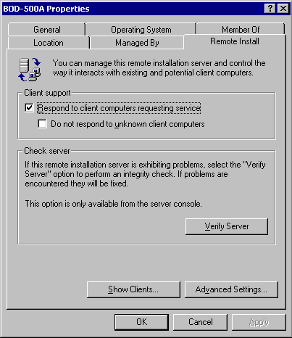
In the dialog box above, you can check to see if the server is set to answer clients. In the example above, you can see that this server is set to answer all clients on the network. Having access to this feature allows you to quickly prevent broken RIS servers from answering clients. If you click Show Clients, you can search for clients that are pre-staged to a particular server. The Verify Server button is active only when using the snap-in on the server itself. If you click Verify Server, RISetup starts with the –check command-line switch. If you click Advanced Settings, you can view the property sheet that determines the setup behavior of the clients.
From this advanced properties dialog box, you can perform tasks such as:
- Setting the default behavior of new clients.
- Adding or removing images from the RIS server.
- Removing or checking the properties of third-party independent software vendor (ISV) tools.
The New Clients dialog box of the advanced settings properties allows you to control what name the client is assigned when a user chooses Automatic Setup, and where the CAO is created in Active Directory. The default naming format is the user name of the account typed in the CIW, followed by an incremental number. For example, if Someone@Microsoft.com logged on and selected Automatic Setup, the resulting computer account in Active Directory is Someone1. You can customize this process using variations provided by the BINL service and Active Directory:
Name | Description
%first | User’s first name
%last | User’s last name
%Username (Default) | User’s logon name
%MAC | MAC address of the network card
%# | Incremental number
%nField | n characters of indicated field
For example, if you type a custom name the following format (where Username = Someone):
%5Username%3#
The results could yield the following name:
Someo123
The “123” is determined by scanning Active Directory for existing CA0s. The search uses the first available “Someo” account. In this case, it had to go up to 123 to find an opening (which resulted in Someo123). By changing the %3# parameter, you can restrict or broaden the search from 0–9 to 0–999999999 (not a good practice). The default is 2 if no number is given.
You can also use this screen to control what OU the CAOs are created in. RIS defaults to the default account creation location as set in Active Directory. This is normally the Computers container.
The next part of the advanced setting properties is the Images dialog box. This dialog box displays all of the remote installation images on the RIS server. When you view this dialog box, you are actually seeing the unattended Setup answer files (SIFs) that are available, not the actual number of images on the computer. You can have multiple SIF templates associated with one CD-ROM–based or Riprep-based installation image. For example, you could install one CD-ROM–based installation of Windows 2000 Professional on this RIS server, and create multiple unattended answer files to fit the specific needs of each organization within your company. To add additional SIFs to an image, click the Add button at the bottom of the page. This action displays another dialog box that contains the following options:
- Associate a new answer file to an existing image.
- Add a new installation image.
NOTE: This version of RIS does not contain any replication features, so none of the servers know about the others. For example, RIS server A does not know what images RIS server B has on its share. To replicate images to other servers, use one RIS server to add or create the image, and then use an automated script (for example, a batch file) or the File Replication service (FRS) used by Distributed file system (Dfs) to copy the images to the other servers. This assures that all images are created in one location and are the same throughout the organization. You should copy the Templates directory of an image last, to ensure that an image being copied does not show up in the CIW until the supporting files have already been copied. For information about using and configuring FRS and Dfs, please see the Microsoft Windows 2000 Resource Kit.
The Tools screen shows you what ISV tools are installed on the RIS server and any properties that the manufacturer has supplied.
NOTE: If you remove any OS or tool using this RIS administration interface, only the associated template (*.sif file) is removed. You must use Windows Explorer to remove the files and directories.
When you want to create a high-security environment or if you want to manually balance the load between multiple RIS servers (thereby losing server availability), the client computers can become known clients in Active Directory so that they are pre-staged. A pre-staged client is a client whose CAO is already created in the Active Directory for a forest. Note the setting on the Remote Install property page of the RIS server (shown in the following diagram).

Pre-staging Client Computers
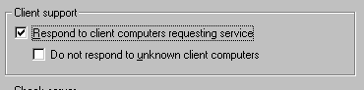
If all clients are pre-staged and you want to make your network more secure, you may want to click to select the Do not respond to unknown client computers check box. This keeps the RIS servers from answering or installing clients that are not pre-staged. In situations where multiple manufacturer PXE solutions are integrated into the network, enabling this option keeps the RIS server from answering clients that you do not want remotely installed using the Microsoft RIS solution.
To pre-stage a client, you can use the Active Directory Users and Computers snap-in (click Start, point to Programs, and then click Administrative Tools). The following screen shots detail this procedure.
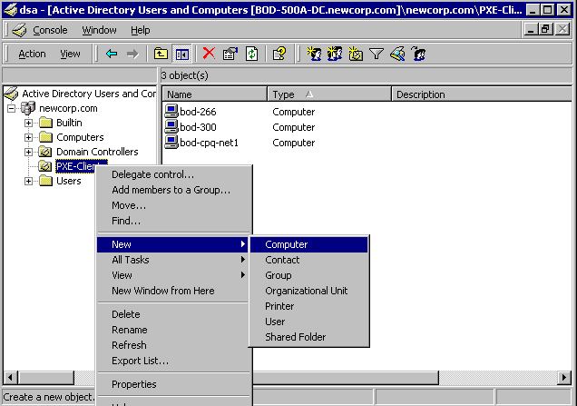
When you choose the option to create a new computer, the following dialog box is displayed, and you can type the name of the computer.
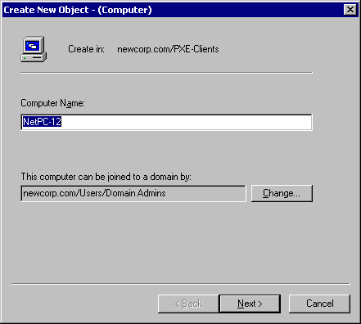

In following dialog box, you must type the GUID of the computer (if RIS is not installed, this dialog box is not displayed).
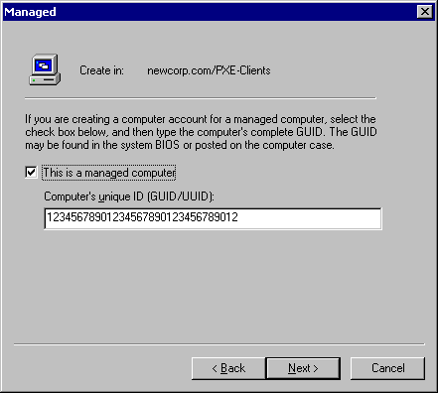
You only see this dialog box on a RIS server or a server that has the optional Administration tools installed. In this dialog box, you must type the GUID of the client. This GUID is unique for each client, much like a MAC address on a network card. This ID is stored with the CAO that is created when you pre-stage the client.
NOTE: Instead of typing the GUID using the user interface, you can put a RIS server in a pre-staging area, where all computers are sent before you send them to users. You can boot these clients to this RIS server that has the “Answer all Clients” option enabled, and when you reach the Summary screen in the CIW, you can shut down the computer and deliver it to the user.
When the client boots up, it broadcasts its GUID across the wire, attempting to contact a RIS server. The RIS server looks at the ID and checks to see if this GUID exists in Active Directory. It also checks to see if any particular RIS server owns the GUID. The RIS server does this by querying Active Directory. If this server is specified (or no server is specified), and the server is configured to answer client requests, the server sends the client its startup information. If the client is unknown or the server is not configured to answer client requests, the server ignores the request. However, if a server in this configuration has the “Answer all Clients” option enabled and receives the request before the RIS server that owns the system account, it refers the client to the correct RIS server. If a RIS server is not specified, the server services the client. In any case, the GUID is still used by the RIS servers to see if the client already exists in Active Directory and the existing CAO is reused if you choose Automatic Setup in the CIW.
In the following dialog box, you can specify the particular RIS server you want to support the client.
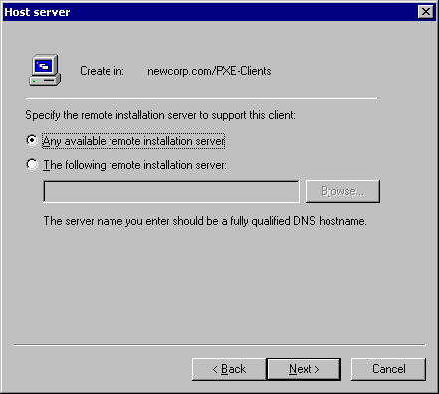
This dialog box is only displayed for managed computers (if the This is a managed computer check box is selected on the previous page). You can specify that the RIS server support or “own” the client. This is useful when you want to manually balance the load of all your RIS servers on the network so that one server does not receive all the requests. A drawback of this model is that if the server is offline or unavailable, the client is unable to install or obtain files needed for components added after Setup until the server is back online. The reason for this is that when the client is installed, this server is noted as the source path for any files that the client needs because most NetPCs do not have a CD-ROM drive and/or the user does not have access to the source media (except across the network).
The following screen shows a summary of the information you typed.
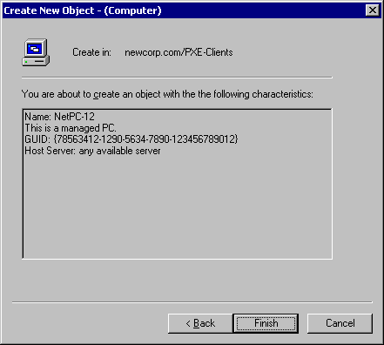
The GUID typed in the previous dialog box and the one noted in the diagram above do not look the same. The GUID that was typed is in the following format
12345678901234567890123456789012
which you would expect to equate to the following format:
{12345678-9012-3456-7890-123456789012}
Upon closer inspection you may notice that the number displayed on the Summary screen only has its first 16 bytes reversed. The remaining 16 bytes are in the correct order. The information that was typed (12345678901234567890123456789012) is known as “wire” format (how it is sent across the network). When the GUID is displayed, it is converted into a “pretty print” format, which results in the following format:
{78563412-1290-5634-7890-123456789012}
You can type the GUID in either format. It is converted and saved in wire format to the CAO for quick lookup and comparison. The user interface always displays the GUID in pretty print format.

Permissions Clients Need to Install Computers
Users log on using their domain credentials, so you need to either make sure they have the permissions necessary to create new CAOs or reset the one that you created for them (or someone with their privileges must log on or reset the CAO). If you do not want to give all users the permissions required, you can create a domain account that has only the following permissions:
- Clients Can Create Their Own Machine Accounts (Non-Pre-Staged)
- Clients Can Install Their Pre-Staged Systems

Clients Can Create Their Own Machine Accounts (Non-Pre-Staged)
This option allows users to start their computer, connect to the RIS server, log on with their domain account, and install their own system. To do this, the users need the following rights on the OU that holds the newly created machine accounts:
- Read permissions
- Create Computer Objects

Clients Can Install Their Pre-Staged Systems
The rights noted here do not apply to the container or OU but to the CAO that is created when the client computer is pre-staged. To enable users to install their own system, you must grant the following right to the user on the specific computer object, not the container.
- Change/Reset Password on the Computer Account Object
This allows a user to install his or her system, but only when an administrator resets the account. To perform this action, you must apply the following rights to the specific computer object:
- Read/write all properties on the computer object.
- Reset and change password rights on the computer object.

The Remote Installation Boot Floppy disk allows clients that do not have a PXE-enabled network card to use the RIS server. The boot disk creates a PXE “emulator” that works on supported PCI network cards, allowing clients to connect to the RIS server. Because one disk works for all cards, a specific network boot disk is not required. The supported network cards are listed in the Rbfg.exe tool that creates the boot disk. The Rbfg.exe tool is located in the Rreminst\Admin\I386\Rbfg.exe network directory.

RIS Boot DISK
NOTE: Rbfg.exe disks only support the adapters listed in the Adapters List box. All of the adapters in this list are PCI cards. ISA, ISA Plug and Play, and PCMCIA cards are not supported.
This disk is useful if you need to install systems on laptop computers using RIS. Because PCMCIA is not supported, you can place the computer in a docking station and use an Rbfg.exe generated boot disk to connect to the server, provided the docking station contains a supported PCI network card.
Because all NetPCs include a GUID that is unique, the Rbfg.exe boot disk needs to be able to create a unique GUID. When a PXE client connects to the server, one of the items that is exchanged before you are presented with a logon screen is the GUID of the system. This is a unique 32-bit number that is stored with the CAO that is created in Active Directory. Network cards that do not have a PXE boot disk do not have this number, so they send 32 zeros or 32 Fs (hexadecimal). To generate a GUID, the BINL service uses the MAC address (which is 12 characters long and prepends 24 zeros). This process creates a 32-bit number that is used as the GUID because it is a unique number on that particular network at a particular time. This means that the newly created CAO is actually associated with the network adapter, not the computer. If you move the network card to another computer, RIS detects the new computer as the old computer. You must delete the GUID from the CAO or the old computer. If a user tries to install the new computer with a different name, a “duplicate GUID” warning message is displayed, showing the names of the computers on the network that already have the same GUID. Relationships of GUIDs to CAOs should be one-to-one.

SIS Overview

Single Instance Store (SIS)
SIS combines duplicate files to allow multiple images on the same RIS server to consume less disk space. This is the case for any type of file in the images, whether it is CD-ROM–based or Riprep-based on the volume. This is especially useful when multiple Riprep-based images are stored on a RIS server. These images can consume a large amount of disk space and most of the images are the same exact files (as in OS files). By combining files, only about 10 percent of the files (excluding installed programs) are different from the installed base CD-ROM image. This allows for significant savings in space.
Risetup.exe installs the following two services that are used to perform this process:
- Single Instance Store (SIS)
- Single Instance Storage Groveler (Groveler)
These two services are not necessary for RIS to work properly. Additionally, SIS does not depend on RIS to work properly. SIS can actually operate on any volume without RIS being installed (this option is currently not supported). When you start the Groveler service, it checks each NTFS volume in the computer to see if it contains a SIS Common Store directory and a MaxIndex file. If the Groveler service finds these items, and the SIS filter driver is installed, the Groveler knows to attach itself to these volumes.
When the SIS service is installed, the NTFS file cache performs extra caching. The NTFS file cache contains files that are recently accessed by the server, either for the server’s own use or by the client computer gaining access to file shares. If one of the reparse point files is read, the NTFS file cache will cache the backing SIS GUID file, making further attempts to gain access to the same files faster.
When the Groveler service attaches itself on a volume, it runs at a low priority so it can adjust its processes if the computer becomes busy. If the disk space on the volume drops below a specified value, the Groveler service increases its CPU usage regardless of system activity. A side effect of the Groveler service’s intelligent CPU usage is that the service does not run at full speed (even if the system is idle) during the first several hours after installation. This is because the service attempts to determine how much CPU and I/O bandwidth it can use without causing problems to other system components. If you want the Groveler service to run at maximum capacity, perform the following steps:
- Expand the Grovctrl.ex_ file from the Windows 2000 Server CD-ROM. This file is located in the I386 directory.
- Run the grovctrl f command to set the Groveler service to foreground mode for all drives.
After the Groveler service completes its work in foreground mode, it resumes normal operation where it intelligently uses the CPU cycles.
When scanning the volume, the Groveler service marks files that are deemed to be identical (and 32 KB or larger in size) to one or more files on the volume. The file is then checked in more detail to verify that the content is identical. After the file is verified, it is copied into the SIS Common Store folder, renamed to a unique GUID for the file name, and given a .sis file extension. The identical files on the volume are then changed to a reparse point. When a program attempts to open a file, the file system redirects any file I/O to the GUID file in the SIS Common Store directory.
When you modify or replace a file so that it is not longer unique (for example, you modify an *.inf file, you update the *.dll or *.exe files on one image with a hotfix, and so on), the actual data is written to the location in which that file resides on the volume (not in the SIS Common Store directory) and the reparse point is removed. The other file(s) still contain their reparse point to the Common Store directory even when only one file is left over. The following example outlines this process.
The server contains two images of Windows 2000 Professional, both containing the Driver.sys driver. Currently, the files in both directories are identical to one another, so the data is placed in the common store and files are truncated to reparse points with referrals to the storage location’s Guid.sis file. An image that is deployed to a certain set of systems requires an update to this binary file for the installation to work properly. Copy the file to the F:\..\Image2 directory. For example, the data is written directly to the location of F:\Image2\Driver.sys and the reparse point at that location is overwritten with the new driver image. However, the reparse point for F:\..\Image1\Driver.sys is not removed and still refers to the common store for its data. The following diagram shows the end result.
The reparse point is not removed because it could create system overhead, causing the Groveler service to rescan files to make sure that only one still exists in the common store. After F:\..\Image1\Driver.sys is modified or deleted, the backing file in the SIS Common Store directory is deleted. This is the case for any files in the common store, whether there are two or more duplicates.

How matching files are found by the groveler
Now that we have seen an overview on how SIS works, how does the groveler deem that a file is a duplicate. The groveler does this by comparing signatures from the files to see if they match. The signature on the file is assigned by the groveler, which computes this number using a pre-defined hash function. Even when you have only one image on the server, the groveler is working on those files and assigning each of them a signature. This way, the groveler can operate more efficiently when new files are added to the SIS managed volume. It will assign a signature to the newly written file and then look to see if it is listed in it’s database located in the \sis common store directory.
When files are found that have matching signatures, the groveler performs a byte-for-byte comparison on the files. If they match, it reports these files to the SIS filter driver, which will prepare them to be turned into SIS linked files.

How files are made into SIS links
It is the groveler’s responsibility to determine if files are identical and report them to the SIS filter. Once this has been done, the SIS filter turns them into SIS links.
SIS links are implemented using NTFS reparse points that are handled by the SIS filter driver. Therefore if SIS is ever uinstalled or not started on the system, you will not be able to access files that have been turned into SIS links (if RIS is ever uninstalled from the system, the SIS filter is left on the system). When SIS finds a duplicate file (files that the groveler reports as duplicate) it copies the contents to the \sis common store folder and replaces the files in the directory with SIS links. As far as the user is concerned they do not see a difference when browsing the files on the volume The file is set to sparse so that the full size of the file is represented but not actually used on the volume. Therefore if quotas are in use on the volume they owner will be charged the correct amount of disk space even though it is physically not being used.
The SIS managed volume can have multiple copies of a duplicate file on the NTFS volume that can be seen via the UI, ex: D:\drivers\fileA.txt, D:\Mydata\FileB.txt, D:\Testdata\FileC.txt where the files, fileA.txt, FileB.txt, and FileC.txt are duplicates and point to one file in the \sis common store directory. However, there will be only one copy of the files data on the entire volume (called the backing file). The backing file contains a reference count that points to each file that it represents data for on the volume. In the example above, the backing file has three reference counts (fileA.txt, fileB.txt, and fileC.txt). When any of the files are either deleted or modified so that are no longer duplicate, the SIS filter not only writes the data locally (or removes the link in case of a deletion), and removes the SIS link for that file, it must reduce the reference count. When the reference count is reduced to one, the SIS link is not removed from the remaining file for performance reasons. However, if the remaining file is modified, the SIS link is terminated and the backing file in \sis common store is removed by the SIS filter.

Backing Up and Restoring SIS Volumes
You should consider a few things when backing up and restoring SIS volumes. Because SIS creates reparse points out of files that are identical, your backup program must understand this capability of the file system. The Ntbackup.exe tool that is included with Windows 2000 handles these files properly. If you use a third-party backup solution, please consult the manufacturer.

How backup programs handle SIS linked files
A backup program must understand which files are linked to what file in the \sis common store and store both the link and the common store file on the backup medium. Just like on the volume, there is not a need to backup multiple copies of the same file on the backup medium. Also when restoring the file it needs to be able to do the same but in reverse.
To accomplish this a SISbkup.dll has been provided to assist backup programs backing up or restoring these files. When a file is being backed up and it is an SIS link, Backup identifies it as a reparse point (noted by the reparse tag on the file) and then uses the provided SIS dll to determine what files in the \sis common store directory to backup. The reparse point representing the file (the SIS link) is backed up just as it is represented on the disk (as a reparse point and a sparse file). When a restore is preformed, similar steps as those noted above are used. Backup identifies this as a reparse point and then restores the file just as it was backed up. The SISbkup.dll is then called to determine if any files located in the \sis common store directory need to be restored that correspond to this file.
Note: The backup application must know to call SISbkup.dll when restoring or backing up SIS links in order to function properly (Ntbackup.exe is aware of this dll). However, if the backup application understands reparse points it will be able to backup SIS managed volumes but the backup medium will contain the full amount of the data on the volume. In other words, multiple copies of the same file will be on the backup media.

Backup/Restore of the RIS Volume
When you back up the RIS volume, you can back up the RemoteInstall directory tree and its subdirectories, or start the backup at the root of the volume. Either method works, but if you only back up the RemoteInstall directory or if you connect over the network to the \\Servername\Reminst share, you back up the full amount of the data. As described in the previous section, SIS removes the duplicate files and reduces the storage space required, but when you back up only the RemoteInstall directory tree (or share), the files are extracted and your backup media requires more storage space than what physically resides on the volume. For example, a RIS volume contains four images that at one time required 2 GB of hard disk space. SIS ran on the volume and eventually the space was reduced to 1 GB. Backing up only the RemoteInstall directory tree or just connecting to the \\Servername\Reminst share requires 2 GB of storage to hold the backup.
However, when restoring an SIS managed volume, the SIS (Single Instance Storage) service must be installed and attached to the volume before the restore process begins. If this is not done, the SIS links will not be restored properly and the data associated with them will not be available. Make sure the RIS service is installed and started. If restoring the data to a volume on a different RIS server or it is a new installation, Risetup.exe must have already been run on this system. This will ensure the SIS is running and attached to the volume. If the volume is just being restored on an existing RIS server where the backup was performed (hard disk drive failed and had to be replaced), please do the following:

- Ensure the drive is online and formatted with the NTFS file system.
- Run Risetup –check so that the RIS directory structure will be created on the volume and along with files and directories required for SIS to attach to the volume.
- Once you have verified that the SIS (Single Instance Storage ) service has started, you can begin the restore.

The remote installation template file guides the installation of the client systems. These file(s) reside in the I386\Templates directory for each image on the RIS server. When you install RIS and run Risetup.exe, a standard template in this directory is copied. The template (Ristndrd.sif) performs a hands-off installation and places the CAO in the domain in which the RIS server resides. This file also contains the description that is displayed during the CIW when you select an OS image to install.

RIS Template files
It is also imperative to note that you can have more than one of these files present in the I386\Templates directory. For example, you may want to perform a custom installation for Marketing, Sales, and Accounting that requires different templates (unattended Setup files). The template file lets you use one set of Windows 2000 Professional source files instead of having to create two other images. Simply create copies of the template, make the appropriate changes for each department, change the description in the [Oschooser] section of the template, and then save the files using different names. The only requirement is that the templates end with a .sif extension.
Because the template file is an unattended Setup answer file with a few additional sections, only the additional sections are covered here. For unattended Setup answer file parameters, please refer to your Windows 2000 documentation. The following sections of the template are described in further detail:
- [Data]
- [SetupData]
- [RemoteInstall]
- [Oschooser]

[Data] Section
This is the first section in the template, and Risetup.exe automatically places these values in the file.
- floppyless = "1"
Instructs Setup that this is an over-the-network installation.
- msdosinitiated = "1"
Instructs Setup that it was not initiated using either a CD-ROM boot disk or floppy boot disks.
- OriSrc = "\\Servername\RemInst\Installpath"
Source path for Setup to locate the files during setup and after setup. Most NetPC clients do not have local CD-ROM drives, and this value does not require users to locate an installation source.
- OriTyp = "4"
This value is set to 4 because it is a remote installation. If Setup is initiated from a local CD-ROM, this value is set to 5).
- LocalSourceOnCD = "1"
Instructs Setup that it is a local CD-ROM installation.
These values are set up by the RIS server and should not need modification. In the OriSrc = "\\Servername\RemInst\Installpat" value, the italicized items are OSC variables, which are supplied later when a client actually uses a template. When this happens, the BINL service substitutes the variable in the file with the values retrieved from the server or configured by the server (for example, Servername is the name of that particular RIS server). This allows the templates to work on any RIS server within the organization. Appendix C includes a list of variables that the BINL service and CIW (Oschooser) exchange, but you can add your own variables to be replaced by values passed back to the BINL service using the CIW. This is covered in more detail in a later section.

[SetupData] Section
The [SetupData] section of the template is not specific to RIS and can even be used in an unattended answer file. This section pertains only to text-mode Setup and two values are specified:
- OsLoadOptions = "/noguiboot /fastdetect"
Instructs Setup to boot into text-mode Setup with no graphical user interface (splash screen) and uses fastdetect.
- SetupSourceDevice = "\Device\LanmanRedirector\Servername\RemInst\Installpath"
Source path for text-mode Setup. Note again that the values are filled in by the BINL service.

[RemoteInstall] Section
The [RemoteInstall] section can contain the Repartition value, which can be set to either Yes or No. If you set the value to Yes, Setup deletes any existing partitions on the physical drive, creates a new drive the same size as the physical drive, and formats it as NTFS. You can also place this value in the [Unattended] section of an answer file. If you set this value to No, text-mode Setup stops and prompts you to select the partition on which to perform the installation. After you select the partition, Setup continues in unattended fashion. The warning message in the CIW is also bypassed if you set the value to No.
The [RemoteInstall] section can also contain the UseWholeDisk value, which you can set to Yes or No. For Riprep-based images, this instructs Setup to repartition the disk to consume the entire physical disk or to repartition the disk to the size of the original image. The default setting is Yes, which instructs Setup to use the entire disk.

[Oschooser] Section
The [Oschooser] section contains some values that are displayed when you select an OS. When you run Risetup.exe for the first time or place a new image on the server, the name and friendly description for which you are prompted are placed in this section of the file.
- Description ="Windows 2000 Professional - Windows2000.com domain"
This is the name a user sees when selecting an OS image, and is visible in the Administration tools.
- Help ="Automatically installs Windows 2000 Professional on the computer without prompting the user for input."
Description that is displayed during the CIW.
- LaunchFile = "Installpath\Machinetype\Templates\Startrom.com"
Instructs the client to download and run this file. This is not a Win32® API executable file. It must be a boot image file such as the Startrom.com file or an ISV-provided PXE tool.
- ImageType = “Flat”
Indicates type of image. You should not change this value because CD-ROM–based SIFs and Riprep-based SIFs are not interchangeable.
- Version="NT 5.0"
Version information for administration purposes. This information is only displayed in the administration user interface.
NOTE: You should leave most items in this section set to their default values except for Description and Help. You can change these values so that they reflect the correct procedures for your organization. You should not modify the other values.
You can store CD-ROM–based and Riprep-based images on the server when using RIS. In this release, RIS only supports the images of Windows 2000 Professional. Downlevel operating systems (Microsoft® Windows® 95/98 or Windows NT® 4.0) are not supported.

Image Types

CD-ROM-Based Images
CD-ROM–based images are almost identical to creating a distribution share on a server so that users can perform installations over the network. When you first run Risetup.exe, the wizard creates a CD-ROM–based image for you automatically. To add a new CD-ROM–based image, you can log on as an administrator and click the Add button on the Images page of the Advanced Settings property sheet, or re-run Risetup.exe and select the option to add a new image.
The following diagram shows the standard directory structure of a CD-ROM–based image that Risetup.exe creates.

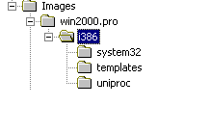
In this example, Win2000.pro is the directory name that is typed during Risetup. This example shows the standard directories that are created. You can add directories (for example, the $Oem$ directory) so that you can copy over additional files and use the Cmdlines.txt file.

Riprep-Based Images
Riprep-based images generally take up more room than CD-ROM–based images because they are a complicated xcopy of the client system’s hard disk stored on the server (which contains the OS as well as preinstalled programs and tools). To store a Riprep-based image on a server, there must be at least one CD-ROM–based image also stored on the same RIS server. This is because the template (.sif) file refers the client to the RIS server to detect and load files for the client’s network card, as well as use the CD-ROM–based drivers to start text-mode Setup, which then performs an xcopy of the client image to the installing client’s hard disk.
To create an image on the server, connect to the RIS server on which you want to store the image. Connect to the Server\Reminst\Admin\I386 share and then run Riprep.exe. This starts a wizard that performs the following tasks:
- Checks for any open files. If files are open, you are prompted to close them and restart Riprep.exe.
- Checks for any known or unknown services that may write to the disk. If either type of service is running, you are prompted to shut down the service.
- Prompts you for the name of the RIS server on which you want to store the image. If you run Riprep.exe from a command line similar to the following example:
\\Server\Reminst\Admin\I386\Riprep
NOTE: The Server variable defaults to the server on which Riprep is run.
- Prompts you for the subdirectory name in which to create the image.
- Prompts you for Description and Help text that you want displayed.
- Creates a default Riprep.sif file using the System Preparation tool unattended parameters.
After all questions are answered, Riprep begins to copy the files to the server. After this process is finished, the computer shuts down. If you restart the client, a wizard runs just as if you used the System Preparation tool (Sysprep.exe).
After the image is copied to the server, the following directory structure exists.
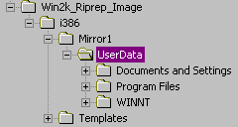
The important files to make note of are Riprep.log, Bootcode.dat, and Imirror.dat. These files contain information about the Riprep-based image and are explained below:
- Riprep.log: This file contains log information while you run Riprep.exe. Any errors that occur (for example, you encounter encrypted files or receive a “files in use” error message) are noted in this log along with other information such as the server name, description, and so on. This file is located in the I386 directory.
- Bootcode.dat: This file contains the boot sector for the computer. This is one of the reasons why the target computers require a drive of the same size or larger to install. This file is located in the I386\Mirror1 directory.
- Imirror.dat: This file contains information about the computer you cloned using Riprep. This file is not readable unless it is dumped out in hexadecimal. It contains information such as the drive letter, installation directory, hardware abstraction layer (HAL) type, ARC path, and so on.

Riprep Rules and Restrictions
Riprep.exe is more flexible than Sysprep.exe because it starts over the network in text-mode Setup. This allows for a greater variation of hardware platforms, such as differing mass-storage disk controllers. The only item that must be the same on all client systems when you use Riprep.exe is the HAL.
NOTE: By default, Riprep-based images do not perform Plug and Play enumeration. If you want Plug and Play enumeration to occur, you must use the –pnp command-line switch when you create your image (for example, type the following command: riprep –pnp). After you run this command, Plug and Play enumeration always occurs. If you want to turn off Plug and Play enumeration, you must re-create the image.
To take advantage of Riprep’s added functionality, be sure to use the following guidelines:
- The client you want to image (run Riprep.exe against) can have only one partition. If the client contains more than one partition, a warning message is displayed and only the system partition (with the Winnt folder) is copied. If your boot partition and system partition are different, the image is unbootable.
- A CD-ROM–based image must reside on the server.
- The system must be running only Windows 2000 Professional.
- The hard disk on the target computer must be at least the same size as or larger than the master computer.
- The target computer must also have the same HAL (Advanced Configuration and Power Interface (ACPI) versus non-ACPI).

RIS comes with a default set of CIW screens. These screens provide basic functionality for installing clients, and you can modify them to fit your organization’s needs. These files are simple text files (with a .osc extension) that are in the OSCML format. The default CIW screens included with a default Installation of Windows 2000 RIS are located on the RIS server in the Drive\RemoteInstall\OSChooser\Language directory.

Customizing Client Installation Wizard (CIW) screens
As noted earlier, the CIW screens (sometimes referred to as OSC screens) are modeled after the HTML 2.0 format. For a complete list of supported tags, please see Appendix B.
NOTE: The CIW screens are only modeled after HTML 2.0, they are not a subset of the HTML 2.0 specification.
In the following example, two items are covered: customizing and adding screens to the CIW, and adding variables to the template files that are passed to the BINL service through the CIW screens.
Microsoft.com has decided to change its CIW screens so that the following occurs:
- Users see a welcome screen (standard/required).
- Users log on (standard/required screen).
- Users see the following choices:
1. Install Windows 2000.
2. Restart an unsuccessful Setup.
3. Tools menu.
NOTE: Depending on the Group Policy of the domain, items 2 and 3 may be hidden.
- User selects an image to install. (Depending on the credentials of the user, only certain images can be selected.)
- User types a password for the local Administrator account.
- User specifies the display settings for his/her computer. (Default is 800x600.)
- User receives a warning message about the hard disk being formatted (standard screen).
- Summary screen is displayed and the installation begins (standard screen).
Microsoft.com must modify one screen (Choice.osc) and create two new screens. Some of the current screens will be modified (such as Logon.osc and others) so the company name and help desk number is displayed to users. The following default screens are displayed during client logon and installation of the OS:
- Welcome.osc: Welcome screen displayed to the user.
- Logon.osc: Requires a user to log on.
- Choice.osc: Displays the following choices to the user: Automatic Setup, Custom Setup, Tools menu, and Restart an unsuccessful Setup attempt.
- Osauto.osc: If you choose the Install Windows 2000 option, this screen is called. The next screen, Checkguid.osc, is also called (the user does not see this screen).
- Checkguid.osc: Checks for a duplicate GUID in Active Directory.
- Oschoice.osc: This screen is displayed only if Checkguid.osc does not find a duplicate GUID.
- Dupauto.osc: This screen is displayed if a matching GUID is found.
- Warning.osc: Warning message informing you that the hard disk is being formatted.
- Install.osc. Displays a summary screen to the user.
NOTE: The user does not see the Checkguid.osc and Dupauto.osc screens.
In the example above, the user logs on successfully and chose Automatic Setup.
If the user selected Custom Setup, the same pattern is followed except that the Custom.osc file is used instead of the Osauto.osc file. The Custom.osc file prompts you to type your computer name and the OU in which you want to create the computer account. At this point, similar screens are called. There are more screens in the Oschooser subdirectory than what are listed above, but they are used for error messages (for example, 00004e28.osc, which is a logon error that is displayed if an incorrect user account or password is typed).
In this example, you must create two new screens to query the user for the local Administrator password and the display settings. These files are named Password.osc and Display.osc. You also need to modify the Choice.osc screen to remove the Custom Setup option, and change the Automatic Setup option to default to “Install Windows 2000.”
Before you edit any default *.osc screen, be sure to make a copy of the original file using a *.bak extension.
Using a text editor such as Notepad, open the Choice.osc file. The following diagram shows the default settings.
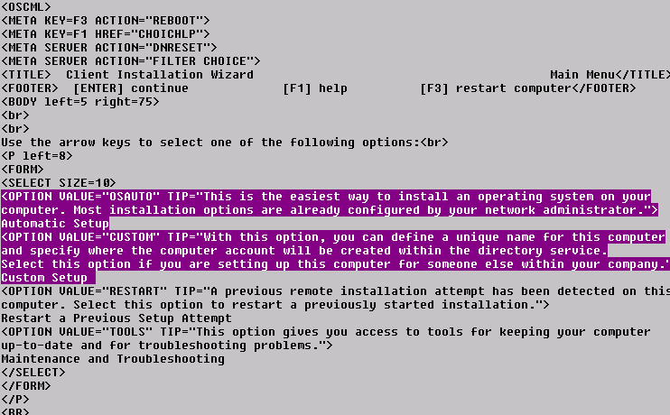
You need to change the <OPTION VALUE=”OSAUTO”> so that it jumps to the correct screen, which is Oschice.osc. This lets you select the image before the user is prompted to input any information. You need to change the description and the display item “Automatic Setup,” to Install Windows 2000. You should remove the line containing the custom choice.
After you make the changes, the file should look like the example in the following diagram.
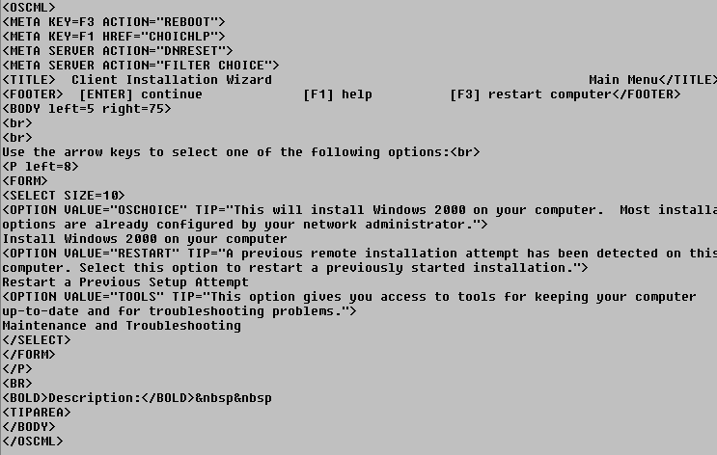
The following example shows what is displayed to the client during the CIW.
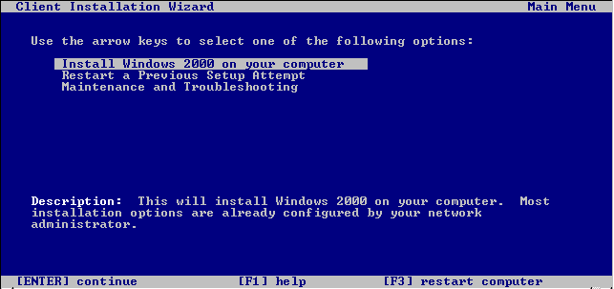
If the user selects the Install Windows 2000 on your computer option, the next screen that is displayed is a list of the OS images stored on the server. Because the Oschoice.osc file only enumerates the Template subdirectory for SIF files to display each OS, that screen does not need to be modified except the <FORM ACTION => line, which you need to change to jump to the password screen (Password.osc). After you complete these changes, the line should read as follows:
<FORM ACTION="PASSWORD">
The following diagram shows the first new screen. This screen is displayed as it appears to the user during the CIW. From here, you can add a screen that prompts the user to type the local Administrator password. To save time, you can use a pre-existing screen, modify it, and then save it with a different name. A prompt is displayed only for the local Administrator password, with the password rules listed below.
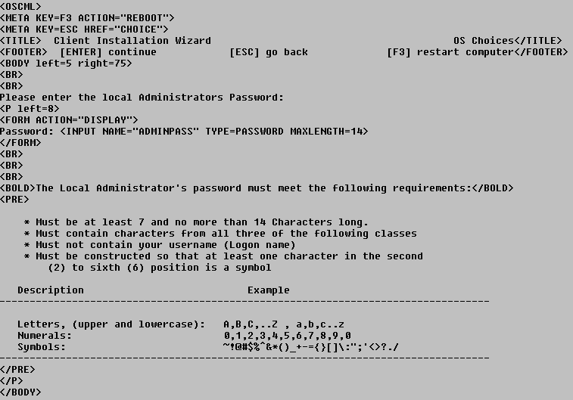
The following diagram shows how the new screen is displayed.
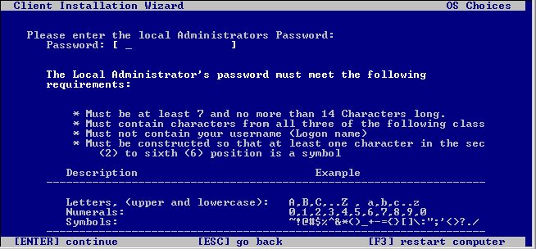
As the screen text at the top of the page shows, you can force some rules on the password field with the following line:
Password: <INPUT NAME="ADMINPASS" TYPE=PASSWORD MAXLENGTH=14>
The value type is “password” so that it is not displayed as clear text on the screen. The maximum length is 14 characters, and the variable name that is passed to the BINL service is “AdminPass.” Although you can specify a few parameters, you cannot control or enforce the user’s input, nor can you make decisions during the CIW (for example, IF, THEN, or ELSE statements). Even though OSCML is based on HTML, it does not have support for VBScript, Jscript®, or Java.
After you finish making changes to the screen, you can create the following Display.osc screen.
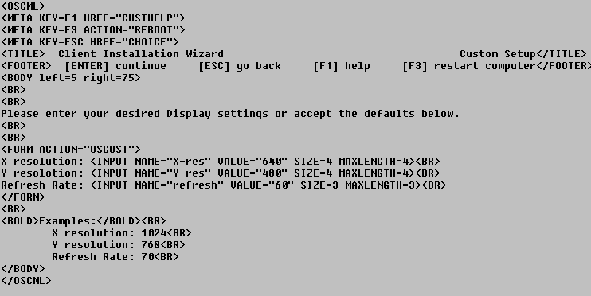
The following diagram shows how the Display.osc screen is displayed in Oschooser.
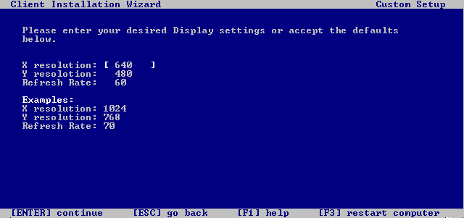
On this screen, you can customize the display settings you want to have on your computer. In addition to the values that you can type on this screen, you can also provide the user with default values. If you simply press ENTER at this screen, the computer is set up using 640x480 video settings.
From this point on, the normal screens take over and users’ customized CIW screens are displayed. During the CIW screens, the following new variables are sent to the BINL service:
- AdminPass = Local administrator password
- X-Res = X resolution of the display
- Y-Res = Y resolution of the display
- Refresh = Refresh rate
After the variables are sent, you must modify the templates located in the Templates subdirectory of each image on the RIS server. Variables in the *.sif file are identified by the percent sign (%) around the variable name. For example, the AdminPass variable above is referred to as %AdminPass%. The modified sections of the template look like the following diagram.
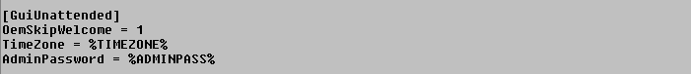
The changes you made to the [Display] section look similar to the following example.
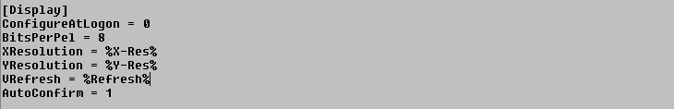
You can create a screen for any item that you can specify in an unattended Setup answer file, and pass it to the BINL service to place in the template. This automates Setup without creating a template for each scenario. For a complete list of variables that are used internally by the BINL service and Oschooser, please see Appendix C.

Adding Debug Information to BINL

Appendix A
When you troubleshoot RIS servers, you may need to view debug information from the BINL service. You can enable a RIS server to run in debug mode and configure it to log debug information out to a text file. This is useful when you troubleshoot client/server issues (such as pre-staged systems not connecting to the RIS server, or clients not receiving information sent to or from the RIS server). To enable debug mode for the BINL service, use the following instructions.
You can enable one of the following debug modes:
- Normal Debug Mode: This mode logs output to a file.
- Full Debug Mode: Displays output using NTSD or Kernel Debugger.
NOTE: You must manually edit the registry to use either of these debug modes.

Configuring RIS for Normal Debug Mode
WARNING: Using Registry Editor incorrectly can cause serious problems that may require you to reinstall your operating system. Microsoft cannot guarantee that problems resulting from the incorrect use of Registry Editor can be solved. Use Registry Editor at your own risk.
For information about how to edit the registry, view the "Changing Keys and Values" Help topic in Registry Editor (Regedit.exe) or the "Add and Delete Information in the Registry" and "Edit Registry Data" Help topics in Regedt32.exe. Note that you should back up the registry before you edit it. If you are running Windows NT, you should also update your Emergency Repair Disk (ERD).
Normal Debug mode enables the BINL service to log information to a %SystemRoot%\Debug\Binlsvc.log file. To enable Normal Debug mode:
- Using the Computer Management snap-in, expand Services and Applications, and then click Services. Locate and stop the BINL service.
NOTE: You can also stop the service by typing the following command at a command prompt:
net stop binlsvc
- After the BINL service is stopped, start Registry Editor (Regedt32.exe) and locate the following registry key:
HKEY_LOCAL_MACHINE\System\CurrentControlSet\Services\Binlsvc\Parameters
- On the Edit menu, click Add Value, and then add the following registry value:
Value Name: Debug
Data Type: REG_DWORD
Value: 0x80FFFFFF
- Quit Registry Editor, and then start the BINL service using the Computer Management snap-in or by typing the following command at a command prompt:
net start binlsvc
The BINL service now logs debug information to a file. You can view the output in the %SystemRoot%\Debug\Binlsvc.log file to assist in troubleshooting. Depending on the problem, you can also boot a client at this time to view BINL output of the client information.
NOTE: The output log file does not have standard control characters. If you use a text viewer such as Notepad.exe, the file may be difficult to read. You may want to stop the BINL service again and view the file using Write.exe.

Configuring RIS for Full Debug Mode
Full Debug mode sends information out an NTSD window on the console. If you add switches to the NTSD command line, you can send the output to a kernel debugger. You can use the steps outlined below to send the NTSD information out to a command window. You can use Normal Debug mode to solve most problems, but when you want more debug information, use the following steps:
- Using the Computer Management snap-in, expand Services and Applications, and then click Services. Locate and stop the BINL service. You can also stop the service by typing the following command at a command prompt:
net stop binlsvc
- After the BINL service is stopped, start Registry Editor (Regedt32.exe) and locate the following registry key:
HKEY_LOCAL_MACHINE\System\CurrentControlSet\Services\Binlsvc\Parameters
- On the Edit menu, click Add Value, and then add the following registry value:
Value Name: Debug
Data Type: Reg_dword
Value: 0x00FFFFFF
- Locate the following registry key:
HKEY_LOCAL_MACHINE\System\CurrentControlSet\Services\Binlsvc
- Change the %SystemRoot%\System32\tcpsvcs.exe value for the ImagePath entry to the following:
ntsd -g -G %SystemRoot%\System32\tcpsvcs.exe
- Verify that the new registry entries appear correctly, and then quit Registry Editor.
- Using the Computer Management snap-in, expand Services and Applications, click Services, and then double-click the BINL service.
- On the Logon tab, click to select the Allow Service to interact with desktop check box.
- Start the BINL service using the Computer Management snap-in or by typing the following command at a command prompt:
net start binlsvc
After the BINL service starts, a command window opens (this is where the BINL service sends its debug information). From here you can attempt to reproduce the problem and look for errors.

Troubleshooting/Tips for Remote Installation Services

Appendix B

Known issues
Listed below are the currently known issues with RIS at the time this document was written. Where relevant a Microsoft Knowledge Base article is listed.
- Remote Install client request a CDROM during installation - Q217893
- Automatic Computer Name Generator Does Not "Zero Fill" Numbers - Q223194
- Cannot create a RIS CD-based or Riprep image of Windows 2000 Server/Advanced Server – In the current release of Windows 2000, only Windows 2000 Professional can be deployed using RIS.
- The INF File Tmp\%GUID_number%.sif Is Corrupt or Missing - Q224830
- SIS Does Not Operate on Files Located in Mount Points or Junctions - Q228906
- Error message: Cannot Create a Temporary Unattended Setup Answer File - Q231410
- When running Riprep to copy an image of Windows 2000 Professional to the RIS server, it displays a message that it copy one volume – This is by design that Riprep image systems that have only one volume.
- Changing Drive or Volume for Remote Installation Images- Q232115
- RIS-Installed Clients Need Access to CD for Additional Languages - Q241063
- Remote Installation Services folder is limited to 39 characters or less - Q241427
- The Client Installation Wizard screens cannot be 100% automated so that no input is required from the user – This is a limitation in the current version of RIS. While the OS installation is completely automated, the CIW will require some user input.
- Using DHCP options 60, 66 and 67 to direct PXE clients to the RIS server – Q259670
- %UserFirstName% and %UserLastName% variables are not resolved in the RIS template answer-file – Q244964
- How to add third-party OEM adapters to RIS installations – Q246184
- Unable to contact DHCP server using the RBFG.exe generated boot floppy –Q255952
- PXE client cannot contact a RIS/DHCP server located on a different subnet – The router needs to be configured to forward the clients request. Please consult the following KB for more information – Q257579
- How to set the administrator password during a RIS installation – Q257948

Trouble Shooting RIS client issues (PXE)
Problem/Error: PXE client does not connect to the RIS server (never receives a prompt to press F12). In addition, the client may receive a “PXE-E53: No Boot filename received from BINL, DHCP, or BOOTP” error mesage.
Proposed Actions/Solutions:
- Check the PXE revision of the client, especially in the case where a router separates the client and the RIS server. The currently recommended version is 99N or greater.
- Check to see that the RIS services are running (BINL, TFTP, and the Groveler service). To do this, click Start, click Run, type risetup –check, and then click OK.
- Check the RIS server to see if the “Answer all Clients” or “Answer only known clients” option is enabled. If the client is not pre-staged in Active Directory and the RIS server has the “Answer only known clients” option enabled, the RIS server does not respond. For more information, please refer to the “Pre-Staging Client Computers” section of this white paper.
- Verify that the RIS server is authorized in the domain. RIS servers do not respond if the server is not authorized. Use the DHCP Management snap-in to view authorized servers. If the RIS server is not displayed in the list of authorized servers, use the following steps to authorize the server and stop and start the RIS service:
- Click Start, click Run, type cmd, and then click OK.
- At the command prompt, type the following commands pressing ENTER after each command:
net stop binlsvc
net start binlsvc
- To verify the server is authorized, check the application event log for an event ID 1045.
- If a router separates the client and RIS server, and clients on the same segment as the RIS server are answered but clients on other segments are not, check the following:
Check to see if the router is forwarding DHCP or IP requests. A good test for this is to see if other clients (Windows 95/98, Windows NT, and so on) can obtain an IP address from that server. If the clients can obtain an IP address, the router may be misconfigured. Check to see if the router has an IP helper address for the RIS server (for more information, refer to the “Deploying RIS Servers” section of this document).
- If RIS and DHCP are on the same computer, make sure the ResponseDelay value is set to 0. This value is located in the following registry key:
HKEY_LOCAL_MACHINE\System\CurrentControlSet\Services\Binlsvc\Parameters
Problem/Error: PXE client seems to sit at the PXE screen for about 15 – 30 seconds before timing out stating that it did not receive response from a server.
Proposed Action/Solution: This most likely occurs when the Binlsvc cannot contact a Windows 2000 Domain Controller. Check to see if the Windows 2000 DC is operational on the network and that the RIS server can contact it (Ping the DC, connect to a shared folder on the system, etc..) Note, if debugging is enabled on the RIS server, check the log file for the following entries:
Cleint ignored – Not answering requests from boot 5 < 0
Client ignored – Not answering requests from boot 14 < 0
This is the number of seconds since the client (PXE) has booted. This will confirm the issue.
Problem/Error: PXE clients will not receive an answer from a Multi-homed RIS server.
Proposed Action/Solution: When a RIS server is multi-homed it is required that the DHCP is installed and configured to run on the system. If DHCP is running on the system and the clients are still not being answered, check the following:
- Make sure the DHCP service has active scopes defined. If the DHCP service is installed but does not have any active scopes, PXE clients will not be answered.
- Ensure that both network interfaces have been authorized using their respective IP addresses.
- Disable one of the network card interfaces via the Network Connections folder. If PXE clients on the active interface begin to work, please consult the following Knowledge Base article:
Q260521 Multi-Homed Ris servers may not answer all PXE clients
Problem/Error: Client stops responding (hangs) after pressing F12 or before the Welcome screen is displayed.
Proposed Actions/Solution: Check the PXE revision of the client, especially in the case where a router separates the client and the RIS server. The currently recommended version is 99N.
Problem/Error: You receive a “TFTP error: File Not found” error message before or after pressing F12.
Proposed Actions/Solutions: Check the Remoteinstall\Oschooser\i386 directory for the existence of the following files:
- Ntldr
- Startrom.com
If either of these files is missing, run the risetup –check command to replace them.
Problem/Error: The CIW screens skip without any user input.
Proposed Actions/Solutions: When only one item is displayed on a CIW screen, it is automatically selected and the screen is only briefly displayed. Also, the CIW buffers any keyboard input so if you accidentally press ENTER twice, the first choice on the next screen is selected.
Problem/Error: All of the installation options may not be displayed (Automatic, Custom, Restart, and Tools).
Proposed Actions/Solutions: The Group Policy Object (GPO) of the domain does not allow one or more of these options to be displayed. An administrator needs to change the policy if you want users to see this options.

Trouble Shooting RIS Server Issues
Problem/Error: The RIS server does not answer clients even though the server is authorized by DHCP in the domain.
Proposed Actions/Solutions:
- DHCP is installed on the same computer as the RIS server but does not contain any active scopes. Create or activate a DHCP scope on the server or remove the DHCP service and authorize the server.
NOTE: DHCP and RIS do not need to be on the same computer. Please refer to the “Authorizing RIS Servers” section of this document for further information.
- Check to see that the RIS services are running (BINL, TFTP, and the Groveler service). To do this, click Start, click Run, type risetup –check, and then click OK.
- The RIS server is a multihomed computer. To use RIS on a multihomed computer, you must also run the DHCP service on this computer with active scopes.
- If RIS and DHCP are on the same computer and a router separates the client and RIS server, make sure the ResponseDelay value is set to 0. This value is located in the following registry key:
HKEY_LOCAL_MACHINE\System\CurrentControlSet\Services\Binlsvc\Parameters
Problem/Error: When you run Risetup.exe to add a RIS server to the network, you receive the following error message: “Service Control Point Error.”
Proposed Actions/Solutions: You do not have the necessary permissions in the domain to create the Intellimirror subobjects below the computer account. For further information, please refer to the “Installing RIS Servers by Non-Administrators” section of this document.
Problem/Error: Clients receive the following error message: “Unable to display operating system (OS) choices.”
Proposed Actions/Solutions:
- The user that logged on using the logon screen does not have sufficient permissions to view the %Servername%\Reminst\Setup\%Lang%\Images\%FolderName%\I386\Templates subdirectory of each image. Check the permissions on these subdirectories to make sure the user can gain access to this folder.
- The server is supporting multiple languages and does not have any images in the language that the client selected. Use Risetup.exe to add an image to the server that supports the requested language.
Problem/Error: Clients receive the following error message: “The system cannot find the path Specified.” The error listed on the OSC screen is Error 00000003.
Proposed Actions/Solutions: Client is looking for the Welcome.osc file or some other OSC file listed on the screen. Verify that the screen is present and replace it if necessary. Also, if the RIS server supports multiple languages, the user may have selected a language that does not exist on the server.
Problem/Error: You receive the following error message when attempting to start the BINL service: “0x0000052e Could not initialize BINL service.”
Proposed Actions/Solutions: The service is reporting an unsuccessful logon attempt when trying to start (ERROR_LOGON_FAILURE). Use the Computer Management snap-in to check the properties of the BINL service. Make sure the Local System option is enabled. If the Local System option is enabled, check to make sure the computer’s CAO is not reset or disabled. It may be necessary to remove the server from the domain and than add it again.
Problem/Error: You receive the following event log message: “The BINL service is shutting down due to the following error:%error_code%.” (This is Event ID 1008 in the application event log).
Proposed Actions/Solutions: This is an event that is displayed each time a fatal error causes the Binlsvc not to start successfully. Here you want to examine at the event ID’s that have been posted previous to this event to determine the actual error. Listed below are some items you may want to check as a general rule if the RIS volume was moved to another server.
- Make sure the %Driveletter%\Remoteinstall directory is still shared. The volume drive letter may have been changed. You can change the volume drive letter back to its original value, reshare the volume as Reminst, and then run the risetup.exe –check command. You can also change the drive letter of the share to match the newly assigned drive letter in the following registry key:
HKEY_LOCAL_MACHINE\System\CurrentControlSet\Services\LanmanServer\Shares
Edit the entry that points to the Reminst share.
NOTE: You should change the volume drive letter back to its original value when Risetup.exe was first run. If this drive letter is not available and you must edit the registry, you must change the following registry value to reflect the new volume:
HKEY_LOCAL_MACHINE\System\CurrentControlSet\Services\TFTPD\Parameters
Edit the value that contains the Directory value.
- RIS images may have been copied to a new volume on the same server for administration/hardware reasons. If this is the case, please use the steps in the bulleted item immediately above to resolve the issue.
Problem/Error: You receive the following warning in you application event log with BINLSVC as the source: Event ID 1006, ‘The BINL service cannot read parameters from the directory service and/or the registry. The server will continue and try to read the parameters.’
Proposed Action/Solution: The BINL service does start but it uses the default parameters. However, any PXE clients will not be answered since it defaults to answer only ‘known’ clients. Most likely the RIS sub-object, created by the RIS service when it was installed, below the computer account object has been deleted or become corrupt. To fix the issue, run Risetup –check so that the object is recreated.
Problem/Error: The Remote Install tab is not displayed when you right-click the CAO in the Active Directory Users and Computers snap-in, even though the services are started.
Proposed Actions/Solutions: Check to see if the imadmui.dll file is in the %Windir%\System32 directory or is corrupted. Copy over a new version of the file from the CD-ROM and run the following command:
regsvr32.exe %windir%\system32\imadmui.dll
Problem/Error: When you attempt to start the BINL service, you receive Event ID 1002 with the following error message: “The BINL service could not initialize its global Data. The following error occurred: 1317.”
Proposed Actions/Solutions: The BINL service does not have the necessary permissions to read the CAO’s Intellimirror settings. To resolve this issue, grant the following permissions to the CAO of the RIS server in Active Directory: Read, Read Personal Information, Read Account Restrictions, Read Public Information.

OSCML/CIW Tags

Appendix B

Brief Summary of the Supported Tags

NOTES:
- [] indicates optional items
- (!HTML2.0) indicates that this differs from the HTML 2.0 spec and/or is OSCML specific.
- <OSCML> (!HTML2.0) </OSCML> (!HTML2.0)
Indicates that this is an OSCML file just like HTML, which uses the <HTML> </HTML> tags. Unlike HTML, this must be the first tag found, otherwise OSChooser goes into an implied <BODY> state and ignores any of the other header tags (<META>, <TITLE>, and <FOOTER>).
- The </OSCML> tag should be at the end of the file. Any items or text after this tag is not displayed to the user. This is where you should put administrative comments and notes.
- <META> tags are supported by HTML 2.0, but the specifics of the meta data vary from server to server, so this next section conforms to HTML 2.0 but is specific to our Oschooser/Binlsvc conversation.
<META SERVER ACTION="server side action">
Tells the BINL service to do a specific action. Currently defined actions are:
- ENUM directory
Enumerate SIF under the X:\RemoteInstall\Setup\%Language%\"directory" name. The complete path on which a SIF is searched is "X:\RemoteInstall\Setup\%Language%\"directory"\<some dir name>\%Machinetype%\templates\*.SIF". The results of the search are stored in the %Options% variable. See the Tools.osc file located in the RemoteInstall\Oschooser\%Language% directory as an example.
- WARNING
Indicates a repartition warning screen. If the "Repartition=No" value is the selected SIF, this screen is skipped and the server searches for the <META KEY=ENTER> line and jumps to that screen.
- DNRESET
Resets all variables to the initial state (as if you logged on again).
- FILTER name
Instructs the BINL service to check the GPO of the domain to see what choices can be displayed to the user.
- CHECKGUID
Checks Active directory to see if there is a duplicate GUID.
Here is an example from Choice.osc:
<META SERVER ACTION="DNRESET">
<META SERVER ACTION="FILTER CHOICE">
When the Choice.osc screen is called, the Binlsvc variables are reset (DNREST) and the GPO is checked to see if any items should be hidden from the user (FILTER CHOICE).
<META KEY= F1 | F3 | ENTER | ESC HREF="screen name">
Jumps to the screen name (.osc is appended by the server) specified when the user clicks that key. Only the F1, F3, ENTER, and ESC keys are supported.
<META ACTION="LOGIN">
Tells Oschooser to authenticate the user with the credentials it has accumulated after the user presses ENTER. If the authentication is unsuccessful, the CIW jumps to Loginerr.osc. If authentication is successful, Oschooser goes to the screen in the <META KEY=ENTER> tag, sending the arguments on this screen. All screens after this are sent in encrypted format. The variables from the screen with this META tag are also sent to the server encrypted.
NOTE: No screen variables except %Language% can be sent to the server prior to logon.
<TITLE> the title </TITLE>
Indicates a title line. This tag is at the top of the screen in blue on bright white background.
<FOOTER> (!HTML2.0) the footer </FOOTER> (!HTML2.0)
Indicates a footer line. This tag is at the bottom of the screen in blue on bright white background.
<BODY [LEFT="left margin" (!HTML2.0)] [RIGHT="right margin" (!HTML2.0)] >
Indicates the end of the header tags and the beginning of text to be displayed to the user. Optionally you can specify the left and right margins (in characters).
<PRE [LEFT="left margin" (!HTML2.0)] [RIGHT="right margin" (!HTML2.0)] > </PRE>
Indicates that the following text is preformatted. No word wrapping is performed. Oschooser clips any lines longer than the current margin settings. Optionally, you can specify the left and right margins (in characters).
<FORM ACTION="screen name"> </FORM>
Indicates that there are input controls on this screen. It also states the next screen to retrieve. If no name is given and the following controls do not contain "NAME=" tags, the resulting value for the control is the next screen retrieved. See the Choice.osc file located in the RemoteInstall\Oschooser\%Language% directory as an example.
<INPUT [NAME="osc var name"] [TYPE="TEXT | PASSWORD"] [VALUE="starting value"] [SIZE="display size"] [MAXLENGTH="max length"]>
Creates an edit type control on the page. This works like HTML 2.0. See the Login.osc file located in the RemoteInstall\Oschooser\%Language% directory as an example.
The NAME tag indicates which OSC variable is sent back with the value the user types.
The TYPE tag defaults to the TEXT tag. When you specify a PASSWORD type, all typed text appears as asterisks. Oschooser does not support the HIDDEN tag.
Adding the VALUE tag allows a default value to be added to the edit box.
The default size of the edit box is the number of remaining characters (minus the brackets and two padding spaces). Adding the SIZE tag specifies how many characters long the edit box is to be displayed. The MAXLENGTH tag indicates the maximum length of the string that you can type. If the SIZE tag is greater than the number of characters left on the line, the INPUT control falls back on automatic size.
The following example shows automatic size calculation (the REMAINING tag indicates the characters remaining until the right margin, less 4 characters for brackets and two padding spaces):
If MAXLENGTH specified and MAXLENGTH < REMAINING, SIZE = MAXLENGTH else SIZE = REMAINING.
The following example shows a screen prompting users to type a computer name and domain they want to join:
<FORM ACTION="Warning">
<BR>
ComputerName: <INPUT NAME="MACHINENAME" SIZE=14 MAXLENGTH=14>
<BR>
Domain: <INPUT NAME="MACHINEDOMAIN" VALUE="%SERVERDOMAIN%" SIZE=30 MAXLENGTH=45>
</FORM>
<SELECT [MULTIPLE] [NOAUTO (!HTML2.0) ] [NAME="osc var name"] [SIZE="height"]> [<OPTION...> ... <OPTION...>] </SELECT>
Creates a list that users can choose from using arrow keys. The following <OPTION> tags specify what the list contains. The </SELECT> tag indicates the end of the list. Below is an example from Choice.osc:
<SELECT SIZE=10>
<OPTION VALUE="OSAUTO" TIP="This is the easiest way to install an operating system on your computer. Most installation options are already configured by your network administrator.">
Automatic Setup
<OPTION VALUE="CUSTOM" TIP="With this option, you can define a unique name for this computer and specify where the computer account will be created within the directory service. Select this option if you are setting up this computer for someone else within your company.">
Custom Setup
<OPTION VALUE="RESTART" TIP="A previous remote installation attempt has been detected on this computer. Select this option to restart a previously started installation.">
Restart a Previous Setup Attempt
<OPTION VALUE="TOOLS" TIP="This option gives you access to tools for keeping your computer up-to-date and for troubleshooting problems.">
Maintenance and Troubleshooting
</SELECT>
The visible size of the list defaults to 1 and can be overridden by the SIZE field. Currently, there is no user interface to indicate extra items in the list (like scroll bars), so make sure the list is large enough to show all your items. See the Choice.osc file located in the RemoteInstall\Oschooser\%Language% directory as an example (above).
This tag is often used with the %Options% variable after an <META SERVER ACTION="ENUM> is performed to list the SIFs available under a particular directory. Here is an example from Tools.osc:
<SELECT NAME="SIF" NOAUTO SIZE=12>
%OPTIONS%
</SELECT>
If the <SELECT> tag only has one <OPTION> tag (see below), Oschooser automatically selects that option and continues. The NOAUTO tag prevents Oschooser from auto-entering.
<OPTION [SELECTED] [TIP="help text" (!HTML2.0) ] [VALUE="return value"]> Item description
Used in conjunction with the <SELECT> tag to indicate what items are shown in the list. The text following the <OPTION> tag is displayed in the list. The VALUE tag indicates what string is sent back to the server. The TIP tag is a way to display help text in the <TIPAREA> tag (see below). The SELECTED tag indicates particular items that should be selected first. If there is more than SELECTED <OPTION>, the last option wins. Below is an example from Choice.osc:
<SELECT SIZE=10>
<OPTION VALUE="OSAUTO" TIP="This is the easiest way to install an operating system on your computer. Most installation options are already configured by your network administrator.">
Automatic Setup
<OPTION VALUE="CUSTOM" TIP="With this option, you can define a unique name for this computer and specify where the computer account will be created within the directory service.
Select this option if you are setting up this computer for someone else within your company.">
Custom Setup
<OPTION VALUE="RESTART" TIP="A previous remote installation attempt has been detected on this computer. Select this option to restart a previously started installation.">
Restart a Previous Setup Attempt
<OPTION VALUE="TOOLS" TIP="This option gives you access to tools for keeping your computer up-to-date and for troubleshooting problems.">
Maintenance and Troubleshooting
</SELECT>
<BR>
New line break.
<P [LEFT="left margin" (!HTML2.0)] [RIGHT="right margin" (!HTML2.0)] > </P>
Indicates a new paragraph. In OSCML (to conserve space) it acts like a <BR> tag, except there are options to change the margins.
<BOLD> text </BOLD>
Displays "text" as bright white. See the Warning.osc file located in the RemoteInstall\Oschooser\%Language% directory as an example.
<FLASH> text </FLASH>
Flashes "text" on the screen. See the Warning.osc file located in the RemoteInstall\Oschooser\%Language% directory as an example.
NOTE: You can only apply a <BOLD> or a <FLASH> tag to text, not both. One tag overrides the other.
<TIPAREA [LEFT="left margin"] [RIGHT="right margin"] [SIZE="height"]> (!HTML2.0)
Indicates where TIPs are displayed. All tips are word wrapped to the margins. The height of the TIPAREA defaults to the amount of screen area left, except if overridden by the SIZE tag. The best example of this can is seen in the following line from the Choice.osc file:
<OPTION VALUE="OSAUTO" TIP="This is the easiest way to install an operating system on your computer. Most installation options are already configured by your network administrator.">
Automatic Setup
The user sees the Automatic setup option (among others in the list). When that option is selected, the text noted by the TIP = “…” is displayed in the area noted by <TIPAREA> in the *.osc file.

Client Installation Wizard (“OSC”) Variables

Appendix C
OSC variables are state variables, as well as variables collected through the Oschooser program (from OSCML screens). You can add any variable in OSCML for use in any other OSC screen (see the Install.osc file located in the RemoteInstall\Oschooser\%Language% directory) and in the generated SIF file that the client will use (see Rstndrd.sif file). You can have up to 64 unique variables per client session, but there are a few that are reserved and set by the server or used internal by Oschooser.
NOTE: You can only set variables after a successful logon (except %Language%) and the variable is only replaced in outgoing OSC screens after a successful logon.
Oschooser and the BINL service use the following variables:
LANGUAGE: The only OSC variable that can be set prior to logon. Indicates the language in which the user wants to view the screens. All OSC screens are pulled from that language as well as any ENUM functions the server performs. The default value of this variable matches what default language of the server. Refer to the Multilng.osc file located in the RemoteInstall\Oschooser directory for an example on how to make the server multilingual.
SUBERROR: The server sets this internally for any errors it encounters. You can add this variable to an error message screen to diagnose internal failures inside the server.
MACHINEOU: Indicates to the server where the new machine account should be generated.
MACHINENAME: Indicates to the server the name of the new machine.
SERVERNAME: Set to the name of the server to which Oschooser is connected.
SERVERDOMAIN: Set to the domain name of the server to which Oschooser is connected.
BOOTFILE: Set when a tool is about to be started.
NETBIOSNAME: The generated (using the DnsHostnameToComputerName() call) NetBIOS name of the new computer.
SIFFILE: Local to the server path of the SIF that the user selected to install the OS. It is similar to the following example:
X:\RemoteInstall\Setup\English\Images\Win2000.pro\I386\Templates\Ristndrd.sif
OPTIONS: This variable is filled with the results of an ENUM action by the server. It contains OSCML and should be placed between a <SELECT> tag and a </SELECT> tag. See the Tools.osc file located in the RemoteInstall\Oschooser\%Language% directory as an example.
MACHINEDOMAIN: The domain that the new client attempts to join during GUI-mode Setup.
NOTE: This might not correspond to the MACHINEOU variable’s domain.
SYSPREPPATH: The path to the sources for a Riprep-based image. For example:
X:\RemoteInstall\Setup\English\Images\Win2000.prep\I386
INSTALLPATH: This is the TFTP relative path to the installation image. For example:
Setup\English\Images\Win2000.pro
SYSPREPDRIVERS: Indicates the path the server thinks best fits the Riprep-based image. This path is used to find Plug and Play drivers.
MAC: Sent by Oschooser to indicate the MAC address of the client.
GUID: Sent by Oschooser to indicate the GUID address of the client.
MACHINETYPE: Sent by Oschooser to indicate the type of hardware on which Oschooser is running. (INTEL = "i386")
USERNAME, *PASSWORD, USERDOMAIN: Oschooser looks for this value to process the logon request. Sent to the server after a successful logon. "*PASSWORD" is a short-lived variable that is overwritten as soon as possible on the server and is not accessible to OSC files or SIF files.
TIMEZONE: Set by the server to the server’s current time zone setting. This setting is helpful if you are replicating images to remote servers in different time zones.

BINL Service Registry Parameters

Appendix D
The BINL service answers clients, checks the Directory service for validation, and passes client information to and from the server. The BINL service is installed when you run Risetup.exe, and is configured with default parameters that are sufficient for optimal performance in an organization. However it may become necessary to adjust some parameters of this service for performance or trouble shooting reasons.
The registry key for the BINL service is located at the following location:

HKEY_LOCAL_MACHINE\System\CurrrentControlSet\Services\Binlsvc
All the values listed below belong in a subkey of Binlsvc, which is not created by default. For any parameter(s) that you add, you must create this key using Regedt32.exe. Unless otherwise noted, all values listed here are of type REG_DWORD.
Port = The port the BINL services listens for client request. The default is 4011 and is the standard port a PXE client uses. This value should not be changed. Currently all PXE clients use this port.
Debug = Sends debugging information from the BINL service to a log file kept in the %Windir%\Debug\Binlsvc.log directory. To enable this option, set the value to 0x80FFFFFF. This allows you to identify errors when PXE clients connect to the servers to install the OS. You can even compare this debug output to another RIS server to try and identify problems.
LdapOptReferrals = (0 is FALSE, 1 is TRUE). A Lightweight Directory Access Protocol (LDAP) boolean command specifying if the BINL service should allow referrals when connecting to a non-global catalog server (domain controller. Note that when connecting to a global catalog, the BINL service always specifies that referrals are on. If the BINL service is having troubles reading its parameters from the Intellimirror object in Active Directory, you may want to turn this value on.
ResponseDelay = (Specified in seconds, default is 0). How long BINL waits to respond to a client that it cannot find an account. This delay is so that servers that think they own the client have a chance to respond first.
LdapTimeout = (Specified in seconds, default is 30) The timeout you specify to LDAP commands. Note that a value of 0 s actually treated as 500 milliseconds.
CacheExpire = (Default is 25000, in milliseconds) How long until BINL expires the Directory service cache entries. These are not expired by the scavenger, but are checked while the list is being scanned as part of normal use.
CacheMaxCount = (Default is 250) The maximum number of entries in the Directory service cache. After this limit is reached, the entries are not cached, which causes a decrease in performance but should not seriously affect your computer. You may want to increase this value if you have a large number of clients connecting and have memory to spare.
DefaultServer = (fully qualified domain name (FQDN) name of the server) The name of the server to talk to when trying to initialize your connection to the Directory service. Normally this is not specified and the computer uses its known server. You can use this in situations where you want the BINL service to talk to a specific server for its Directory service information.
DefaultGCServer = (FQDN name of the server) The name of the server to talk to when trying to initialize our connection to the Directory service global catalog. Normally this is not specified and the computer uses its known server.
ClientTimeout = (Specified in seconds, default is 900) How long a period of inactivity before the server removes a client entry from its cache, which may cause the client to receives timeout errors in Oschooser if it sits idle for that long.
ScavengerSleep = (Specified in seconds, default is 60) How often the scavenger runs. The scavenger cleans up client entries that have been around longer than the client timeout, and also re-reads parameters based on the UpdateParameterPoll value.
UpdateParameterPoll = (Specified in seconds, default is 14,400 which equates to 4 hours) How often the BINL service re-reads all its parameters (this includes registry settings and Directory service information) during normal operation.
MaxDSErrorsToLog = (default is 10) How many LDAP errors are logged individually within a specified error interval (see DSErrorInterval). If more errors than that are encountered, they are not individually logged. Instead, a generic error listing the number of errors is logged at the end of the interval. You may want to increase the value when trying to troubleshoot LDAP errors.
DSErrorInterval = (Specified in minutes, default is 10) The interval size for logging errors as described by the entry MaxDSErrorsToLog.
AssignNewClientsToServer = (0 is FALSE, 1 is TRUE, default is FALSE) Should new clients be “assigned” to a server. If this is TRUE, this binds a client to that server, preventing other servers from responding. Note that clients pre-staged in the server user interface are still bound to the server specified.

For more information about Windows 2000, see http://www.microsoft.com/windows2000/

For More Information

