Work progress and achievements during the period

Please provide a concise overview of the progress of the work in line with the structure of Annex I of the Grant Agreement.

For each work package -- except project management, which will be reported in section 3.5--please provide the following information:
- A summary of progress towards objectives and details for each task;

- Highlight clearly significant results;

- If applicable, explain the reasons for deviations from Annex I and their impact on other tasks as well as on available resources and planning;

- If applicable, explain the reasons for failing to achieve critical objectives and/or not being on schedule and explain the impact on other tasks as well as on available resources and planning (the explanations should be coherent with the declaration by the project coordinator) ;

- a statement on the use of resources, in particular highlighting and explaining deviations between actual and planned man-months per work package and per beneficiary in Annex 1 (Description of Work)

- If applicable, propose corrective actions.

WP2

Work Package 2 is dealing with “e-NMR grid deployment and operations”. According with Annex I, it has been designed to achieve the following objectives:
- O2.1: Deployment of the e-NMR grid infrastructure
- O2.2: Support of the e-NMR grid infrastructure
Three tasks were established to achieve the above objectives:
- T2.1: e-NMR grid deployment at the three NMR sites
- T2.2: to establish a e-NMR Grid Operations Centre (GOC)
- T2.3: integrating JRA software developed components into e-NMR grid middleware

A significant progress has been obtained towards the objective O2.1 as result of the work carried out under task T2.1 by all of the four project partners. It can be summarized as follows:

- The NMR sites identified (in case of BMRZ) or became (in case of BCBR and CIRMMP) Registration Authority (RA) of their national Certification Authority (CA):
  - BCBR à Dutchgrid CA/O=universiteit-utrecht/OU=chem
  - BMRZ à GermanGrid CA/OU=UniFrankfurt
  - CIRMMP à INFN CA/L=CIRMMP
- The enmr.eu VO was established and registered on the EGEE Operations Portal (cic.gridops.org)
- The basic gLite services (CE+WNs, SE and MON-box) were deployed at the NMR laboratories with the latest middleware release 3.1 and continuously kept updated
- A set of basic e-NMR dedicated grid services (VOMS, BDII, LFC, WMS, LB, etc.) were deployed at CIRMMP and INFN
- A total of 28 Worker Nodes (WNs) with 220 CPU-cores and a total of 3.1TB of data storage capability were deployed at the 3 NMR sites and fully dedicate to e-NMR grid infrastructure
- Additional 359 CPU-cores and 4.5 TB of storage were made available by 3 sites of the Italian Production Grid infrastructure, which on voluntary basis decided to support the enmr.eu VO, in competition with their other supported regional and global VOs

A significant progress has been obtained also towards the objective O2.2 as result of the work carried out under task T2.2. In fact, a number of grid monitoring and accounting services and operational tools have been deployed mainly at CIRMMP and INFN sites. These form the basis of a Grid Operations Centre aiming at controlling, managing and proactive monitoring the status of the e-NMR grid infrastructure, helping to discover issues before the end users could be affected.

The following monitoring tools were deployed:

- GridICE - http://gridice-enmr.cerm.unifi.it
- GStat - http://gstat.gridops.org/gstat/e-nmr/ (EGEE server hosted by Academia Sinica Grid Computing of Taipei, Taiwan)
- SAM - https://ui-enmr.cerm.unifi.it/sam/sam.py
- WMSMonitor– https://eu-india-01.pd.infn.it:50080/wmsmon/main/main.php?scope=enmr.eu

while for accounting the DGAS system was adopted, with its visualization tool:

- HLRMon - https://dgas.cnaf.infn.it/hlrmon_enmr

A wiki page with guides and a mailing list to support site administrators to deploy gLite middleware was also made available.
A full description of the e-NMR grid deployed in the first year of the project has been given in the project’s deliverable D2.1: e-NMR grid infrastructure operational, which is available on the e-NMR project website, section “News & Events”.
This deliverable D2.1 is also accompanying the project’s milestone M2.1: Grid infrastructure operational.

A snapshot of the five monitoring and accounting tools listed above is given in the figures here below.
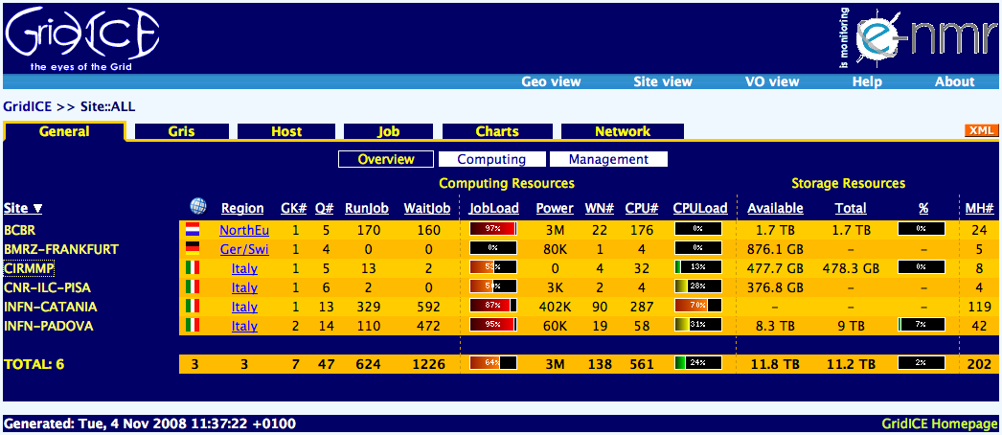
Figure A: GridICE view of the e-NMR grid

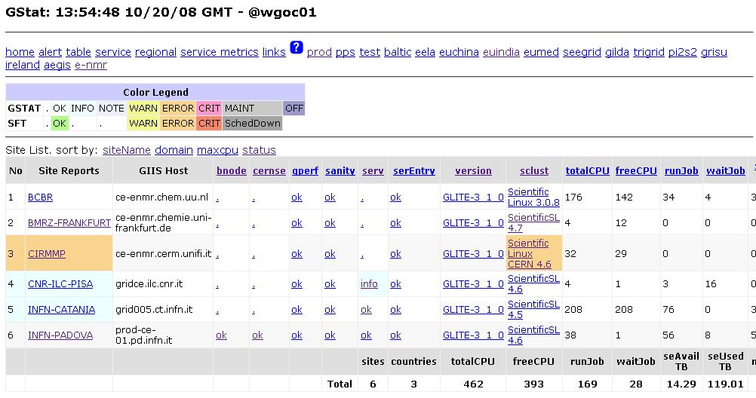
Figure B: Gstat view of the e-NMR grid

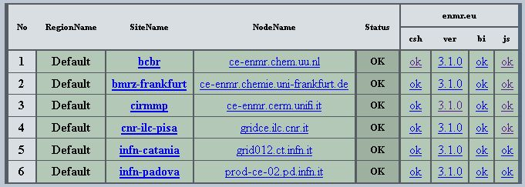
Figure C: results of basic SAM tests for the e-NMR grid

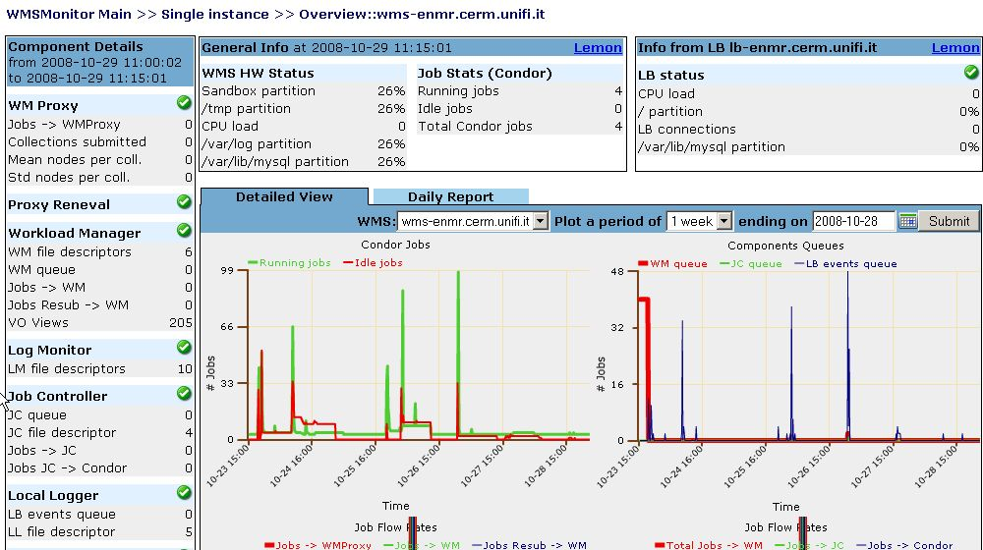
Figure D: detailed view of the e-NMR dedicated gLite WMS/LB system main processes as seen from WMSMonitor tool

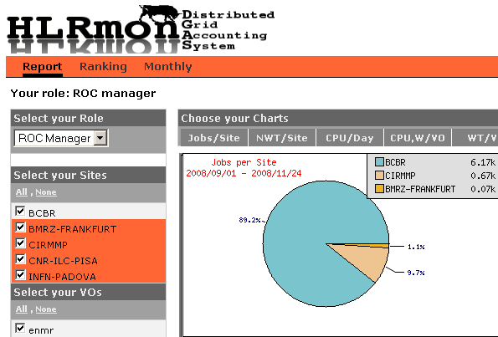
Figure E: grid job distribution among NMR sites as seen by HLRMon/DGAS accounting system

Finally, concerning the task T2.3, it is strictly related to the outcome of Joint Research Activities in charge of WP3. It is expected in fact that WP3 will produce new middleware/software components specific for e-NMR community. During the first year a new component was developed by WP3 to access application web portals through users’ certificate in the browser, allowing for VO membership verification and subsequent permission to submit grid jobs using robot certificates (special X509 certificates tied to an application). In order to enable easy deployment at e-NMR sites, INFN provided and maintained a software repository based on SVN and available at https://forge.cnaf.infn.it/projects/enmrwebui/.

A total effort of 6 Man Months funded plus a 1.2 Man Months unfunded were provided by INFN for carrying out WP2 activities. It is only slightly less of one third of the overall resources planned for INFN contribution to WP2 over the 3 years of the project (22 MMs), and is due to the fact that the first contracts for new personnel started only in May 2008, six months after the official start of the project. Thus, in the first six months the activity was carried out with unfunded effort.

Explanation of the use of the resources

Please provide an explanation of personnel costs, subcontracting and any major costs incurred by each beneficiary, such as the purchase of important equipment, travel costs, large consumable items, etc. linking them to work packages.

There is no standard definition of "major cost items". Beneficiaries may specify these, according to the relative importance of the item compared to the total budget of the beneficiary, or as regards the individual value of the item.

These can be listed in the following tables:

Table 3.4 Personnel, subcontracting and other major cost items for Beneficiary 4 for the period

Work Package | Item description | Amount | Explanations
WP0 | Personnel costs | 0 | M. Verlato contributed to task T0.3 with 1.2 MM-UF effort
WP1 | Personnel costs | 8611 | M.Verlato 2.4 MM-UF, S. Dal Pra 2.5 MM-F contributed to task T1.2 and T1.3 giving training and consultation
WP2 | Personnel costs | 21319 | M.Verlato 1.2 MM-UF, S. Dal Pra 1 MM-F, E. Frizziero 2.4 MM-F, S.Traldi 2.1 MM-F, S.Badoer 0.5 MM-F contributed to all tasks performing:  - deployment of e-NMR grid services at the labs  - support and operations of e-NMR grid, set up of monitoring and accounting tools  - set up of repository and deployment of enmrwebui code developed by WP3
WP3 | Personnel costs | 26472 | M.Verlato 1.2 MM-UF, S. Dal Pra 1.5 MM-F, E. Frizziero 3.6 MM-F, S.Traldi 1.8 MM-F, S.Badoer 0.5 MM-F contributed to task T3.2 developing the enmrwebui component
WP3 | Travels | 2109 | Participation of M.Verlato and S.Dal Pra to developers meeting of 16-17/7/2008
 | Remaining costs | 0
TOTAL DIRECT COSTS AS CLAIMED ON FORM C |  | 58511

