 | 

2nd Periodic Report

SEVENTH FRAMEWORK PROGRAMME
Research Infrastructures
INFRA-2007-1.2.2 - Deployment of eInfrastructures for scientific communities

Grant agreement for: Combination of Collaborative projects & Coordination and support actions

Proposal/Contract no.: 213010 – e-nmr
Project full title: Deploying and unifying the NMR e-Infrastructure in System Biology
Project coordinator: Prof. Dr. Harald Schwalbe
Project website: http://www.enmr.eu/
Period covered: from 01-11-2008 to 31-10-2009

Project funded by the European Community

PROJECT OBJECTIVES FOR THE PERIOD

Work Package 1 aims to tackle the following general objectives (objectives 1.2-1.4 as described in Annex I – “Description of work” to the Contract):

Work Package 2 is dealing with “e-NMR grid deployment and operations”. Its main objectives, as stated in Annex I, are:

- to deploy the e-NMR grid infrastructure
- to support the e-NMR grid infrastructure

Objective 1 has been mainly achieved in the first year by the deployment of the following basic grid services:
- the enmr.eu Virtual Organisation
- gLite User Interfaces (UI), Computing Elements (CE) and Storage Elements (SE) services at BCBR, BMRZ and CIRMMP centres
- gLite central services for job management at CIRMMP and INFN centres (WMS, LB, LFC, BDII)
and by the deployment of the application software on the shared areas of the CEs.
The deployment activity however has to continue throughout the whole lifetime of the project in order to keep the e-NMR grid infrastructure aligned with the most recent middleware releases, to update it with the new tools, applications or components produced by the Joint Research activities, and to possibly include new grid sites willing to join the e-NMR infrastructure.
The objective 2 aims to set up an operational structure for the management, control and support of the e-NMR infrastructure, often referred with the term Grid Operation Centre (GOC). The basis was the deployment of a number of monitoring and accounting tools at CIRMMP and INFN centres. A team of grid experts makes use these tools to proactively monitor the e-Infrastructure in order to check its health status and to account the use of the central grid services and of the remote computing and storage resources. The team advertises the local site managers about grid related issues at their site and suggest how to fix problems. It also answers to any support request from application developers and site managers.
For the reporting period under consideration, two additional objectives were added after the interim review of June 2009:
- the setup of a enchanced data security infrastructure for increasing user data confidentiality
- the definition and publication of a survey of the interest and demands of the user community as well as the potential industrial stakeholders with respect the provision of fee-based services and/or training activities.

Work Package 3 is dealing with the […]:

XX tasks were established to achieve the above objectives:

WORK PROGRESS AND ACHIEVEMENTS DURING THE PERIOD

WP2: e-NMR Grid deployment and operation

Summary of progress

A significant progress has been obtained in the second year of the project towards the deployment of the e-NMR infrastructure (objective O2.1) and its monitoring, usage accounting and support (objective O2.2) as result of the work carried out by all of the four project partners.

It can be summarized as follows.

Concerning the inclusion of new resources:
- In January 2009 two new grid sites of Italian National Grid, INFN-LNL-2 and INFN-TRIESTE, added its support to enmr.eu VO initially with 228 CPUs (now are more than 900) shared with others VOs.
- In April 2009, BiG Grid, the Dutch e-Science Grid, officially agreed to support enmr.eu VO. As a consequence, a large cluster farm with around 1600 CPUs at Philips in Eindhoven, and an analogous cluster with around 1150 CPUs operated at NIKHEF in Amsterdam, joined the e-NMR grid in May 2009.
- The BCBR partner, starting from June 2009, has been gradually incorporating new grid services into its site, with the aim of reducing the load on critical VO grid services such as WMS and LB.
- BMRZ has performed planned step-wise extension of the Frankfurt grid cluster ahead of the increasing volume of jobs.
- The EBI engaged in discussions with the UK National Grid Service (NGS) who have agreed to support the enmr.eu VO.
- EGEE Central Europe Regional Operation Centre has offered support to enmr.eu VO.
- At the 4th EGEE User Forum Conference held in Catania, Italy, the 2-6 March 2009, contacts were established with the South African National Compute Grid (SAGrid) Joint Research Unit, and its related Life Science community. The interest into e-NMR was formalized with a letter of support, which stated the support of the Bioscience Unit of the South African Council of Scientific and Industrial Research (CSIR), and the offer of sharing with enmr.eu VO computing resources from the CSIR Cluster Computing Centre. SAGrid is deploying on its sites the IGI Release, so their integration into e-NMR grid is expected to be quite straightforward. A detailed work plan was agreed with the SAGrid Operations group and it is described in the deliverable D2.2. The WP2 team started to coordinate and support this activity and will follow it until the end of the project.

Concerning the NMR labs computing resources to join EGEE grid:
- In March 2009, CIRMMP grid site joined the EGEE production grid after following the procedure implemented by the Italian ROC for adding new resources to IGI grid infrastructure.
- In late June 2009, the Nothern European Regional Operation Centre (ROC) added BCBR grid site to EGEE infrastructure to initiate the certification process. An update on all the BCBR grid services had to be made in order to support both OPS and DTEAM virtual organizations, responsible for the certification and maintenance of EGEE grid sites.
- In July 2009 The BMRZ registered at the Germany/Switzerland ROC and is following the procedure to become a fully certified EGEE site.

Concerning operational support, service deployment and maintanance:
- For all of the grid services, 14 middleware updates to gLite / INFNGRID release issued during the reporting period were applied.
- A mailing list enmr-sitemanagers@lists.infn.it restricted to site managers and supporters of e-NMR project was set up at INFN for service alert notifications in January 2009. A team of e-NMR funded staff set up at the INFN site had the task of checking daily the status of e-NMR grid using the monitoring tools set up in the first year of the project.
- Per-application accounting has been implemented defining a VOMS group for each application
- The deployment of a number of Hydra keystores was completed in October 2009 at all the main e-NMR grid sites in order to enable the gLite Encrypted Data Storage system.

Concerning the integration of JRA components:
- A joint platform for code development was implemented in July 2009, as a result of task T2.3 activity. The Trac system (http://trac.edgewall.org/) was selected as a platform to share expertise, knowledge and code (plus descriptions) between the sites. It provides a Wiki, a timeline to track changes, support for project planning and issue tracking, as well as access to a subversion (SVN) source code repository. The integration of JRA developed components into e-NMR plarform, described in the deliverable D2.3, has been completed and the corresponding milestone M2.2. has been timely achieved.

Finally, a survey for catching the interest and demands of the user community as well as of potential industrial stakeholders with respect to the provision of fee-based services and/or training activities has been implemented. It has been published on the eNMR project web site and can be filled online. It has also been advertised on the Belief project portal, and presented at the eNMR event held in Cambridge at the premises of the EMBL-EBI Genoma Campus in early November 2009. The survey addresses the D2.8 project deliverable. Its results will be analysed and the relevant actions implemented in the deliverable D2.9 due by month 27.

Detailed description of progress

Resource deployment

Since the beginning of the project CIRMMP and INFN centres are hosting the central core services for the e-NMR grid. While services hosted by CIRMMP are fully dedicated to e-NMR, the services hosted by INFN are shared with the Italian Grid Infrastructure (IGI), which in turn is part of the EGEE grid infrastructure.
In the reporting period, the BCBR partner put in operation 3 additional central services (the gLite WMS, LB and top-BDII) fully dedicated to e-NMR, in order to cope with the increasing job load.
Furthermore, the National Dutch Grid Initiative BiGGrid enabled the sharing of its central services to support e-NMR Virtual Organisation, adding thus in total 2 WMS, 1 LB and 3 top-BDII services.
The full list is shown below in Table 2-1.

 | WMS | LB | Top-BDII | Shared
BCBR | wms-enmr.chem.uu.nl | lb-enmr.chem.uu.nl | bdii-enmr.chem.uu.nl | NO
BiGGrid | graszode.nikhef.nl, graspol.nikhef.nl | grasveld.nikhef.nl | bdii03.nikhef.nl, graskaas.nikhef.nl, kraal.nikhef.nl | YES
CIRMMP | wms-enmr.cerm.unifi.it | lb-enmr.cerm.unifi.it | bdii-enmr.cerm.unifi.it | NO
INFN | prod-wms-01.pd.infn.it,  egee-wms-01.cnaf.infn.it | prod-lb-01.pd.infn.it, albalonga.cnaf.infn.it | prod-bdii-01.pd.infn.it,  egee-bdii.cnaf.infn.it | YES

Table 2-1: List of central services for job management and information system supporting the e-NMR grid. In italics the services added in the reporting period.

Other specific VO services necessary to run the e-NMR grid are listed in Table 2-2. In the last year, 5 Hydra servers were deployed at the premises of the partners sites in order to enable the Encrypted Data Storage on e-NMR grid.

 | VOMS | LFC | Hydra
BCBR | - | - | hydra-enmr.chem.uu.nl
BMRZ | - | - | hy-enmr.chemie.uni-frankfurt.de
CIRMMP | - | - | hydra-enmr.cerm.unifi.it
INFN | voms02.cnaf.infn.it,  voms-02.pd.infn.it | lfcserver.cnaf.infn.it | amga.pd.infn.it,  egee-bdii.lnl.infn.it

Table 2-2: List of VO specificcentral services for security, file cataloguing and data encryption. In italics the services added in the reporting period.

Computing and storage resources of e-NMR grid are geographically distributed across the Dutch and Italian NGIs and the three NMR laboratories which are part of the project: BCBR in Utrecht, BMRZ in Frankfurt, CIRMMP in Florence.
CIRMMP grid resources have joined the Italian Grid IGI and becomed part of EGEE production grid and its operations under the coordination of the Italian Regional Operation Centre (ROC).
BCBR has joined the EGEE Northen European ROC and its grid resources are registered in the GOCDB as candidate for certification.
BMRZ joined the Germany/Switzerland ROC and registered with GOCDB, and is finalizing the procedure at to become a fully certified EGEE site. The BMRZ has performed a small extension of its grid cluster ahead of the increasing volume of jobs; currently there are next to the common services (CE, SE, UI, HYDRA), 6 high-performance worker-nodes operational for grid computing with a total of 44 Intel Xeon E5462 cpu cores at 2.80GHz.
Furthermore, UK National Grid Service (NGS) has been contacted by EMBL-EBI partner and has shown interest in supporting the e-NMR VO; EGEE Central Europe ROC is considering to support their NMR user community in adding their resource to e-NMR grid. This could lead to a further increase of the number of EGEE grid sites supporting e-NMR in the next project period.

The overall current picture is shown in Table 2-3 below, which collect data taken from GStat.

 | Month 12 |  |  | Month 24
Site | CPUs | KSI2K | TBs | CPUs | KSI2K | TBs
BCBR | 176 | 314 | 1.81 | 176 | 424 | 1.81
BMRZ | 16 | 40 | 0.89 | 44 | 148 | 0.89
CIRMMP | 32 | 89 | 0.17 | 32 | 89 | 0.17
Total dedicated | 194 | 443 | 2.87 | 252 | 661 | 2.87
INFN-PADOVA | 58 | 60 | 5.65 | 82 | 85 | 5.65
INFN-CATANIA | 204 | 399 | - | 389 | 817 | -
CNR-ILC-PISA | 4 | 3 | 0.37 | 4 | 3 | 0.37
INFN-LNL2 | - | - | - | 564 | 1229 | -
INFN-TRIESTE | - | - | - | 354 | 420 | 20.43
HTC-BIGGRID | - | - | - | 1648 | 3461 | 6.60
NIKHEF-ELPROD | - | - | - | 1144 | 1779 | 2.20
Total shared | 266 | 462 | 6.02 | 4185 | 7794 | 35.25
TOTAL | 460 | 905 | 8.89 | 4437 | 8455 | 38.12

Table 2-3: Computing and storage resources forming the e-NMR grid at project month 12 and 24.

Resource usage accounting

At the end of October 2009, the VO counted 128 members, mainly concentrated in the countries which have the NMR laboratories as project partners. An initial expansion towards East Europe countries is however visible in the Figure 2-1. It can be considered a result of the joint East-NMR and e-NMR workshop held in Florence in June 2009. Notably, many users who joined from US followed directly the release of the CS-Rosetta portal which they are already using, though the later was not yet been advertised. More users are expected since this is a typical example of software that cannot be run on local resources. Other than from US, outside Europe users coming from Israel (2), Korea (2), South Africa (1) and New Zealand (1) were recruited at international bio-NMR events.

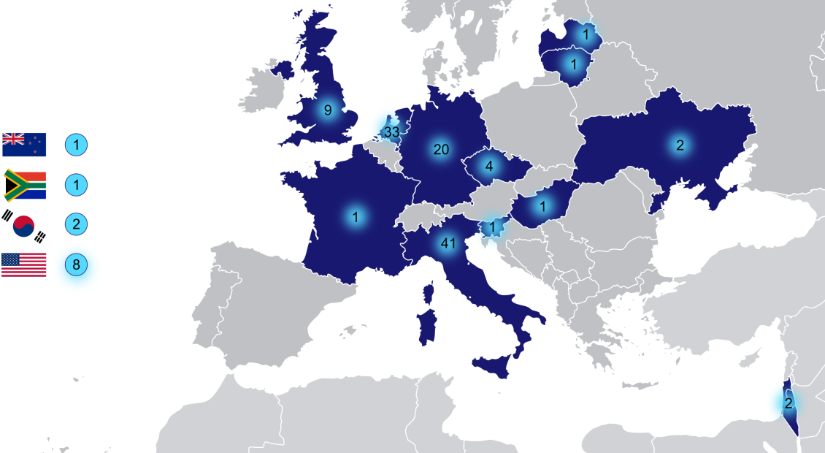
Figure 2-1: Geographical view of e-NMR users distribution

The availability of applications accessible via web portal increased at the same time as shown in Table 2-4 below.

Month 12 |  |  | Month 24
# VO members | Application | Access via portal | # VO members | Application | Access via portal
26 | NMRPipe |  | 128 | NMRPipe
26 | PROSA |  | 128 | PROSA
26 | INFIT |  | 128 | INFIT
26 | CNS |  | 128 | CNS
26 | CYANA |  | 128 | CYANA | ✓
26 | XPLOR-NIH | ✓ | 128 | XPLOR-NIH | ✓
26 | HADDOCK | ✓ | 128 | HADDOCK | ✓
26 | CSRosetta |  | 128 | CSRosetta | ✓
26 | GROMACS |  | 128 | GROMACS
26 | MAPPER |  | 128 | MAPPER
26 |  |  | 128 | CcpNmr FormatConverter | ✓
26 |  |  | 128 | MARS
26 |  |  | 128 | MDDnmr | ✓
26 |  |  | 128 | NUSSAMPLE
26 |  |  | 128 | TALOS+ | ✓

Table 2-4: Evolution of the number of enmr.eu VO members, applications and their availability through web portal

The DGAS system has been used, together with the EGEE Accounting Portal, to account the usage of the e-NMR grid by enmr.eu VO members. The period considered is in the interval from the 1st of November 2008, official opening of the e-NMR grid, to 31st of October 2009 (end of project month 24).

Figure 2-2 thus shows the number of jobs run, and the corresponding normalized CPU time, per each site supporting e-NMR grid in the last year. The normalized CPU time is the clock time consumed on the computing nodes in KSI2K.years units. KSI2K unit is used to benchmark CPU performance for integer operations (see http://www.spec.org). For instance, a typical 3 GHz Intel or compatible CPU corresponds to about 1 KSI2K.

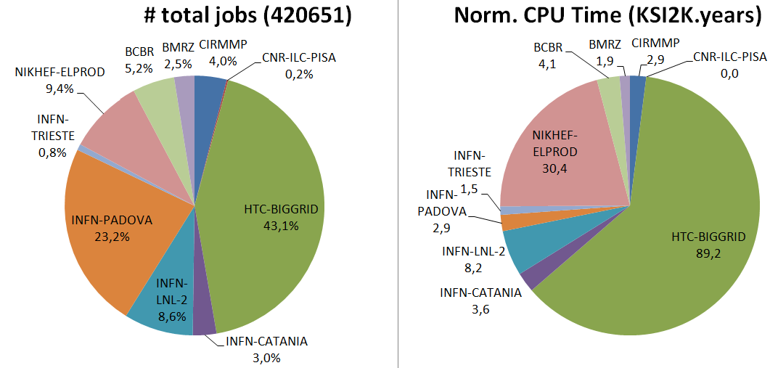

Figure 2-2: on the left the number of job run by each grid site in the last year; on the right the normalized CPU time consumed

A total of 145 KSI2K.years of normalized CPU time was consumed in the last year. As can be seen from Figure 2-3, a big increase in the infrastructure usage happened after May 2009, when on one side the two BigGrid sites with more than 2700 CPU-cores were added to e-NMR grid, and on the other hand the very CPU time demanding CSRosetta application was deployed and made available to the users. Notably, if we consider the period May-October 2009, enmr.eu VO accounts for the 23% of the total Life Sciences community grid usage (130 CPU.years over 570), with peaks in June and in October 2009 where enmr.eu was the first most used VO in Life Sciences, as shown in Figure 2-4.

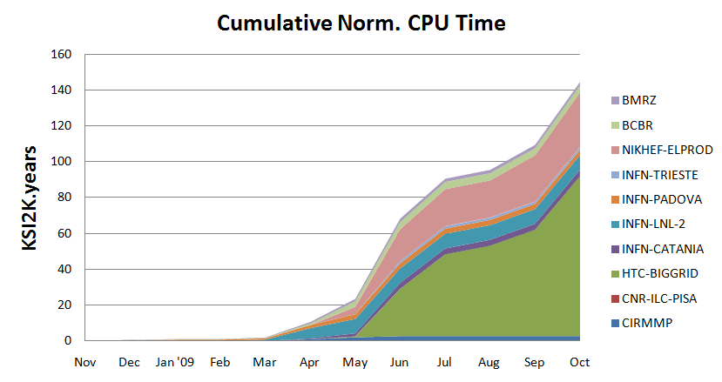
Figure 2-3: Cumulative normalized CPU time consumed by enmr.eu VO per site versus time

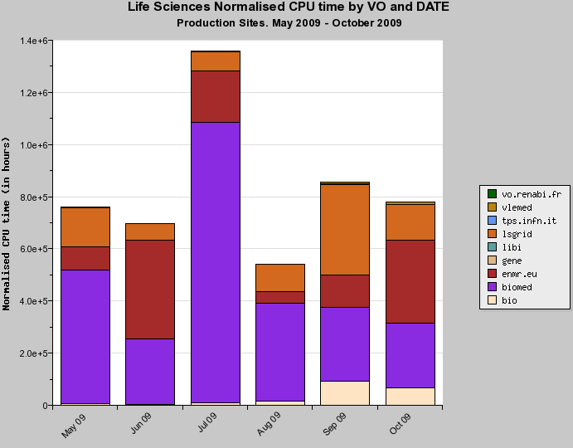

Figure 2-4: Life Sciences VOs usage in the last 6 months, in terms of normalised CPU time, with enmr.eu VO shown in red

Concerning per-application accounting, it has been planned exploiting the granularity made available by the VOMS service. A VOMS group has been defined for each application. In this way, as an example, each user willing to run HADDOCK would then use a VOMS proxy created by him, or by the portal engine on his behalf, with a command like voms-proxy-init -voms enmr.eu:/enmr.eu/haddock
The usage records collected and stored by the grid accounting services have the VOMS group information and allow the aggregate usage of each application to be measured and shown through the accounting visualization tools. The implementation of the per-application accounting has started gradually, because it requires both a re-configuration of the main grid services (WMS and CEs) as well as a not negligible modification of the code behind the portals which handles the automatic grid job management. It was thus chosen not to interrupt the production services offered to the users, testing deeply the solution in parallel instances before switching to production mode. These tests are currently ongoing for all the e-NMR portal based applications.

Grid operations and support

For all the grid services, the following middleware updates to gLite / INFNGRID were applied:
- packed update 32-33-34 for SL4 services, issued the 7/11/2008
- packed update 35-36-37 for SL4 services, issued the 5/12/2008
- packed update 38-39 for SL4 services, issued the 23/01/2009
- packed update 40-41 for SL4 services, issued the 4/3/2009
- packed update 42-43-44 for SL4 services, issued the 24/4/2009
- packed updates 45/46 for SL4/i386 services, issued the 25/5/2009
- packed updates 42/43/44/45/46 for SL4/x86_64 services, issued the 25/05/2009
- packed updates 47/48/49/50 for SL4/i386 and x86_64 services, issued the 14/7/2009
- packed gLite 3.2 updates 01/02 for SL5/x86_64 WN service, issued the 24/7/2009
- packed gLite 3.2 updates 02/03 for SL5/x86_64 UI and BDII services, issued the 27/7/2009
- packed gLite 3.1 updates 51/52 for SL4/i386 and x86_64 services, issued the 19/8/2009
- packed gLite 3.1 updates 53/54/55 for SL4/i386 and x86_64 services, issued the 23/9/2009
- packed gLite 3.1 update 56 for SL4/i386 services, issued the 7/10/2009
- packed gLite 3.2 updates 05/06 for SL5/x86_64 services, issued the 22/10/2009

A team of e-NMR funded personnel has been set up at INFN with the task of checking daily the status of e-NMR grid using the monitoring tools set up in the first year. Due to the limited number of people involved in grid operations, support requests from site administrators to grid experts are handled through the appositely set up electronic mailing list enmr-sitemanagers@lists.infn.it. This is a closed mailing list which includes all of the site managers of the three NMR centres. It was set up in January 2009, and has an archive allowing the tracking of problems for further reference. It has seen an activity of 345 mail exchanges in the reporting period, i.e. a monthly average of 35. Via the mailing list the e-NMR/INFN support team promptly notifies e-NMR site managers about local grid issues or malfunctioning, in order to minimize the impact of badly working sites on job efficiency. The site affected by the problem is indicated on the subject of the e-mail, but the e-mail is sent to the full list to make all site managers aware of the kinds of problems which can arise on e-NMR grid, so they can share solution pertaining to all participants.
For those sites of e-NMR part of IGI production grid, the IGI ticketing system is also used for communication with their site managers. For the two sites that are part of the Dutch production grid and that were added at the end of May 2009, their local support mailing lists have been used for the first contacts. The use of the Global Grid User Support (GGUS) system will be, however, the natural choice for communication.
At the 4th EGEE User Forum Conference held in Catania, Italy, the 2-6 March 2009, project representatives established contacts with the South African National Compute Grid (SAGrid). Its manager has shown great interest in the e-NMR project. SAGrid is deploying production high-performance grid computing services to South African research institutes and universities using the gLite stack from EGEE. It is currently supporting four scientific domains: Life Sciences, High Energy Physics, Nuclear Medicine (radiotherapy), and Astronomy/Astrophysics.
The interest in e-NMR was formalized with a letter of support (added as annex in D2.2), which states the support of the Bioscience Unit of the South African Council of Scientific and Industrial Research (CSIR), and the offer of sharing with enmr.eu VO computing resources from the CSIR Cluster Computing Centre.
SAGrid is deploying on its sites the IGI Release, so their integration into e-NMR grid is expected to be quite straightforward. A 7 steps work plan was agreed with the SAGrid Operations group as follows:

- Virtual site installation at University of the Free State (UFS) in Bloemfontein or at University of Cape Town (UCT), test integration into e-NMR central services
- Repeat installation at CSIR centre, validate configuration
- Applications installation, tag and testing on virtual site
- Repeat and validation at C4, final application configuration
- Run pilot jobs to test infrastructure (at this point we will have an evaluation of the procedure to discuss major issues)
- CSIR centre into e-NMR production grid
- Repeat at any site which wants to support e-NMR VO

The execution of this work plan is currently ongoing. The SAGrid CA is planned to get officially accredited by EUGridPMA in April/May 2010, so in the initial phase the sites were deployed and configured with the fake GILDA CA and VO. It allowed to make basic tests on site services proper installation, configuration and on the effectiveness of their network connectivity, but not to proceed further in the integration of these sites with e-NMR grid. In the meantime, INFN CA has offered to act as catch-all CA for SAGrid until their national CA gets approved, and planned to issue host certificates since November 2009.
We expect that some of the most stable sites of SAGrid will join the e-NMR grid during the next period of the project.

Integration of JRA components

A joint platform for code development was deployed, as a result of task T2.3 activity. The Trac system (http://trac.edgewall.org/) was selected as a platform to share expertise, knowledge and code (plus descriptions) between the sites. It provides a Wiki, a timeline to track changes, support for project planning and issue tracking, as well as access to a subversion (SVN) source code repository. Using this platform will help to identify further issues (for example which NMR data formats are in use and need to be interconverted to create a pipeline between resources), and is essential for the project to continue smoothly beyond the current funding period, and when core developers leave.
This WEB-eNMR Software Development Site is accessible at https://websql-enmr.cerm.unifi.it/trac/WEBeNMR/. For security reasons, access to this site is restricted so only users with a login can participate (for evaluation purposes, please click on the login link at the top right of the main menu, then log in as user eNmrGuest with password EU_evaluate!).
After discussions on the platform Wiki and the development meeting at the BCBR (7th-8th of July 2009), a set of subdivisions for the code was proposed and agreed upon, which serve to classify the software and simplify navigation:

- Web layer: user interaction, HTML form handling, gathering data for program execution, etc.
- Grid layer: job submission, job polling, SE data handling, etc.
- “Worker” layer: Scripts that run on worker nodes (e.g. to set up environment to run an application).
For the directory structure and use of the SVN repository, it was agreed that the directory structure in SVN (for sharing and tracking code) does not have to be the same as the directory structure used for deployment (to provide a live web service), but that there has to be some scope for consistently handling and organising generic code that is useful for all sites. See https://websql-enmr.cerm.unifi.it/trac/WEBeNMR/wiki/eNmrDiscussion/DirectoryStructure.
These shared decisions on the Trac site organisation now allow the partners to deposit their code and initiate or follow up discussions on the Wiki site. We are also creating a resource that describes the available software in terms of the process it performs the input and dependencies it requires, and the output and log files it generates. The site also contains documentation on how to access the integrated SVN server so all partners have straightforward access.
The shared development platform thus provides much clearer access to the e-NMR software (on the source code level), gives insights into the development process, and provides a single unified software structure that simplifies deployment of all e-NMR at the different sites. It will also help in making the e-NMR software available to external sites (e.g. industry).
More details are available on the document D2.3, delivered at month 21.

Security enhancement

On the gLite based grids a number of SEs and a VO level LFC are normally used for data management over unencrypted data storage. However, to allow a model where confidential data are saved on SEs managed by an external organization, a mechanism to prevent the administrator of the machine accessing the sensible data is required.
At the present time the gLite middleware provides the same security infrastructure for all grid services. The authentication is performed using a X.509-based PKI infrastructure and the VOMS attributes are used to authorize users according to their roles. Moreover, an authorization method based on Access Control Lists (ACL) ensures data access only by their owners. However, data are stored in a clear format. The Storage Element administrator can access them bypassing the grid security infrastructure. This is known as the insider abuse problem.
At the end of 2008 the EGEE project made available a solution to ensure confidentiality on user data stored in the grid:
the Encrypted Data Storage (EDS, https://twiki.cern.ch/twiki/bin/view/EGEE/DMEDS).
The solution has been widely used by the Biomedical user community in the context of Digital Imaging and Communications in Medicine (DICOM), where ensuring a high data protection level to respect patients privacy is strongly required. It has also been used in Finance research by a stock analysis application deployed by EU-IndiaGrid project involving a statistical analysis of individual financial instruments (stocks, bonds, options, etc.), where the input consisted of several years data about all market events having commercial value.
The Encrypted Data Storage provides a system that encrypts/decrypts files and stores/retrieves them from GFAL (Grid File Access Library) library-compliant storage systems. It provides a client-side C library to encrypt and decrypt block level data on the fly. It uses the OpenSSL cryptographic library for the symmetric cryptography routines, thus it can utilize any of the available cipher algorithms, such as the AES cipher. For additional security and redundancy, the encryption keys used to encrypt the files are split and stored in separate keystores: the Hydra servers. Hydra is the central element in the encrypted file storage solution. Hydra servers store the pieces of the encryption key and their associated ACL information. Therefore the key pieces are only accessible by their respective owners. These encryption keys are split using a particular scheme, Shamir Secret-Sharing Scheme (SSSS) that provides another layer of protection. The encryption key may be split into M fragments and may be recovered with possession of N fragments, where N<M. These parameters M and N are configurable by the number of Hydra servers deployed and the SSSS algorithm respectively. In this case, the security and reliability of the overall service has been increased: an attacker would have to gain access to at least N Hydra keystores to recover an encryption key; a legitimate user can tolerate the loss of M-N keystores and still recover their key.
An example of use of EDS is shown in Figure 2-5. More details are available on the document D3.9, delivered at month 24.

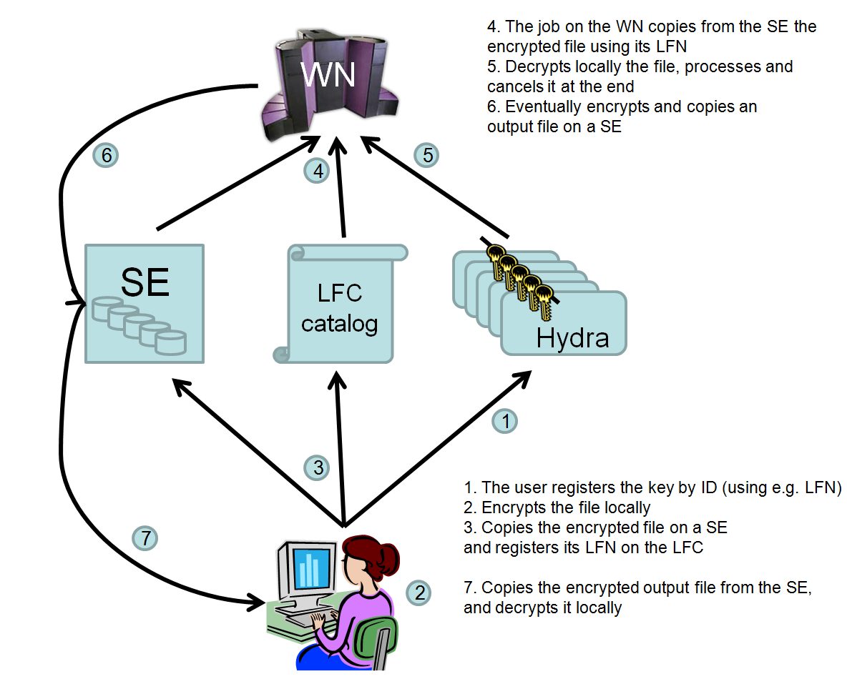
Figure 2-5: Encrypted data storage system use case

The deployment of the Hydra keystores started in July 2009. It required some troubleshooting and interaction with CERN developers because initially the gLite documentation was not complete. A IGI customized profile was created and its deployment and configuration instructions were made available by INFN team at http://igrelease.forge.cnaf.infn.it/doku.php?id=doc:guides:install-3_1. The deployment of 5 Hydra servers at the premises of INFN, BMRZ and CIRMMP grid sites was successfully completed in October 2009, the full list is given in Table 2-2 above.

Highlights

The following are the main achievements obtained in the reporting period of activity within WP2.

- Deliverable “D2.2: Assessment of the e-NMR infrastructure and GOC report” timely delivered at Month 18.
- Deliverable “D2.3: New components’ integration and deployment report” timely delivered at Month 21
- Milestone “M2.2: First integration of JRA developed components” achieved
- Deliverable “D2.8: Survey of the interest and demands of the user community as well as the potential industrial stakeholders with respect the provision of fee-based services and/or training activities” timely delivered at Month 24
- Resource usage proplerly accounted; per-application accounting introduced
- Grid data security enhanced through the adoption of the gLite Encrypted Data Storage system
- New resources from IGI and Dutch e-Science Grid smoothly added
- Plans to add SAGrid resources have been made and the testing activity started
- CIRMMP site entered IGI production grid, BCBR and BMRZ ready to enter in their national production grids
- Support from UK National Grid Service and Central Europe ROC offered
- GOC support team set up for checking e-NMR grid health and providing user support

