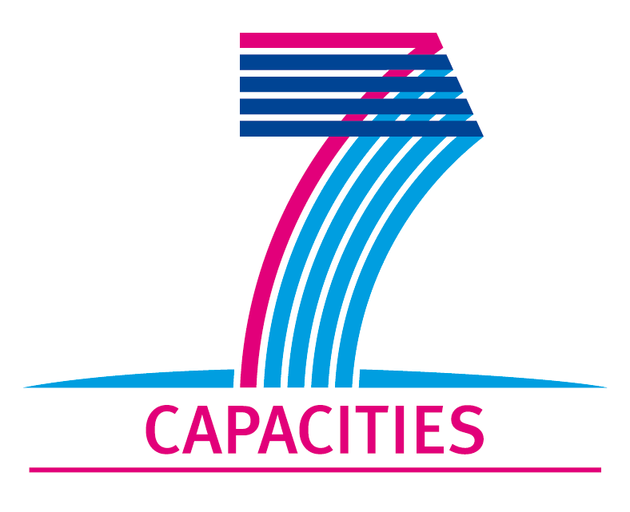 | 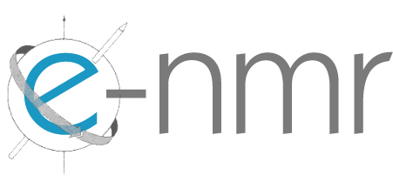

Deliverable 2.8

Survey of the interest and demands of the user community as well as of potential industrial stakeholders with respect to the provision of fee-based services and/or training activities

SEVENTH FRAMEWORK PROGRAMME
Research Infrastructures
INFRA-2007-1.2.2 - Deployment of eInfrastructures for scientific communities

Grant agreement for: Combination of Collaborative projects & Coordination and support actions

Proposal/Contract no.: 213010 – e-nmr
Project full title: Deploying and unifying the NMR e-Infrastructure in System Biology
Project coordinator: Prof. Dr. Harald Schwalbe
Project website: http://www.enmr.eu/
Period covered: from 01-11-2007 to 31-10-2009

Project funded by the European Community
Table of contents

1. Introduction 3
2. Survey layout 4
2.1. Security policy survey 4
2.2. Survey about the interest with respect to the provision of fee-based services and/or training activities 7

Introduction

An anonymous on-line survey has been proposed on the e-NMR web site with the goal of:

- Obtaining feedback on the security policy implemented by the e-NMR project
- Investigating the interest and demands of the user community as well as of potential industrial stakeholders with respect to the provision of fee-based services and/or training activities.

The survey has been published on the e-NMR project web site www.enmr.eu, under the Survey menu item, and can be filled online.

It has also been advertised the 29 of October on the Belief project portal (see Figure 1-1), and presented at the e-NMR event held in Cambridge at the premises of the EMBL-EBI Genoma Campus in early November 2009.

The goal 1 is the second round of the survey about security issues presented in the document D3.3, delivered at month 18.

The goal 2 addresses the D2.8 project deliverable due by month 24. Its results will be analysed and the relevant actions implemented in the deliverable D2.9 due by month 27.

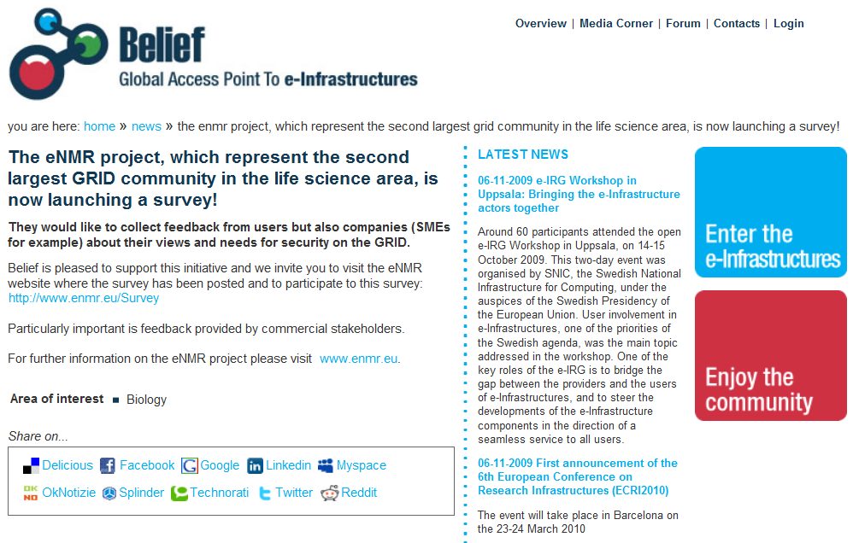

Figure 1-1: e-NRM survey launched on the Belief portal

Survey layout

Security policy survey

After the first survey published in D3.3, a lesson learned was that most of users had limited knowledge of grids and in particular of their security aspects.
It was thus decided to go for a second round, adopting a different approach: the security related part of the survey consists now in a FAQ format survey, where typical security related questions are simply posed and answered by our team. The user can approve or reject the answer, or leave his comment.
At the end of the survey, the user is asked to have a look at the more detailed e-NMR Security Policy Document available at http://www.enmr.eu/files/eNMR-security-policy.pdf, and provide his feedback optionally.

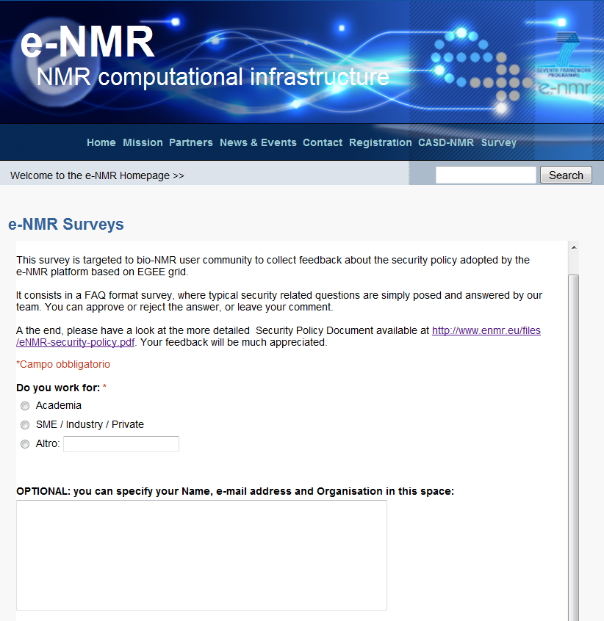

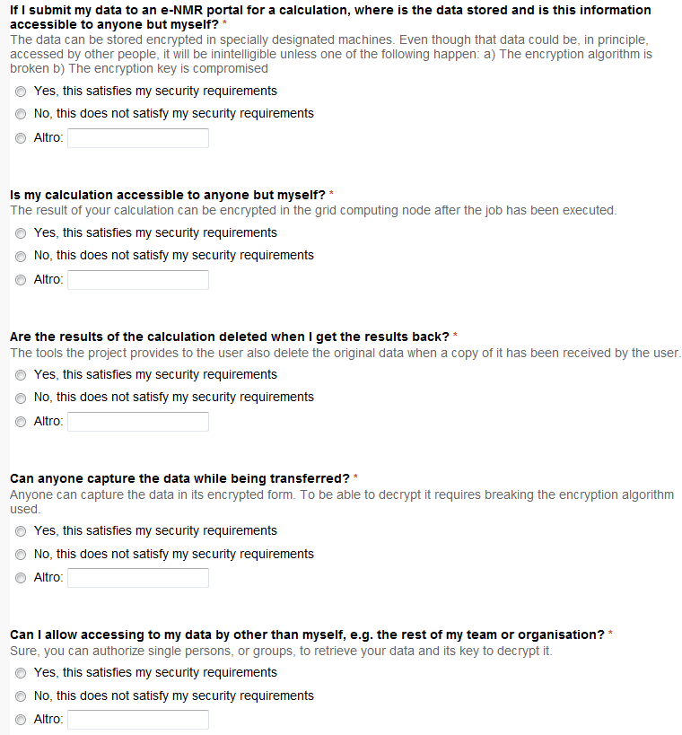

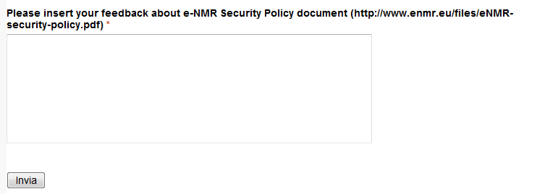

The results of this survey are reported in detail in the project deliverable “D3.9: Analysis of security issues brought about by the user community and by industrial stakeholders” timely delivered at month 24.
The security measures were judged as satisfactory by both academic users and industry. Some respondents from industry indicated that even if the security measures in place seem to be more than sufficient, industry in general will refrain from using grid based services and will rather invest in computational resources in-house, to minimize any potential security risks.
We can conclude from this survey that our current implementation of security including the new measures implemented described in D3.9 is thus satisfactory.

Survey about the interest with respect to the provision of fee-based services and/or training activities

This survey specifically addresses the D2.8 deliverable.
It consists of the five questions listed below.

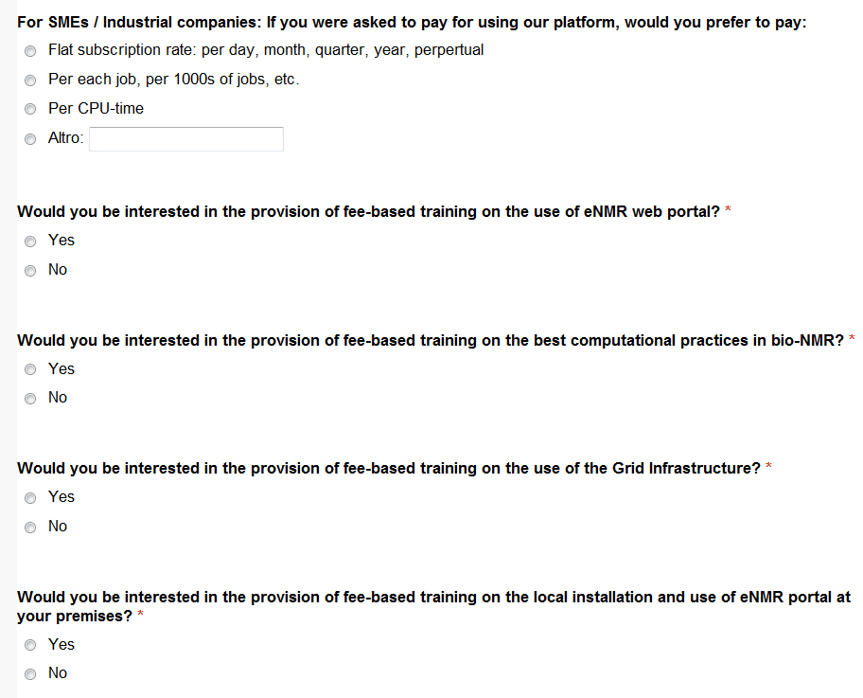

At the time of writing (16 November 2009), four SMEs answered, partially, to the above questions.

The first question was answered by three of them: two voted for the pay-per-job basis, one for the flat subscription rate. The latest one inserted a comment suggesting that, on the basis of his experience in the industry world, he does expect that any industrial partner that decide to participate in the e-NMR grid would be interested in paying also for training, most probably best negotiating both access and training in one fee.

The last four questions were answered by two out the four industrial partners: one was interested in all of the four offers (the one suggesting the above joint access/training fee), the second one only to the provision of training on the use of the e-NMR portal.

