WP2: e-NMR Grid deployment and operation

Summary of progress

A significant progress has been obtained towards the deployment of the e-NMR infrastructure (objective O2.1) and its monitoring, usage accounting and support (objective O2.2) as result of the work carried out by all of the four project partners.
At the end of May 2009, 70 registered users with enmr.eu VO were reached. As a comparison, the number of users registered with the EGEE global VO “biomed” at that time was 204. Notably, the biomed VO is covering a broad scientific applications area divided into the three sectors of medical imaging, bioinformatics and drug discovery, and counting actually about twenty regularly used applications since the beginning of EGEE project.
The planned training events and workshops demonstrating the e-NMR application platform organised in the second half of the project are expected to attract new users for enmr.eu VO, allowing meeting the target of 120 VO members as stipulated in the Annex I.
At present, nearly 150000 jobs and 12 years of normalized CPU elapsed time were consumed on the grid by e-NMR applications until April 2009.
A complete description of the e-NMR grid usage and its operations control was published in the Deliverable D2.2 (Assessment of the e-NMR infrastructure and GOC report) timely delivered at Month 18.
Here below is the summary of the main activities headed by the WP2 team during the reporting period:

- Two new grid sites of Italian National Grid, INFN-LNL-2 and INFN-TRIESTE, added its support to enmr.eu VO with 228 CPUs shared with others VOs.
- In April 2009, BiG Grid, the Dutch e-Science Grid, officially agreed to support enmr.eu VO. As a consequence, a large cluster farm with 1616 CPUs at Philips in Eindhoven, and an analogous cluster with 1152 CPUs operated at NIKHEF in Amsterdam, joined the e-NMR grid in May 2009.
- In March 2009, CIRMMP grid site joined the EGEE production grid after following the procedure implemented by the Italian ROC for adding new resources to IGI grid infrastructure.
- For all of the grid services, the following middleware updates to gLite / INFNGRID release issued during the quarter were applied:
  - packed update 32-33-34 for SL4 services, issued the 7/11/2008
  - packed update 35-36-37 for SL4 services, issued the 5/12/2008
  - packed update 38-39 for SL4 services, issued the 23/01/2009
  - packed update 40-41 for SL4 services, issued the 4/3/2009
  - packed update 42-43-44 for SL4 services, issued the 24/4/2009
- A mailing list enmr-sitemanagers@lists.infn.it restricted to site managers and supporters of e-NMR project was set up at INFN for service alert notifications in the fifth quarter. A team of e-NMR funded staff set up at the INFN site had the task of checking daily the status of e-NMR grid using the monitoring tools set up in the first year of the project and described in the deliverables D2.1 and D2.2. They promptly notify via the mailing list e-NMR site managers about local grid issues or malfunctioning, in order to minimize the impact of badly working sites on job efficiency. The site affected by the problem is indicated on the subject of the e-mail, but the e-mail it is sent to the full list to make all site managers aware of the kinds of problems which can arise on e-NMR grid, so they can learn each others. The list has an archive allowing the tracking of problems for further reference. It has seen an activity of 87 mail exchanges in the reporting period.
- At the 4th EGEE User Forum Conference held in Catania, Italy, the 2-6 March 2009, contacts were established with the South African National Compute Grid (SAGrid) Joint Research Unit, and its related Life Science community. The interest into e-NMR was formalized with a letter of support, which stated the support of the Bioscience Unit of the South African Council of Scientific and Industrial Research (CSIR), and the offer of sharing with enmr.eu VO computing resources from the CSIR Cluster Computing Centre. SAGrid is deploying on its sites the IGI Release, so their integration into e-NMR grid is expected to be quite straightforward. A detailed work plan was agreed with the SAGrid Operations group and it is described in the deliverable D2.2. The WP2 team started to coordinate and support this activity and will follow it until the end of the project.

Detailed description of progress

Since the beginning of the project CIRMMP and INFN centres are hosting the central core services for the e-NMR grid. While services hosted by CIRMMP are fully dedicated to e-NMR, the services hosted by INFN are shared with the Italian Grid Infrastructure (IGI), which in turn is part of the EGEE grid infrastructure.
The e-NMR grid is in fact a mixed infrastructure, composed by services and resources which are in part shared with other VOs of EGEE, and in part neither included in any National Grid Initiative (NGI) nor in the EGEE production grid.
Currently, central core grid services span all the areas of the gLite architecture: job management, information system, security, data management, monitoring and accounting.
GStat service is hosted by Academia Sinica Grid Computing (ASGC) of Taipei, Taiwan, the coordinator of EGEE Asia-Pacific ROC, which courtesy agreed to add an instance for e-NMR grid on its EGEE-wide server. A failover instance of GStat is provided by INFN.

Computing and storage resources of e-NMR grid are geographically distributed across the four partners’ institutions: BCBR in Utrecht, BMRZ in Frankfurt, CIRMMP in Florence and INFN in a number of centres in Italy. An additional site managed by the CNR, member of IGI, supported enmr.eu VO on best effort basis.
The overall picture is shown in Table 1 below, which collect data taken from GStat.

 | Month 12 |  |  | Month 19
Site | CPUs | KSI2K | TBs | CPUs | KSI2K | TBs
BCBR | 176 | 314 | 1.81 | 176 | 314 | 1.81
BMRZ | 16 | 40 | 0.89 | 28 | 70 | 0.89
CIRMMP | 32 | 89 | 0.17 | 32 | 89 | 0.17
Total dedicated | 194 | 443 | 2.87 | 236 | 473 | 2.87
INFN-PADOVA | 58 | 60 | 5.65 | 86 | 144 | 5.65
INFN-CATANIA | 204 | 399 | - | 204 | 399 | -
CNR-ILC-PISA | 4 | 3 | 0.37 | 4 | 3 | 0.37
INFN-LNL2 | - | - | - | 132 | 356 | -
INFN-TRIESTE | - | - | - | 96 | 114 | 20.43
HTC-BIGGRID | - | - | - | 1616 | 3383 | 6.60
NIKHEF-ELPROD | - | - | - | 1152 | 1791 | 2.20
Total shared | 266 | 462 | 6.02 | 3290 | 6190 | 35.25
TOTAL | 460 | 905 | 8.89 | 3526 | 6663 | 38.12

Table 1: Computing and storage resources forming the e-NMR grid at project month 12 and 19.

The above table does include the two large cluster farms of BigGRID (www.biggrid.nl) which joined the e-NMR grid in May 2009: one with 1616 CPUs at Philips in Eindhoven, and one with 1152 CPUs operated at NIKHEF in Amsterdam. The total number of CPUs shared with other VOs is then 3290 at the end of May, compared with the 522 available at the end of April.
The BCBR partner has in fact obtained support from BigGRID, the Dutch e-Science Grid. A meeting was organized in Utrecht on April 24th with BigGRID representatives and the EGEE ROC manager, Dr. Ron Trompert, to discuss details and initiate the certification of the BCBR site into the EGEE.

The BCBR partner has also invested in new hardware (4 dual core E6750 nodes and 1 dual quad core E5450 server) and deployed under XEN virtualization the following services, currently all in the testing phase using a local configuration and the latest gLite version:
- top-level BDII (currently reading a local configuration file to the test phase)
- BDII
- WN for testing
- CE
- UI
- MonBOX
- WMS

At the end of the first year, October 2008, the enmr.eu VO counted 26 people registered, all of them internal to the Consortium. After the milestone M2.1: “e-NMR grid operational” was achieved at project month 12, the registration was opened to research groups of the bio-NMR community outside the Consortium.

In general, registration is expected to occur in a two-stage process:
- Users located at the Infrastructures sites of Partner 1-3 register and gather first experiences about the practicability and scientific implementation. Thus, the e-NMR platform is tested and informal feed-back is immediately exchanged.
- At the beginning of the 2nd year, outside user start to enrol to the e-NMR platform, but numbers are expected to gain momentum during the third annual period when the platform matures beyond the testing phase.

At the end of May 2009, the VO counted 70 members, mainly part of the Consortium. It includes now a people from Slovenia, UK, US and New Zealand recruited at international bio-NMR events. Notably, the last users who joined (3 from US and 1 from France) followed directly the release of the CS-Rosetta portal which they are already using; though the later was not yet advertised. More users are expected since this is a typical example of software that cannot be run on local resources.
The availability of applications accessible via web portal increased at the same time as shown in Table 2 below.

Month 12 |  |  | Month 19
# VO members | Application | Access via portal | # VO members | Application | Access via portal
26 | NMRPipe |  | 70 | NMRPipe
26 | PROSA |  | 70 | PROSA
26 | INFIT |  | 70 | INFIT
26 | CNS |  | 70 | CNS
26 | CYANA |  | 70 | CYANA | ✓
26 | XPLOR-NIH | ✓ | 70 | XPLOR-NIH | ✓
26 | HADDOCK | ✓ | 70 | HADDOCK | ✓
26 | CSRosetta |  | 70 | CSRosetta | ✓
26 | GROMACS |  | 70 | GROMACS
26 | MAPPER |  | 70 | MAPPER
26 | AMBER |  | 70 | AMBER | ✓
26 |  |  | 70 | CcpNmr FormatConverter | ✓
26 |  |  | 70 | MARS
26 |  |  | 70 | MDDnmr
26 |  |  | 70 | NUSSAMPLE

Table 2: Evolution of the number of enmr.eu VO members, applications and their availability through web portal

The DGAS system, described in the next section, has been used to account the usage of the e-NMR grid by enmr.eu VO members. The period considered is in the interval from the 1st of November 2008, official opening of the e-NMR grid, to 30th of April (end of PM 18).

Figure 3-1 shows the number of jobs run per site in the given time interval.

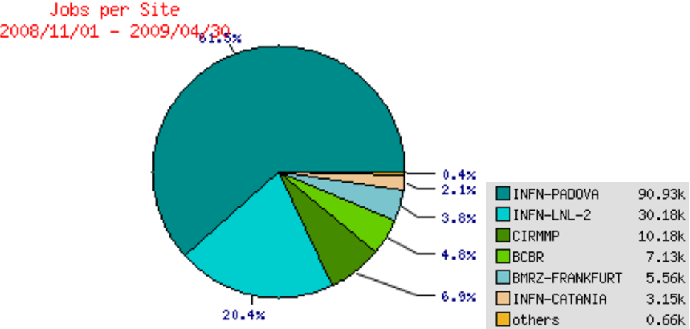

Figure 3-1: Number of job run by each grid site (147768 in total)

96% of the jobs (141805 over 147768) were actually submitted to the entire e-NMR grid through the grid-enabled web portal hosted at BCBR, making use of its robot certificate. The internal User Tracking System of the portal has shown that these jobs correspond to about 200 HADDOCK runs (a typical run submits to the grid 250 jobs, but for guru users the number can increase up to 15000) plus about 10 CSRosetta test runs (each run in this case submits from 1000 to 2500 jobs).

Figure 3-2 shows the normalized Wall time per grid site, i.e. the Wall clock time consumed on the computing nodes in KSI2K.days units. KSI2K unit is used to benchmark CPU performance for integer operations (see http://www.spec.org). For instance, a typical 3 GHz Intel or compatible CPU corresponds to about 1 KSI2K.

A total of 12.2 KSI2K.years of normalized Wall time was consumed in the reported period. In this case about 32% of the computing was provided by the NMR dedicated centres of BCBR, BMRZ and CIRMMP.
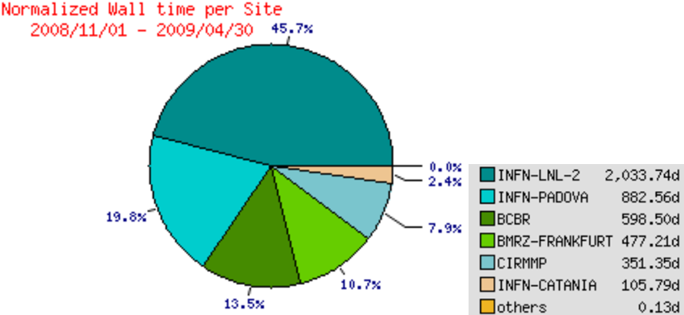

Figure 3-2: Normalized wall clock time consumed in each grid site (12.2 KSI2K.years in total)
Concerning accounting, in the second phase of the project the GOC will investigate the possibility to account the usage of each particular application deployed on the e-NMR platform. The goal is to allow for the implementation of alternative licensing revenues: instead of paying once a license fee, fine grained revenues could be charged according e.g. to the number of jobs executed, or the number of structures calculated. The best suited choice will be driven by the industrial partners.

Concerning the operational support, a team of e-NMR funded personnel has been set up at INFN with the task of checking daily the status of e-NMR grid using the monitoring tools set up in the first year. Due to the limited number of people involved in grid operations, support requests from site administrators to grid experts are handled through the appositely set up electronic mailing list enmr-sitemanagers@lists.infn.it. This is a closed mailing list which includes all of the site managers of the three NMR centres. It was set up in January 2009, and has an activity of about 30 mails per month. Via the mailing list the e-NMR/INFN support team promptly notifies e-NMR site managers about local grid issues or malfunctioning, in order to minimize the impact of badly working sites on job efficiency. The site affected by the problem is indicated on the subject of the e-mail, but the e-mail is sent to the full list to make all site managers aware of the kinds of problems which can arise on e-NMR grid, so they can share solution pertaining to all participants. The list has an archive allowing the tracking of problems for further reference.
For those sites of e-NMR part of IGI production grid, the IGI ticketing system is also used for communication with their site managers. For the two sites that are part of the Dutch production grid and that were added at the end of May 2009, their local support mailing lists have been used for the first contacts. The use of the Global Grid User Support (GGUS) system will be, however, the natural choice for communication.

At the 4th EGEE User Forum Conference held in Catania, Italy, the 2-6 March 2009, contacts were made with the South African National Compute Grid (SAGrid). Its manager has shown great interest in the e-NMR project. SAGrid is deploying production high-performance grid computing services to South African research institutes and universities using the gLite stack from EGEE. It is currently supporting four scientific domains: Life Sciences, High Energy Physics, Nuclear Medicine (radiotherapy), and Astronomy/Astrophysics.
The interest in e-NMR was formalized with a letter of support (added as annex in D2.2), which states the support of the Bioscience Unit of the South African Council of Scientific and Industrial Research (CSIR), and the offer of sharing with enmr.eu VO computing resources from the CSIR Cluster Computing Centre.
SAGrid is deploying on its sites the IG Release, so their integration into e-NMR grid is expected to be quite straightforward. A 7 steps work plan was agreed with the SAGrid Operations group as follows:

- Virtual site installation at University of the Free State (UFS) in Bloemfontein or at University of Cape Town (UCT), test integration into e-NMR central services
- Repeat installation at CSIR centre, validate configuration
- Applications installation, tag and testing on virtual site
- Repeat and validation at C4, final application configuration
- Run pilot jobs to test infrastructure (at this point we will have an evaluation of the procedure to discuss major issues)
- CSIR centre into e-NMR production grid
- Repeat at any site which wants to support e-NMR VO

We expect that some of the most stable sites of SAGrid will join the e-NMR grid already in 2009.

Highlights

The following are the main achievements obtained in the reporting period of activity within WP2.

- “D2.2: Assessment of the e-NMR infrastructure and GOC report” timely delivered at Month 18.
- Resource usage proplerly accounted
- New resources from IGI and Dutch e-Science Grid smoothly added
- Plans to add SAGrid resources have been made
- CIRMMP site entered IGI production grid, BCBR and BMRZ ready to enter in their national production grids.
- GOC support team set up for checking e-NMR grid health and providing user support

