Concerning the security issue related to the use of certificates, the access rights to the portals were guaranteed by requiring:
- a X509 personal certificate issued by a IGTF accredited CA loaded into the users’ browser
- the personal certificate DN had to be registered with the enmr.eu VO

Behind the portal a business logic software component performed the needed operations to allow job submission over the e-NMR grid. The current version of the HADDOCK, CS-Rosetta and Xplor-NIH portals job submission is implemented making use of X509 robot certificate issued per application by NIKHEF and INFN CAs, according with the VO Portal Policy draft documented by the Joint Security Policy Group (JSPG) of EGEE. In particular, the large number of jobs to be submitted and monitored by the HADDOCK and CS-Rosetta portals calls for automation. The current implementation of these two portals makes use of a robot certificate, qualifying them as a “parametric portal” according to the Joint Security Policy Group (JSPG) (see http://www.jspg.org/wiki/VO_Portal_Policy#.E2.80.9CParameter.E2.80.9D_Portals). The portal also obeys to the BigGRID (Dutch e-Science GRID) policies (see http://www.biggrid.nl/infra/BiGGrid-VO-Portal-Policy-v1.pdf ).

A custom User Tracking System was implemented by portal developers in order to keep track of applications usage by each user, associating the DN of the users’ certificate read at portal access time with the identifiers of grid jobs submitted with the robot on behalf of the user. Of course the usual grid accounting tools will see only the aggregate application usage, while the portal administrator will be always able to see the usage records of each user.

During the reporting period, a second version of the Xplor-NIH portal was developed with the goal of replacing robot-based job management with one based on user credentials via the so-called proxy delegation mechanism.
In this version, the user accessing the portal delegates his credential to both the MyProxy server and the portal web server. The latter will generate a proxy certificate to be used for job submission on users’ behalf. The interaction between the user and the delegation service is managed by a java applet.
The new architecture is shown in Figure 3-1. The generation of a proxy certificate is as follows. The user does contact the delegation service running on the web server. The service creates a public-private key pair and uses it to generate a Certificate Sign Request (CSR). This is a certificate that has to be signed by the user with his private key. The signed certificate is then sent back to the service. This procedure is similar to the generation of a valid certificate by a CA and, in fact, in this context the user acts like a CA. The certificate generated so far is then combined with the user certificate, thus forming a chain of certificates. The service that examines the proxy certificate can then verify the identity of the user that delegated its credentials by unfolding this chain of certificates. Once the proxy has been created and associated to the user ID in the web server database, it is transferred on the UI local to the web server LAN and behind a firewall. Decoupling the web server hosting the portal from the UI performing the job submission adds a further level of security. In fact, user proxies created in the web server are immediately destroyed after their transfer to UI. On the other hand, the UI is carefully protected inside the private network, with the minimum set of communication ports left open in order to interact with the e-NMR grid services (VOMS, WMS and MyProxy).
Jobs are submitted to gLite WMS using the short-lived proxy (12 hours of lifetime). Jobs lasting more than 12 hours will have the short-lived proxy automatically renewed before its expiration via the gLite proxy renewal mechanism acting at WMS level using the long-lived credentials (with maximum lifetime of two weeks) stored in the MyProxy server.

The suitability of this new portal implementation with proxy delegation mechanism for implementation in the HADDOCK and CS-Rosetta portals (both requiring a smooth automation with a very large volume of grid jobs to be submitted and monitored) will be investigated in the coming months by the INFN partner who will support the BCBR team in the transition process once proven suited for implementation.

A more detailed description of the adopted solution will be given in the document “D2.3: New components’ integration and deployment report”, a project deliverable due by Month 21.

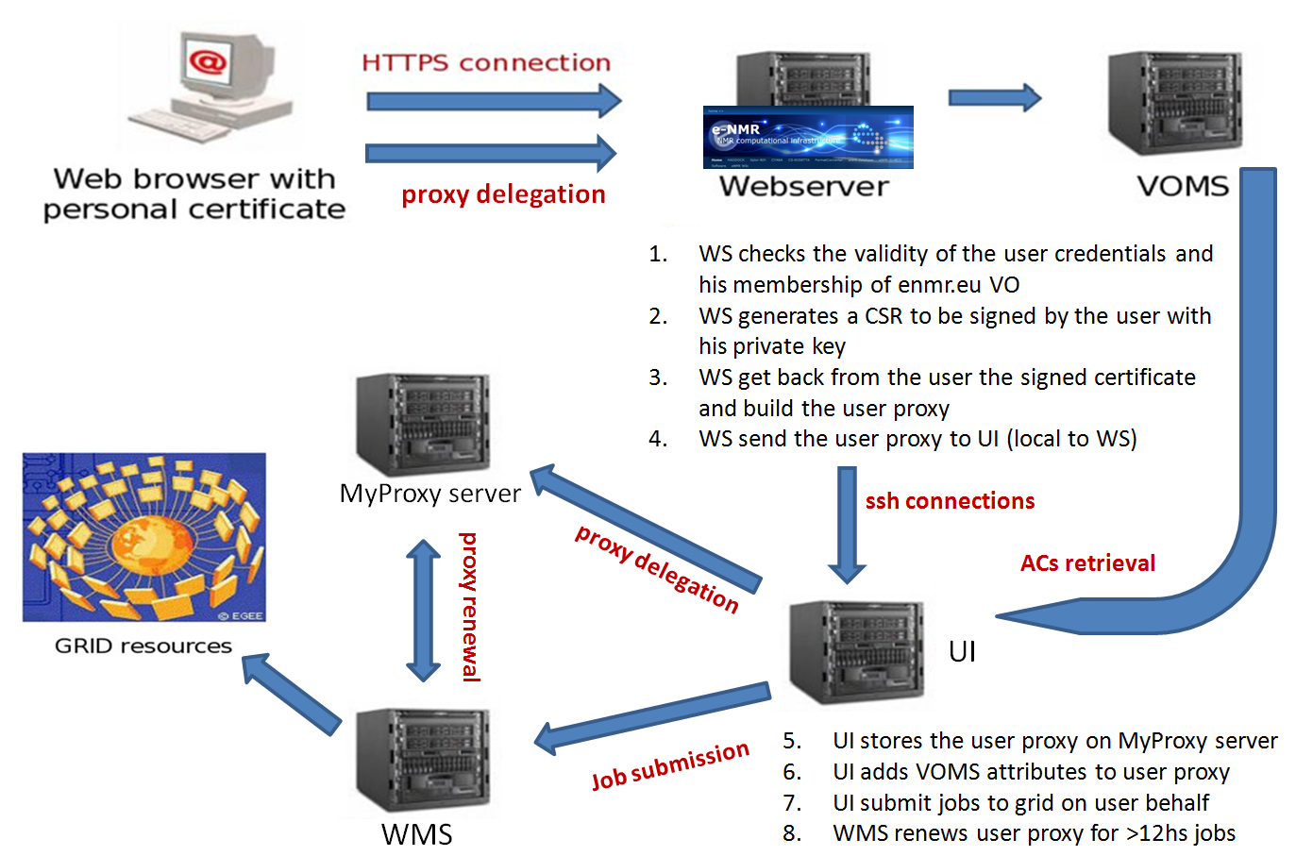

Figure 3-1: New web portal security architecture

The security risks associated with model described above are not higher than the ones normally accepted by users willing to run their applications on the EGEE grid. These risks are actually lower in our case, if we consider that in other communities most of the grid users keep their personal X509 certificate and private key permanently on the $HOME/.globus area of shared UIs provided by their institutes. In our model the private key is used only to sign via applet the CSR generated by the web server, so it can be kept secure in a USB key or in the owner’s laptop. Short-lived proxy certificates can of course be stolen by external attackers managing to get fraudulent access to UI, WMS, MyProxy server as well as the distributed Worker Nodes where jobs are running, other than by internal administrators of these services, but this is a general issue of the EGEE production grid. It is under the responsibility of the grid site managers to enforce strict policy on the network use to avoid the chance of their site being liable for playing a role in any malicious use such as attacks on other connected systems on the Internet.

For what concerns user data security, the gLite Data Management system based on a number of SEs and a VO level LFC has been used so far in the e-NMR grid for unencrypted data storage. The authorization mechanisms in the SE are based on how the SE maps the user credentials (the proxy certificate with VOMS AC) to the virtual UID and GIDs. The virtual UID is derived from the DN and the virtual GID either from the FQANs or a data management specific mapfile.
The file catalogue LFC is using the same model, whereas its virtual UID and GIDs are not correlated to the values used by the SE. Access Control Lists (ACLs) on files and directories are supported on both LFC and SE.

Several solutions are available to ensure confidentiality on user data stored in the grid, e.g.:
- Secure Storage (http://securestorage.sourceforge.net/index.html)
- GS3 (http://grid.ct.infn.it/twiki/bin/view/Main/GridSecureStorageSystem)
- Encrypted Data Storage (EDS, https://twiki.cern.ch/twiki/bin/view/EGEE/DMEDS)

The latest one has been developed by the EGEE project, and has been widely used by the Biomedical user community in the context of Digital Imaging and Communications in Medicine (DICOM), where ensuring a high data protection level to respect patients privacy is strongly required. It is an encrypted data service solution which provides a system that encrypts/decrypts files and stores/retrieves them from GFAL library-compliant storage systems. For additional security and redundancy, the encryption keys used to encrypt the files are split and stored in separate keystores (Hydra servers).
Hydra is the central element in the encrypted file storage solution. The Hydra service comprises at least one Hydra server and a set of command-line interfaces to perform the basic commands. The Hydra server consists of a MySQL database and a Tomcat server that acts to contain the actual Hydra software, written in Java.
The encrypted data service solution uses the Hydra servers to store the pieces of the encryption key and their associated ACL information. Therefore the key pieces are only accessible by their respective owners. These encryption keys are split using a particular scheme, Shamir Secret-Sharing Scheme (SSSS) that provides another layer of protection. The encryption key may be split into "M" fragments and may be recovered with possession of "N" fragments, where N<M. These parameters "M" and "N" are configurable by the number of Hydra servers deployed and the SSSS algorithm respectively. In this case, the security and reliability of the overall service has been increased: an attacker would have to gain access to at least "N" Hydra keystores to recover and encryption key; a legitimate user can tolerate the loss of M-N keystores and still recover their key.
In addition, a legitimate administrator of a Hydra keystore would not have access to the full encryption key.
Encryption keys are generated in the Hydra system based upon the concept of a globally unique identity (GUID) of the file in question to be encrypted. This GUID can be retrieved from sources such as an LFC catalogue that contains the logical names for files inside a storage element. The GUID is necessary for retrieval and decryption of files.
A view of the basic operations performed with EDS is shown in figure 3-2.
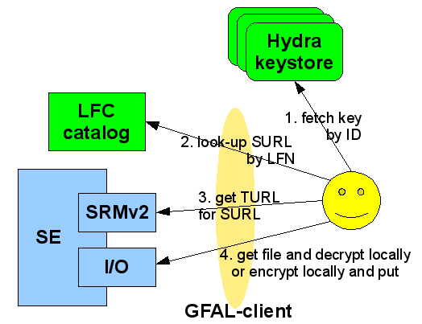

Figure 3-2: New web portal security architecture

The first release of the gLite Hydra service has been made available in December 2008, and Hydra clients are already included into gLite UI and WN profiles. It is therefore very easy to implement the EDS solution into e-NMR grid.
We are planning to deploy a number of Hydra servers on a few of e-NMR sites in the short term.

